**PROJECT-1**

**Deploying a**

**Multi-Tier Website Using AWS EC2**

**DONE BY  
RANJITH KUMAR**

**Problem Statement:**

Company ABC wants to move their product to AWS. They have the following

things set up right now:

1. MySQL DB

2. Website (PHP)

The company wants high availability on this product, therefore wants Auto

Scaling to be enabled on this website.

**Steps To Solve:**

1. Launch an EC2 Instance

2. Enable Auto Scaling on these instances (minimum 2)

3. Create an RDS Instance

4. Create Database & Table in RDS instance:

a. Database name: intel

b. Table name: data

c. Database password: intel123

5. Change hostname in website

6. Allow traffic from EC2 to RDS instance

7. Allow all-traffic to EC2 instance

STEP 1 : Open VPC from aws services

STEP 2 : Create a VPC

STEP 3 : Go to subnet and create two subnets(public&private)

STEP 4 : select the subnet1(public) and edit it to assign a public ip address

STEP 5 : Select internet gateway and create a internet gateway to access internet and attach it to our vpc

STEP 6 : Create a route table for subnet1 and associate the subnet1 to the route table and add routes to direct traffic(Destination : Anywhere Target : Internetgateway)

STEP 7 : Open EC2 from aws services

STEP 8 : Give name and select AMI , Instance type ,Keypair , Network settings(my vpc, subnet1, SSH&HTTP from anywhere)

And launch a instance

STEP 9 : Connect to the instance using instance connect

STEP 10 : Update the instance , Remove the index.html file.

Copt the link of the github(index.php and images) and add in the instance by using the command :- **sudo git clone** [**https://github.com/Training-Demo/AWS-Project-1.git**](https://github.com/Training-Demo/AWS-Project-1.git)

STEP 11 : Then move the index.php and images to the cd /var/www/html**(command:- sudo mv * /var/www/html)**

STEP 12 : Use the command:- **sudo add-apt-repository -y ppa:ondrej/php sudo apt install php5.6 mysql-client php5.6-mysqli -y to install php repository in it**

STEP 13 : Open RDS from aws services

STEP 14 : Select subnet group and create a subnet group for our rds instance

STEP 15 : Select database and create a MYSQL database using intial database name as intel and password as intel123

STEP 16 : database has been created

STEP 17 : Go the instance use the command:-sudo vim index.php and add the database endpoint in the servername

STEP 18 : To save use **ESC >> (colon) >>W(write) >>Q(Quit)**

STEP 19 : Website starts loading because of security group of the database is not modified

STEP 20 : Go to the Database security group and add the source as our VPC cidr to connect to the database running inside our vpc

STEP 21 : Now refresh the website error appears we need to create a table in the database

STEP 22 : Connect to the database using the command:- **sudo mysql -h(endpoint of the rds) -u(username) – p(password)**

STEP 23 : Connected to the database. Use the commands:- **show databases;** to display the database . To get into the intel **use intel;**

STEP 24 : Use the command:- **create table data(firstname varchar(25),email varchar(30));** to create a table in it

STEP 25 : Refresh the website , New record in the databse has been created tostore the data

STEP 26 : Select Load balancing and create a target groups to keep our instances inside it and then create a application load balancer

STEP 27 : Select Auto scaling groups and create a auto scaling group with minimum 2 instances.I have created a image from our existing ec2 instances and used to create launch template for the auto scaling groups

STEP 28 : Auto scaling group has been created with minimum capacity of 2

STEP 29 : Go to the Database security groups to allow traffic from our instances to database.add rule port:3306 source:security group of our instance

STEP 30 : Created a security group for the application load balancer having http and add it to the load balancer.So that it can allow all traffic to instances which has application load balancer infront it

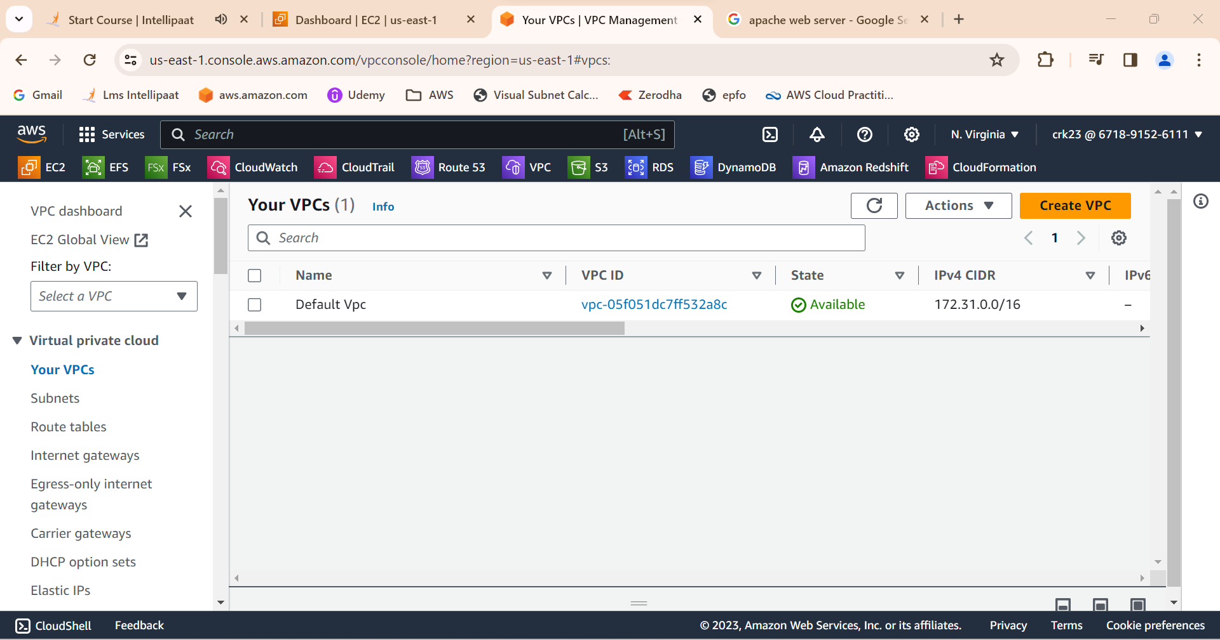

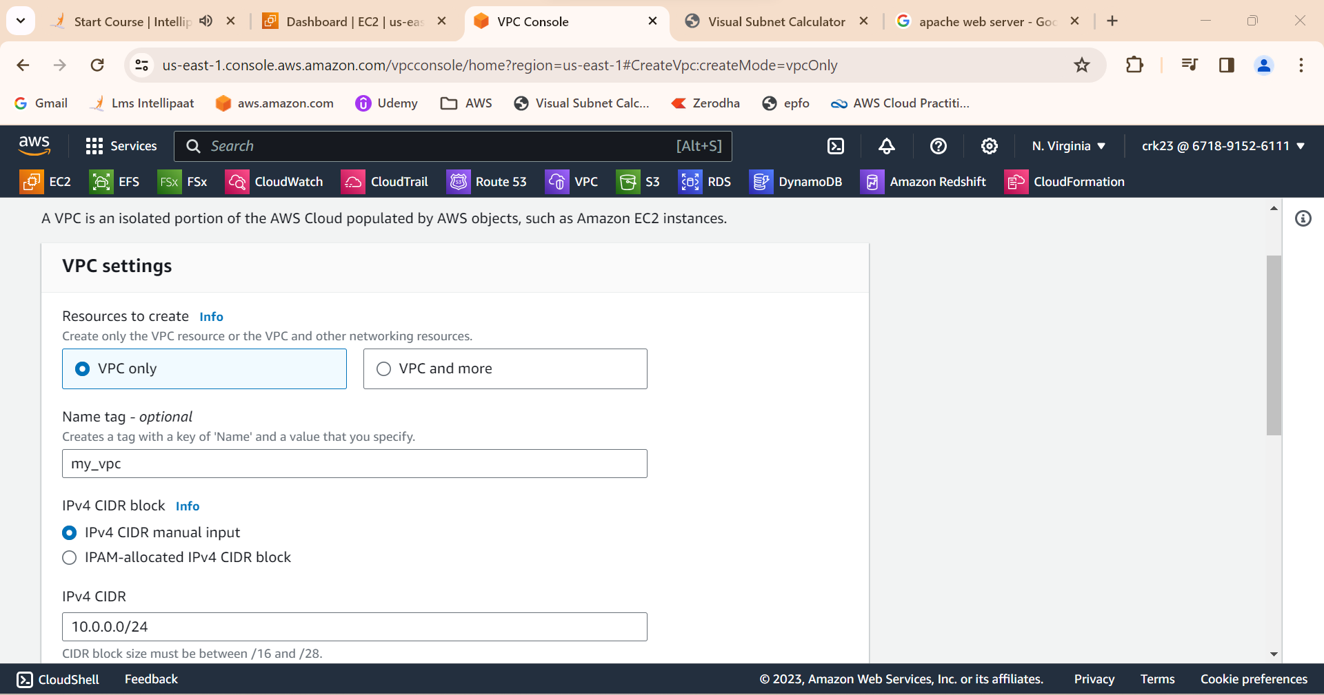

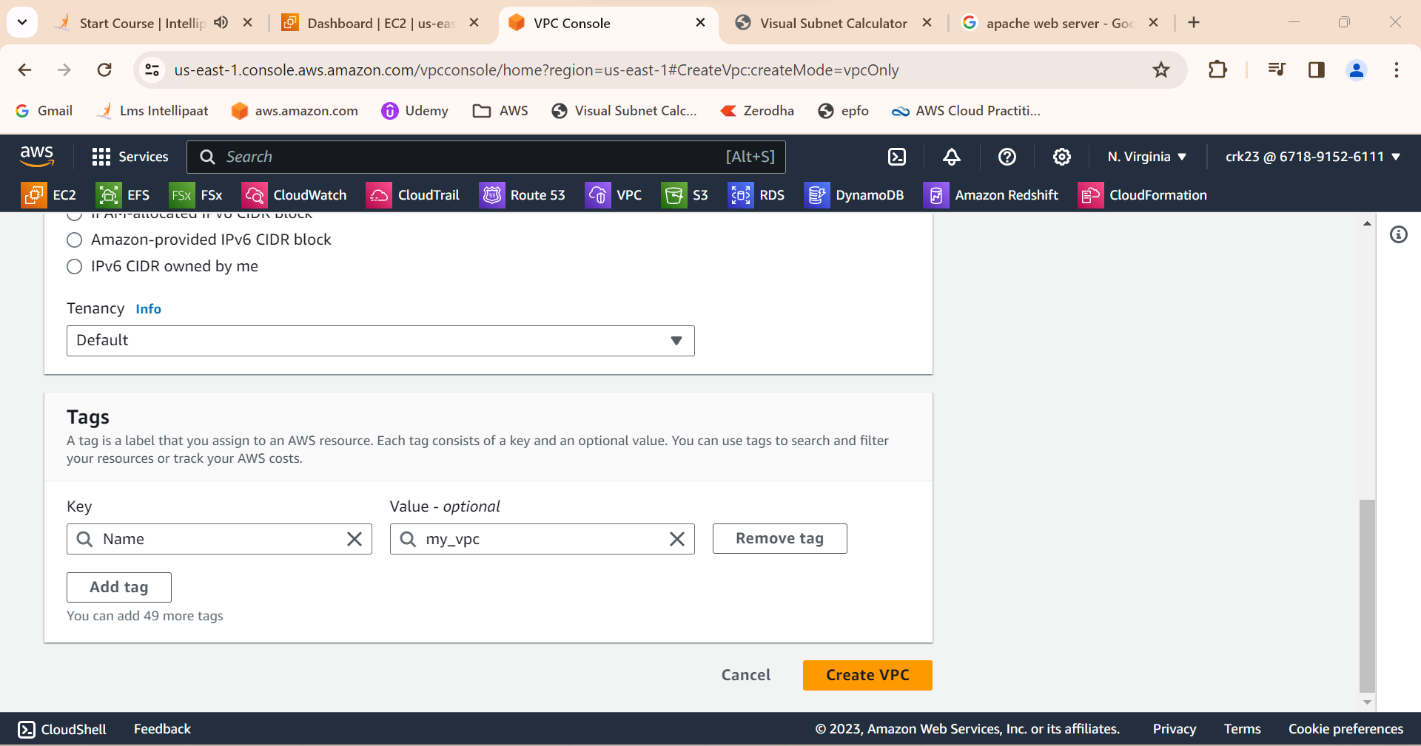

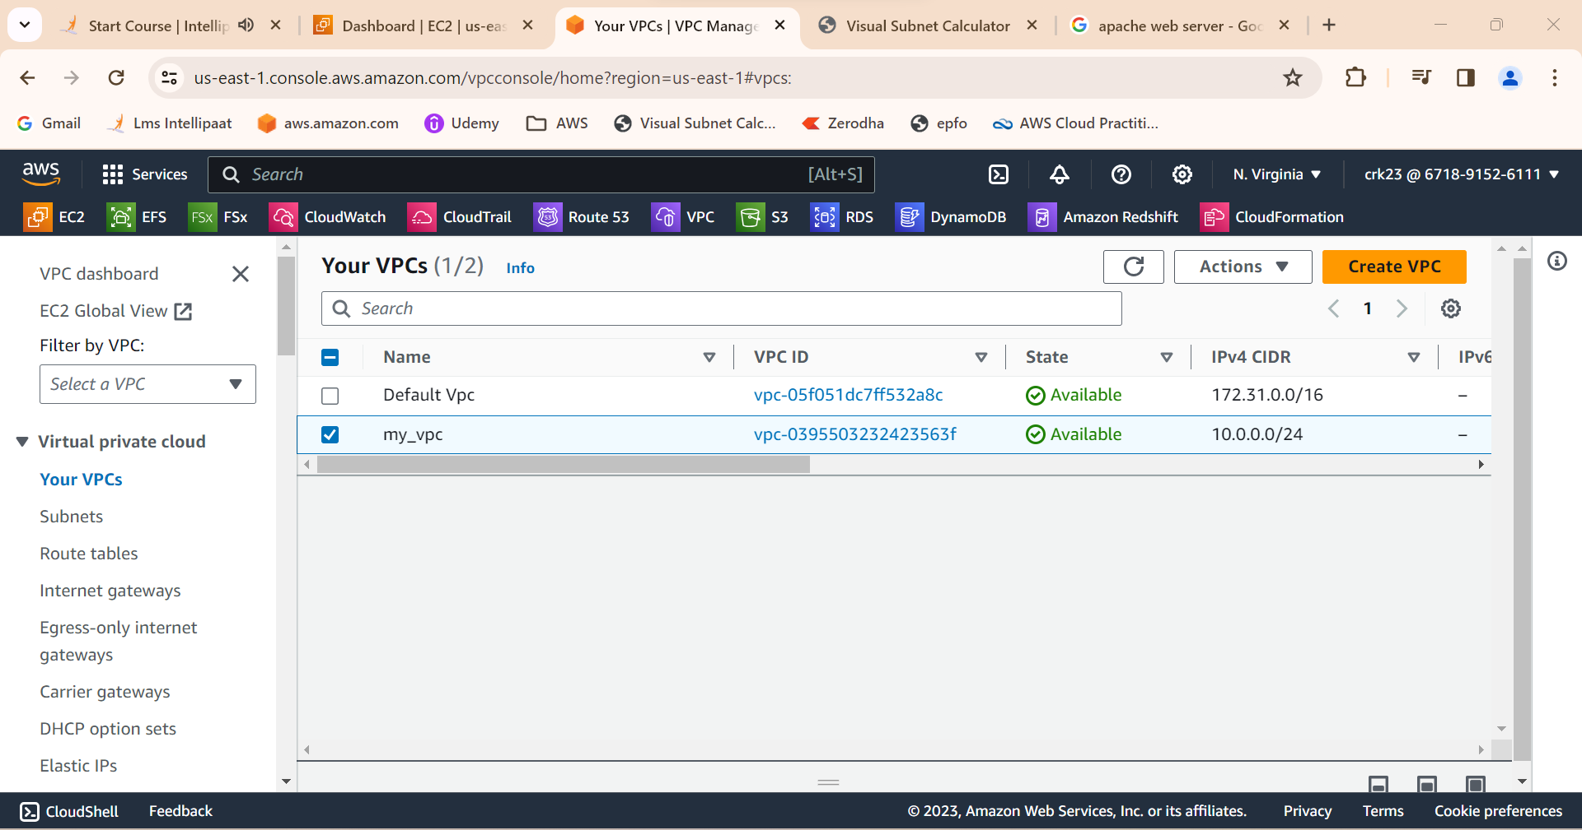

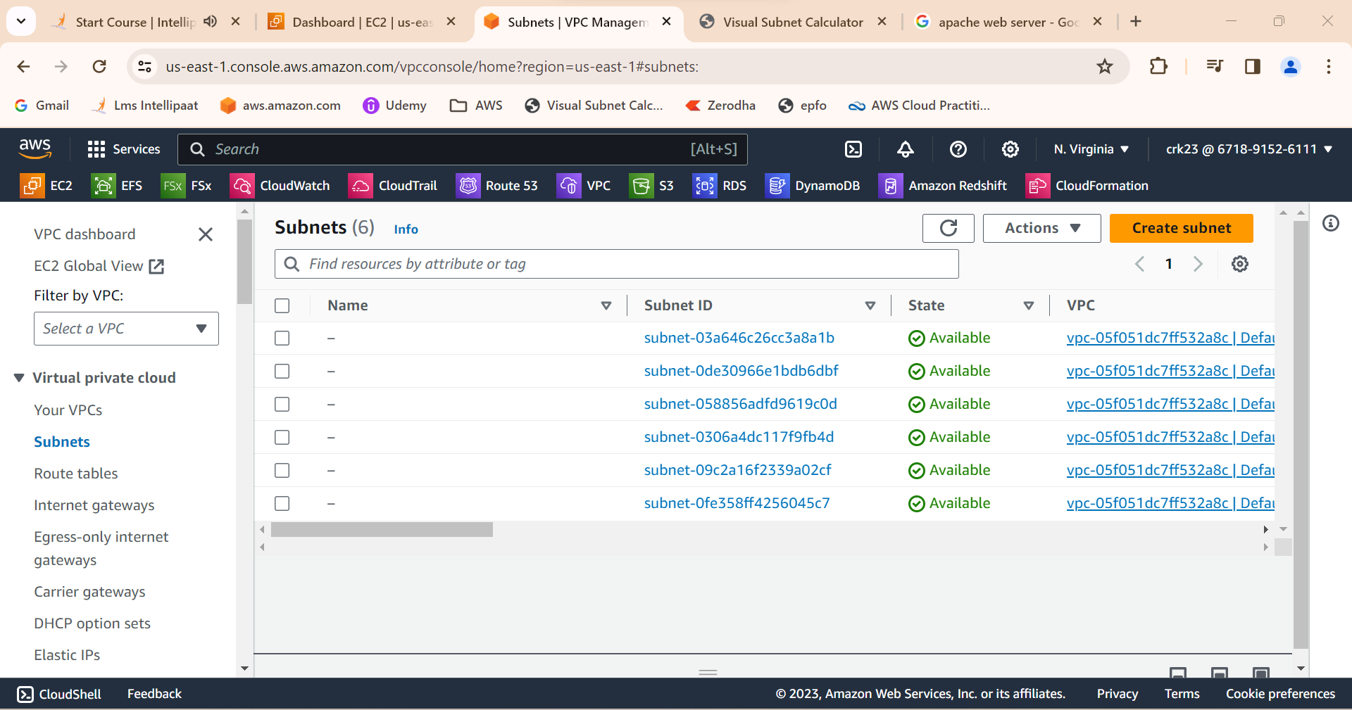

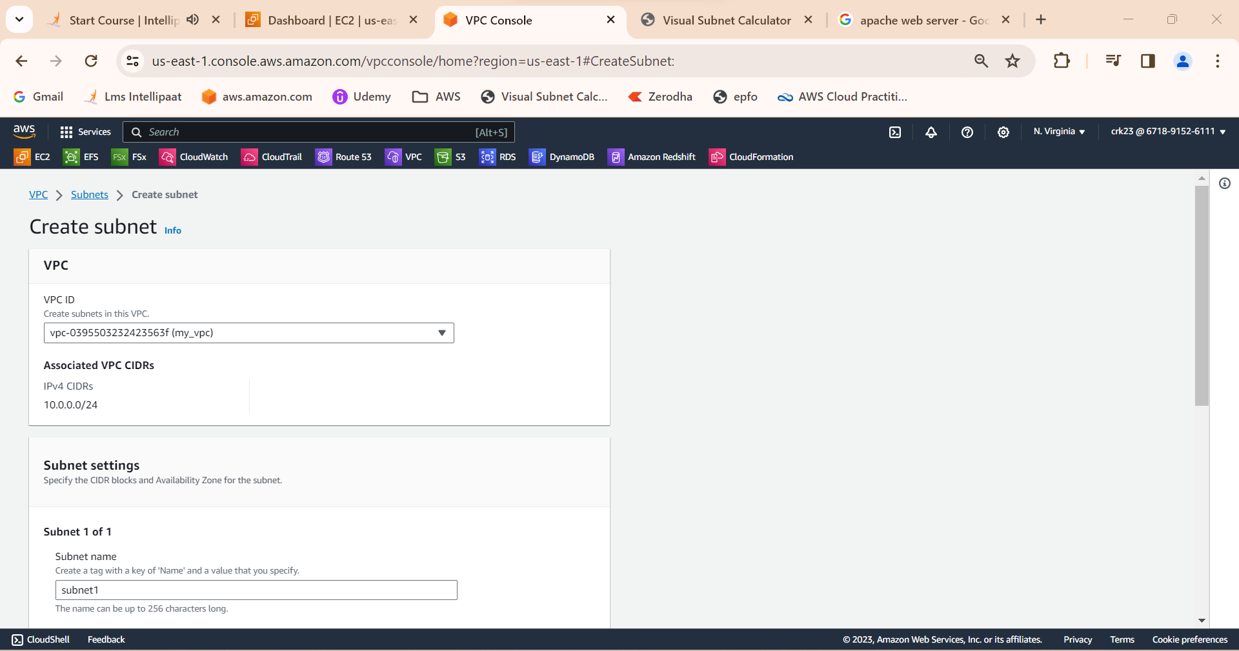

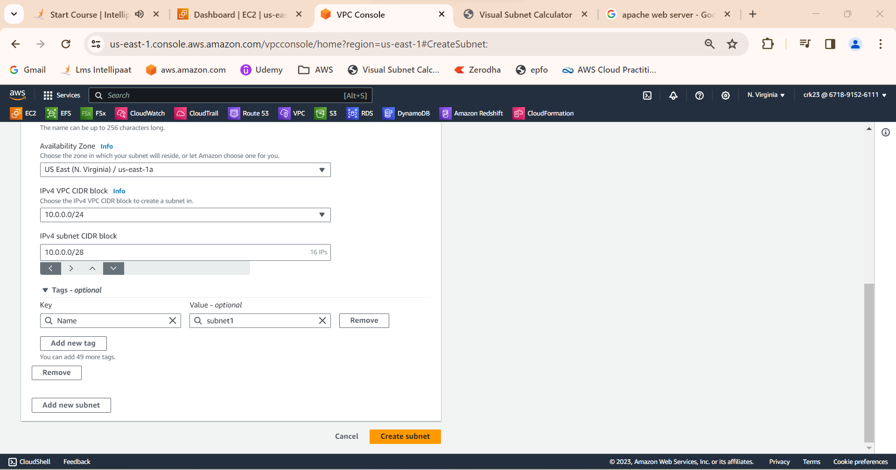

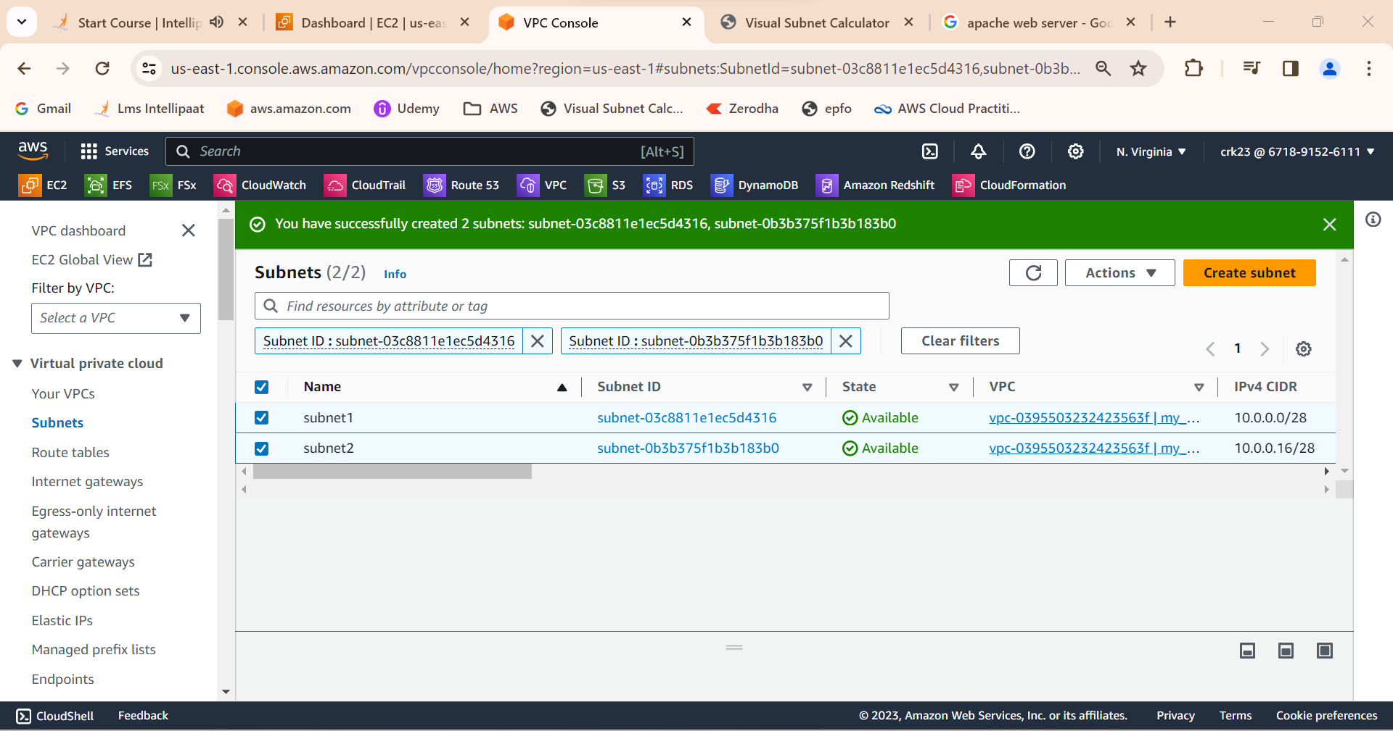

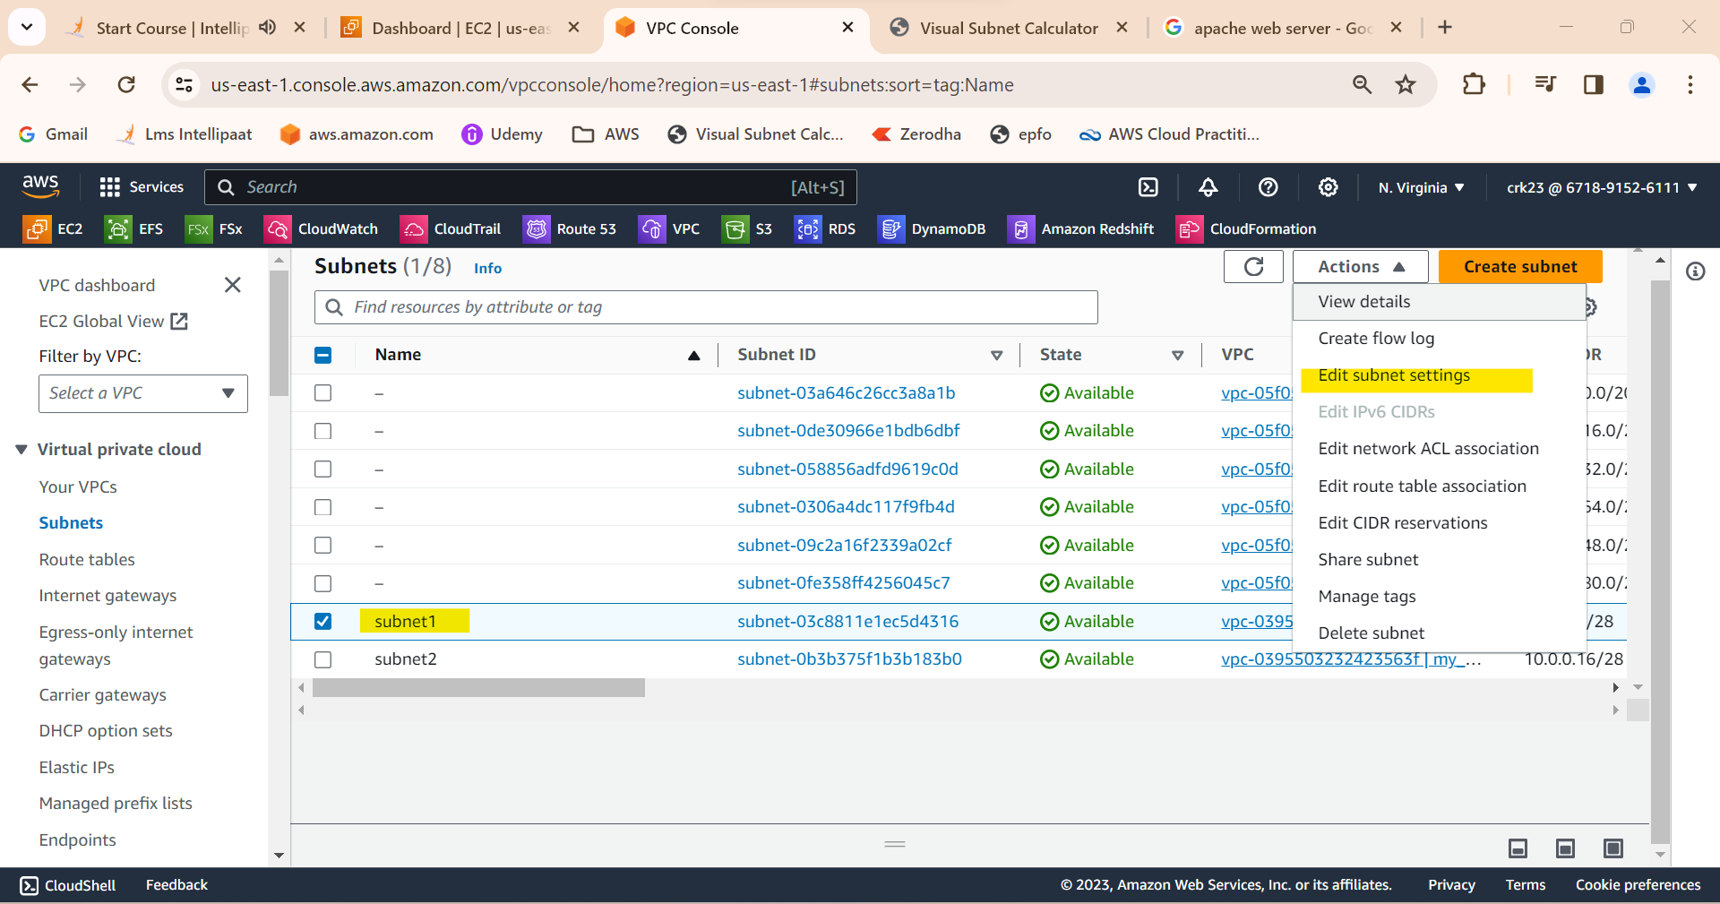

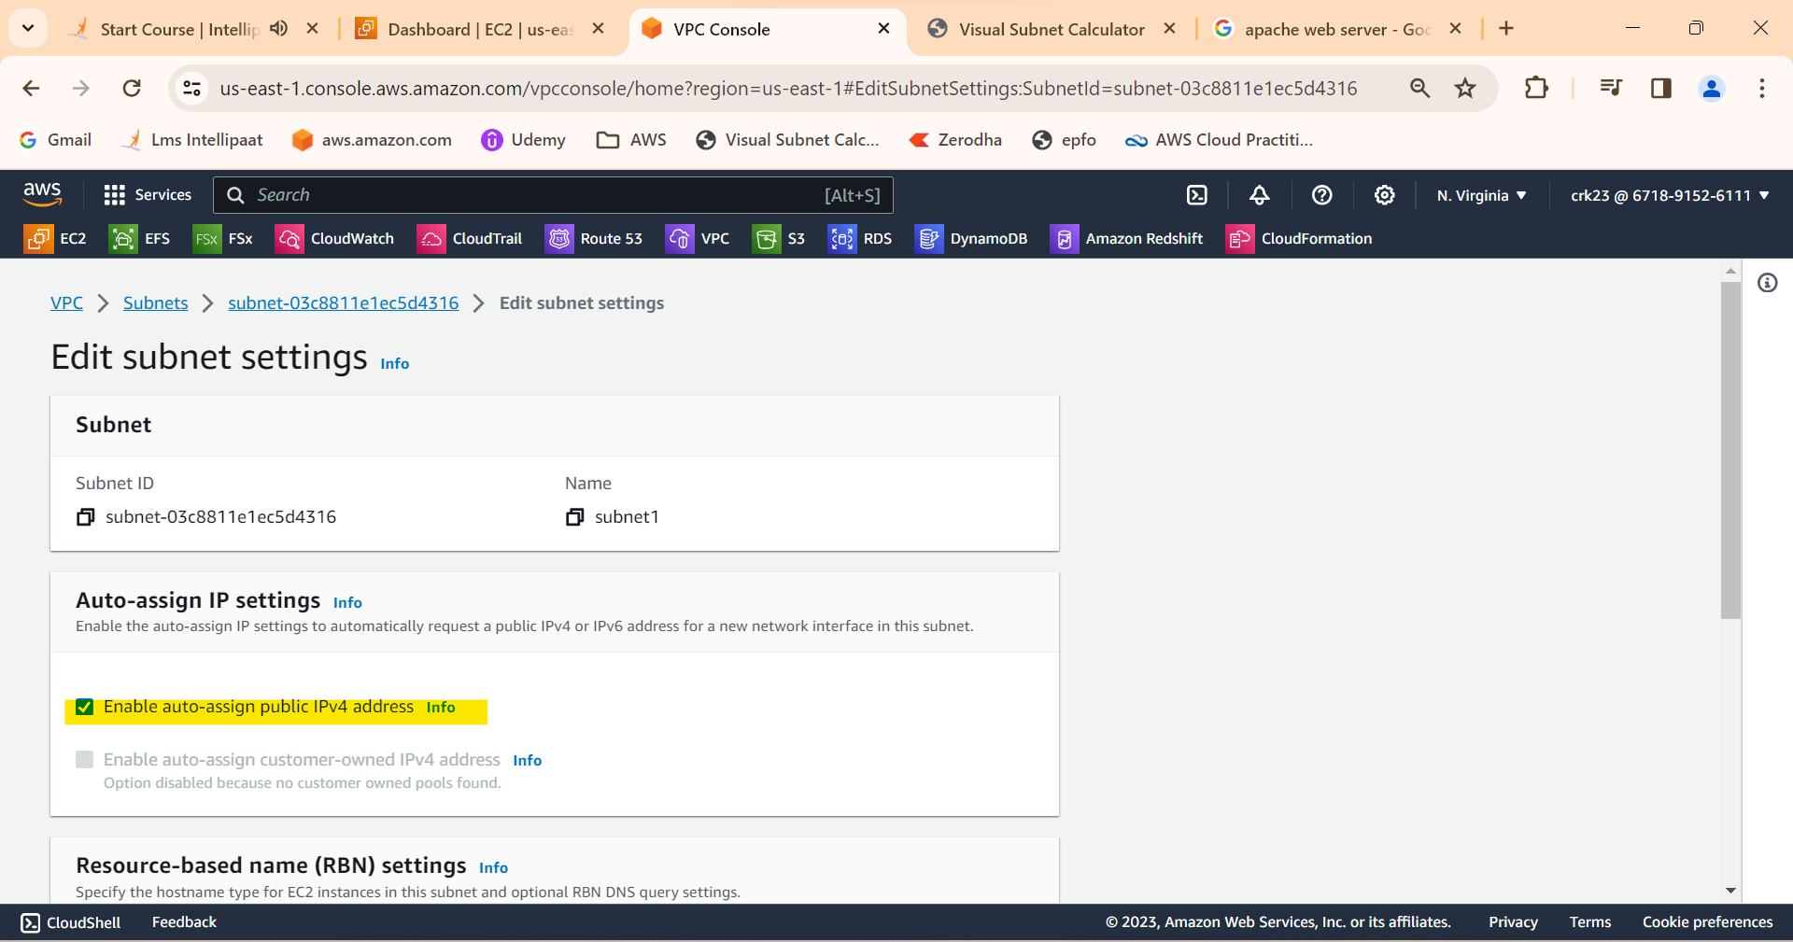

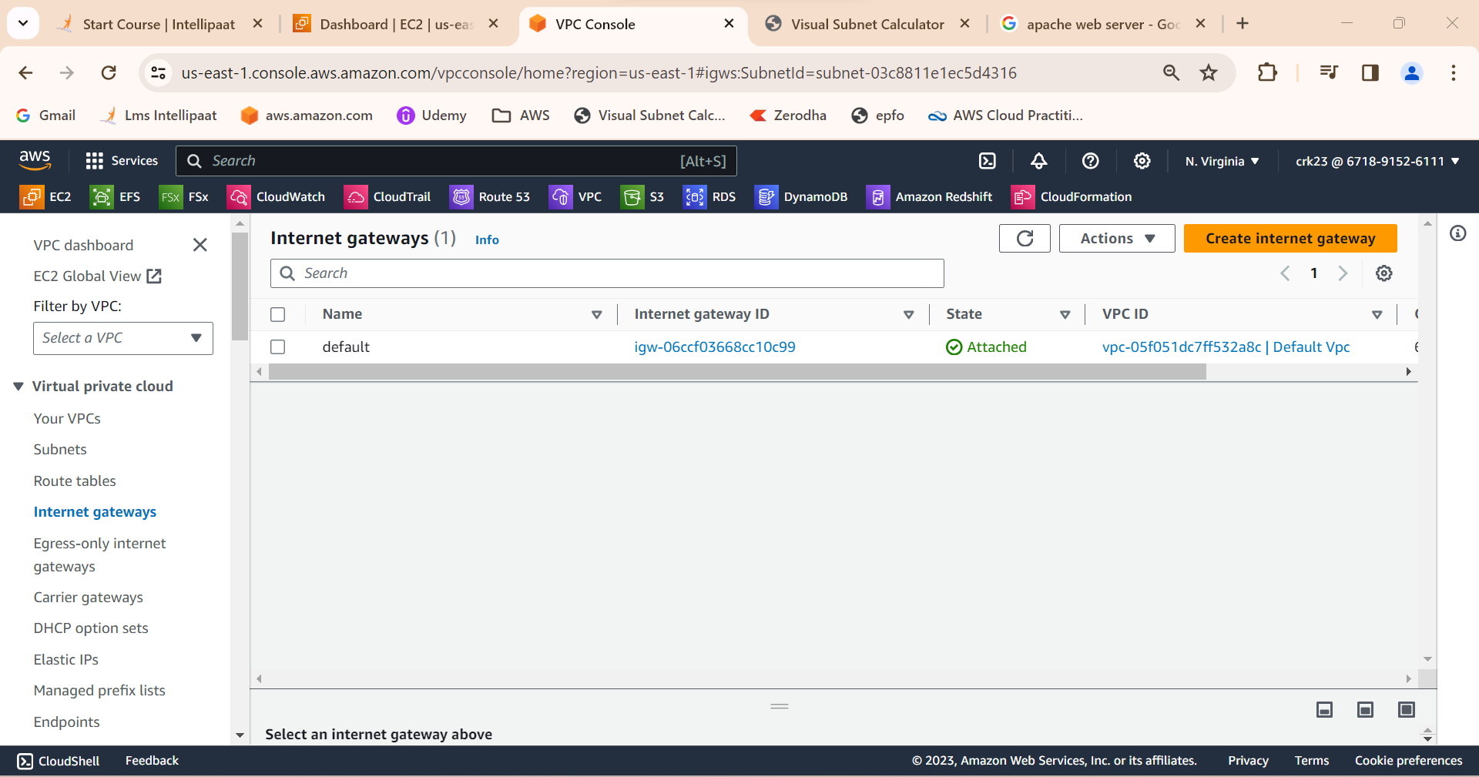

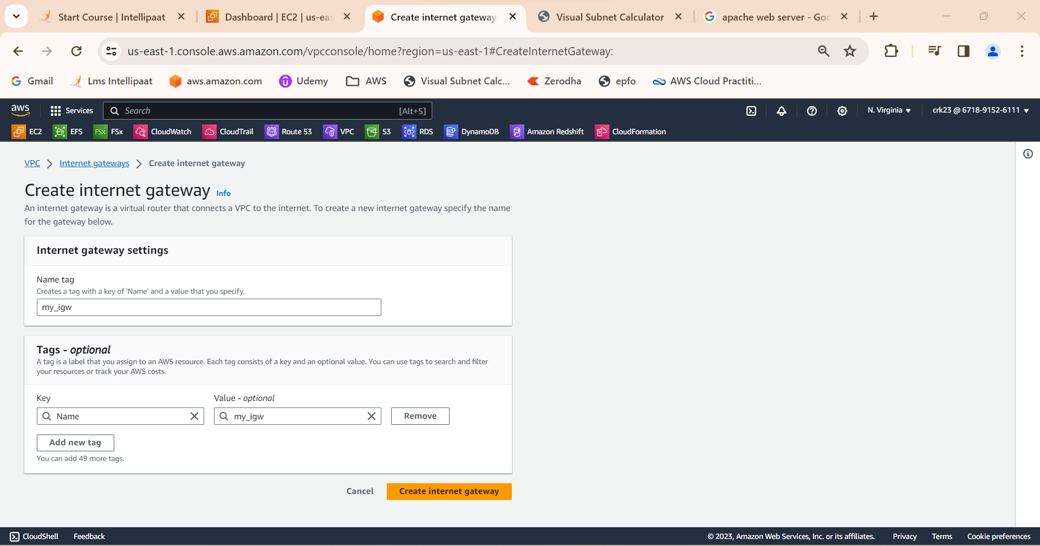

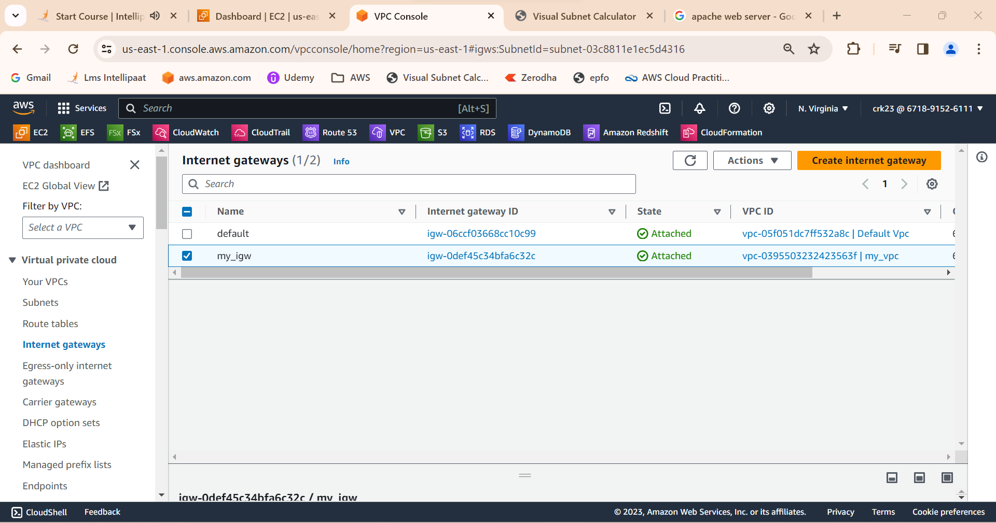

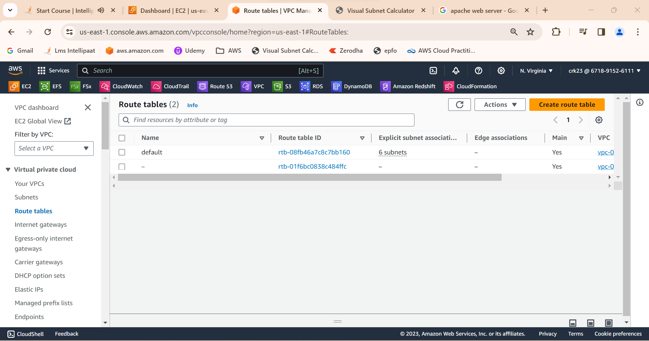

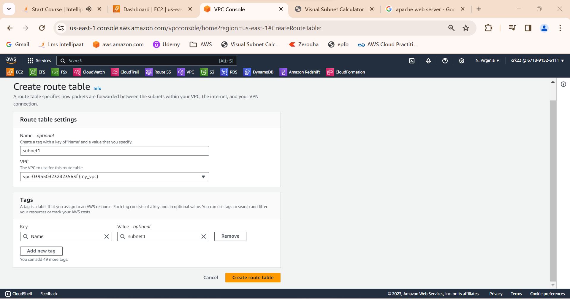

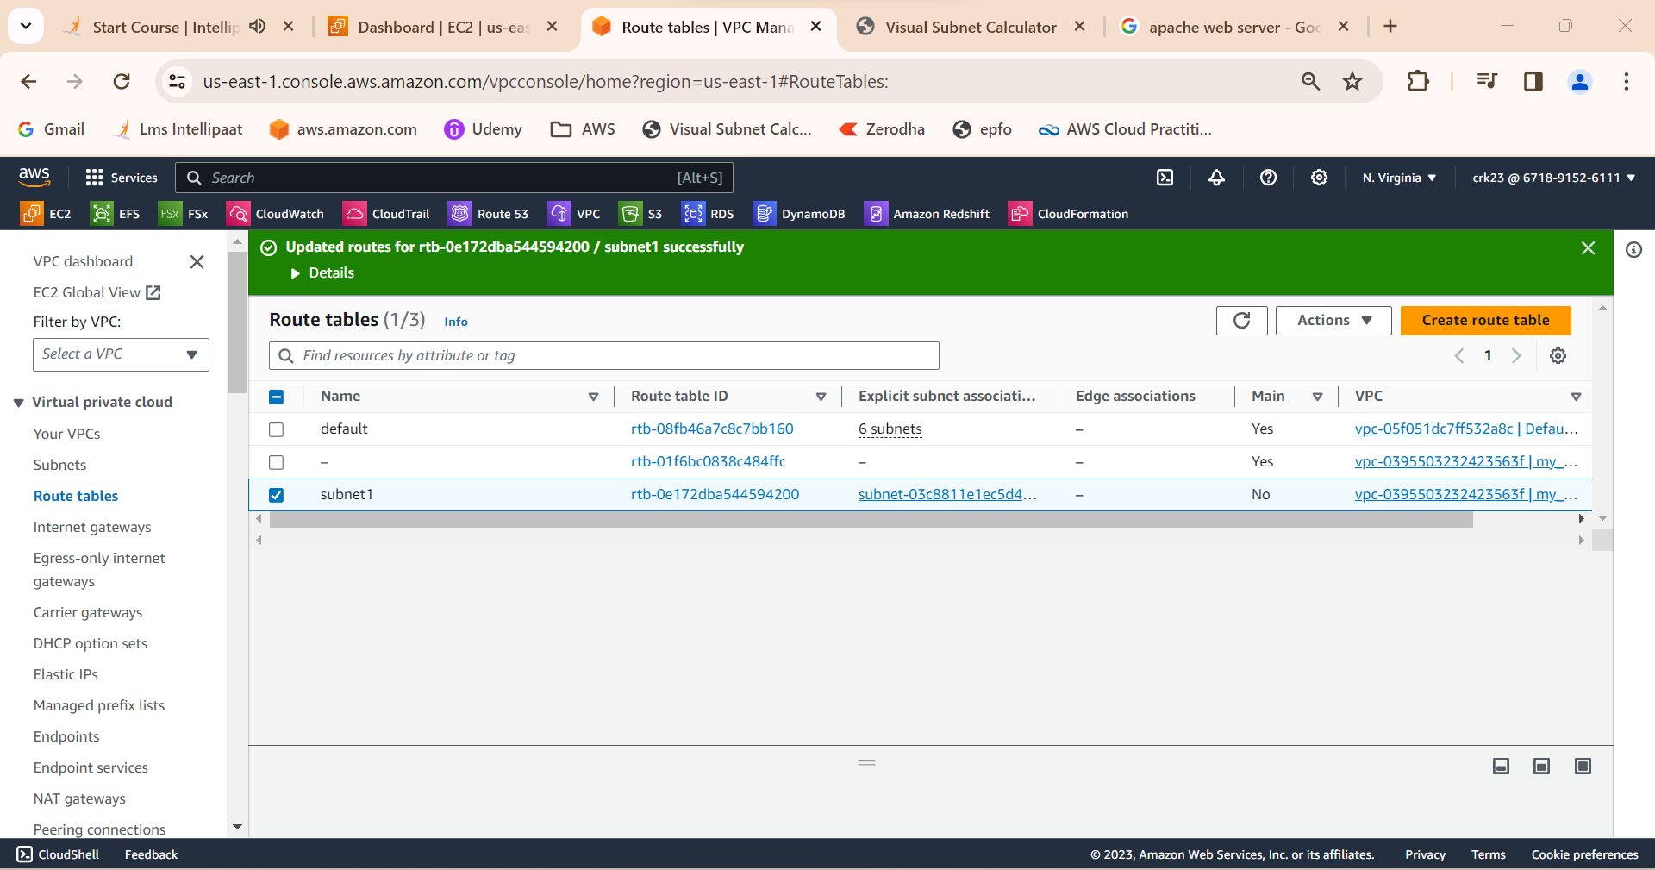

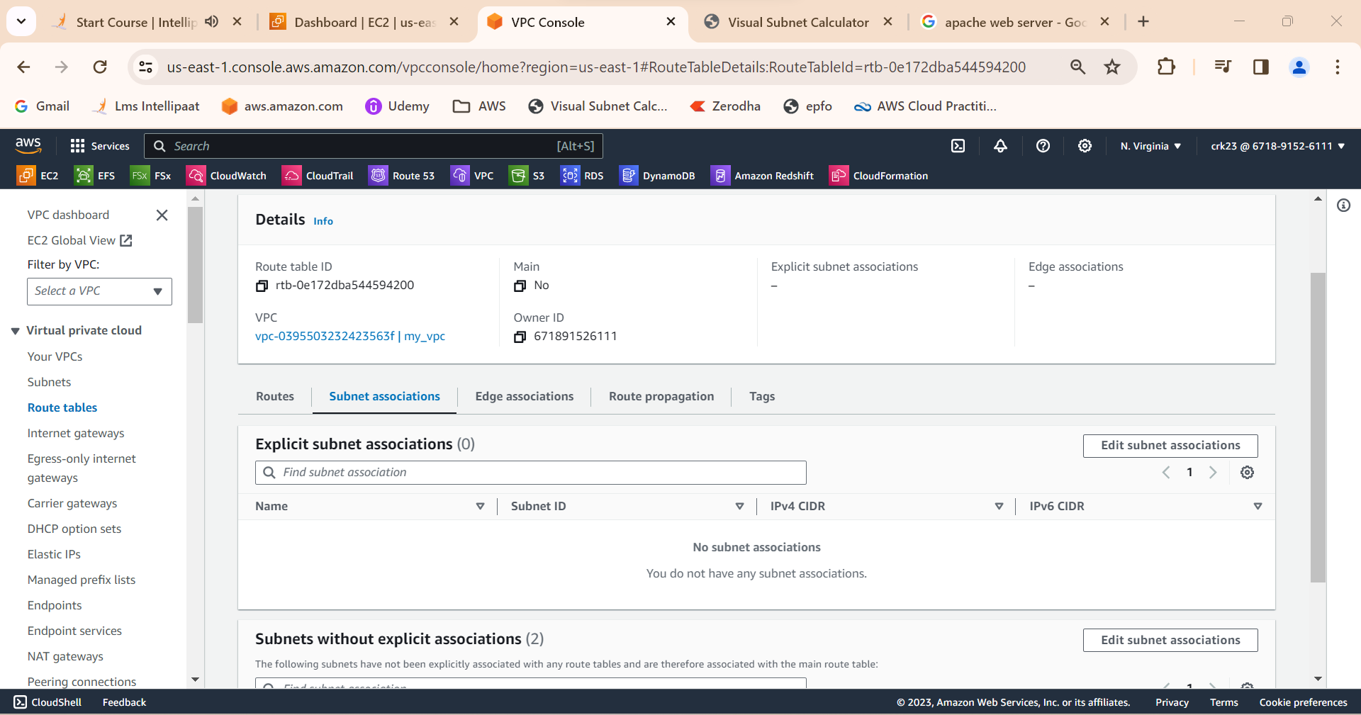

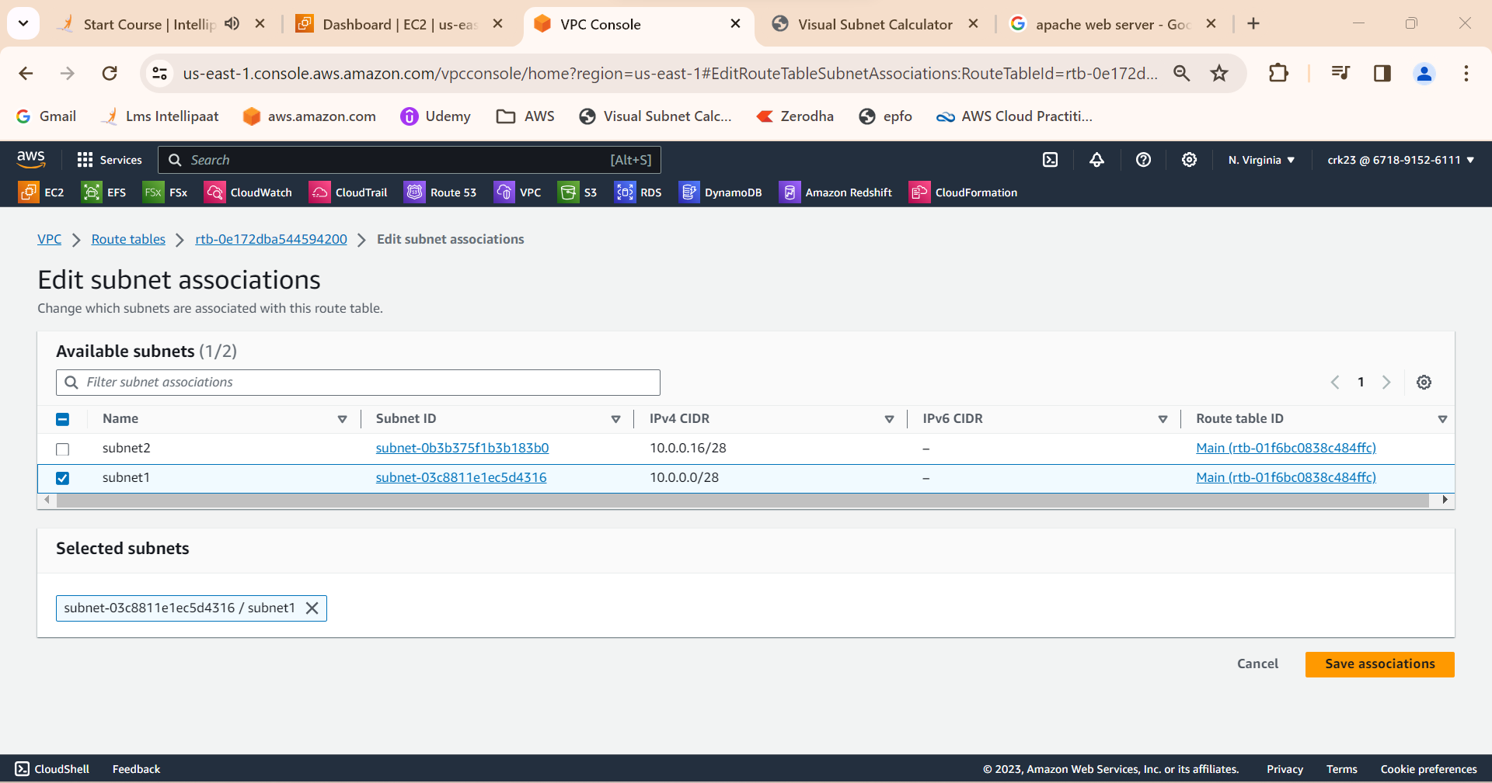

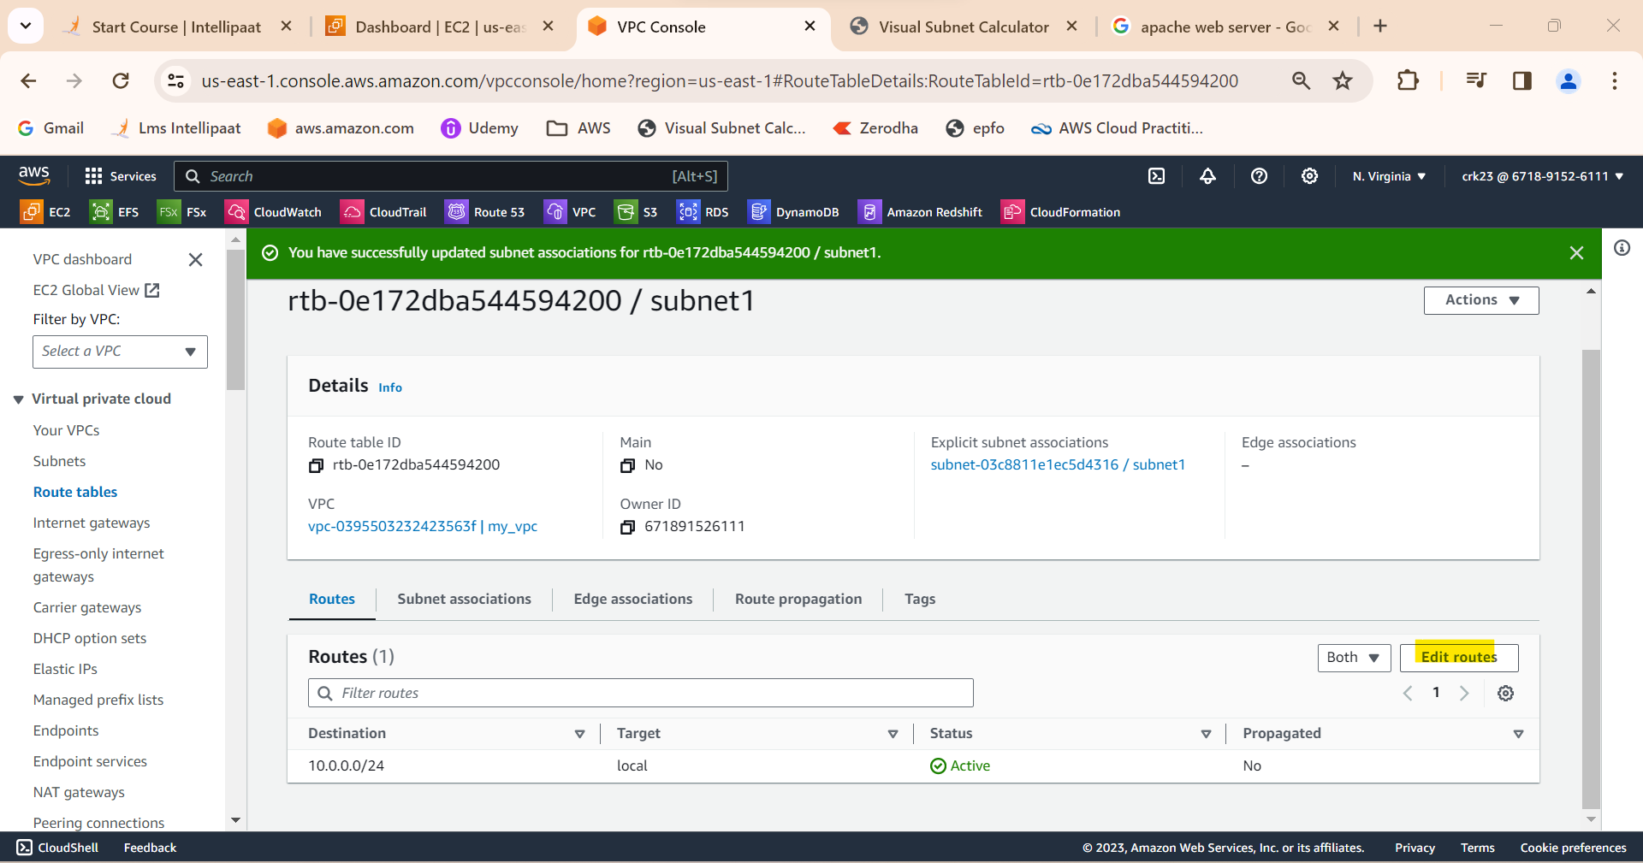

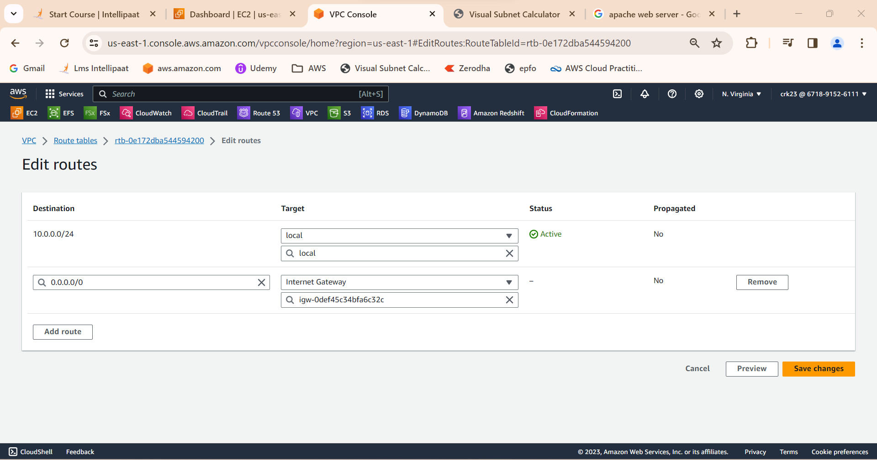

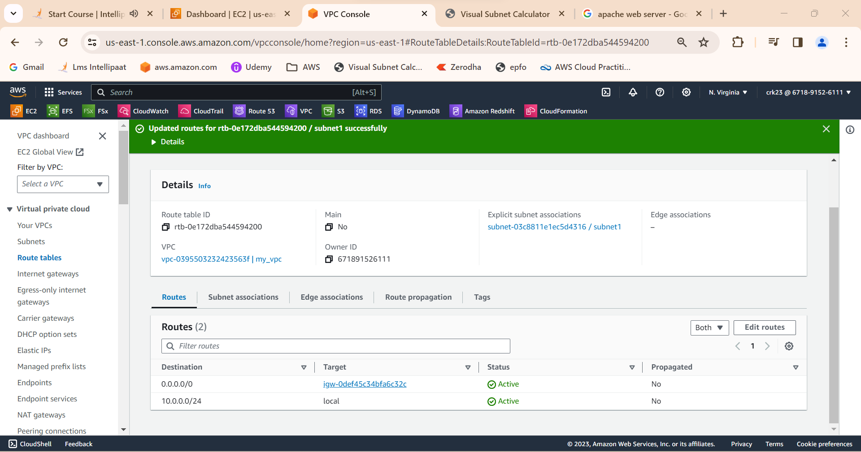

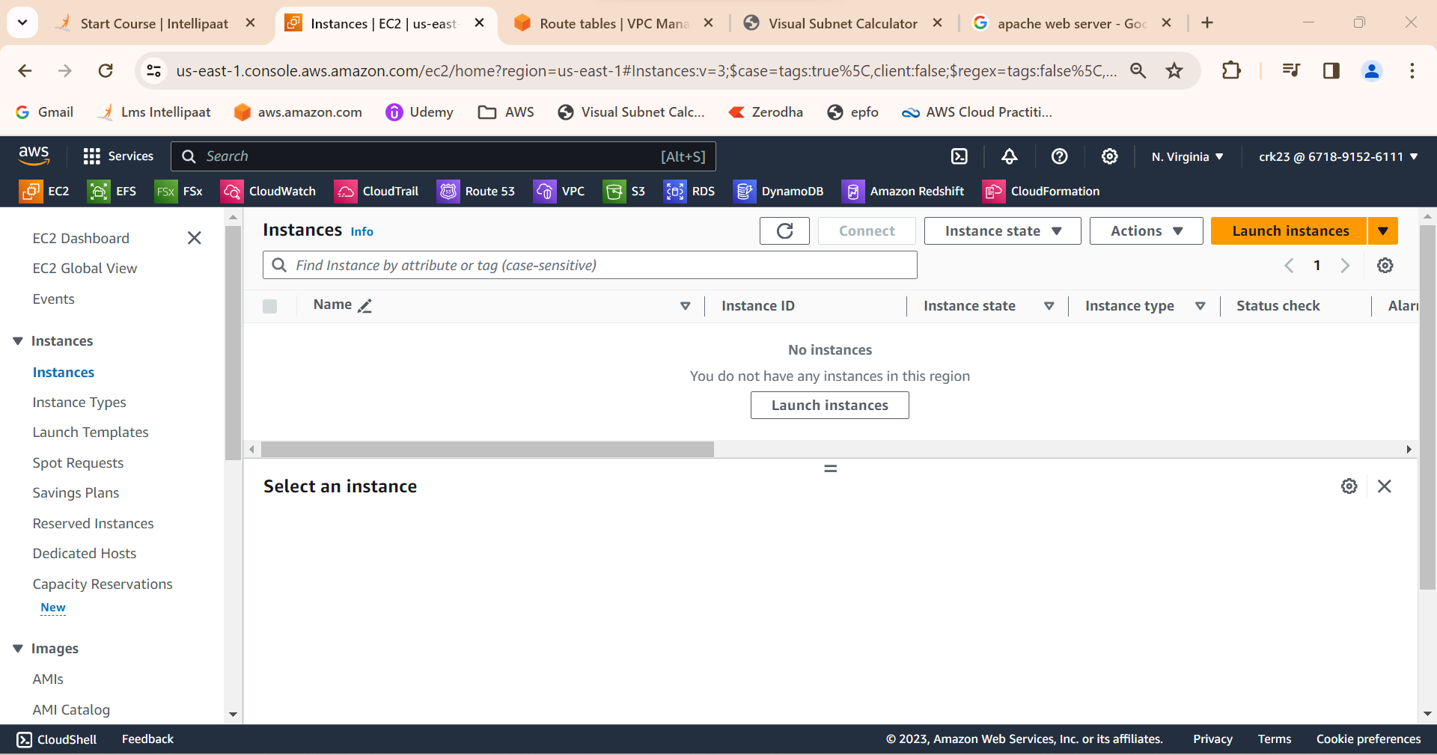

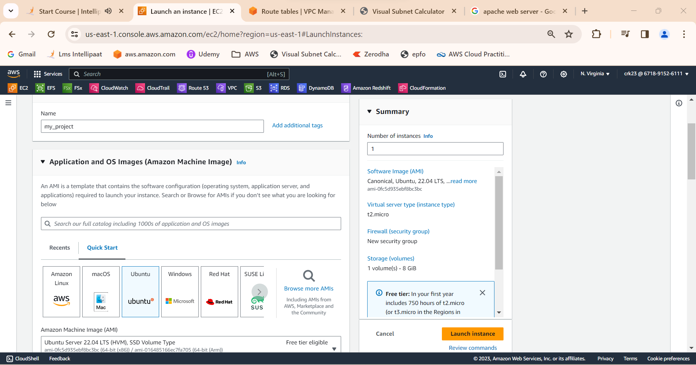

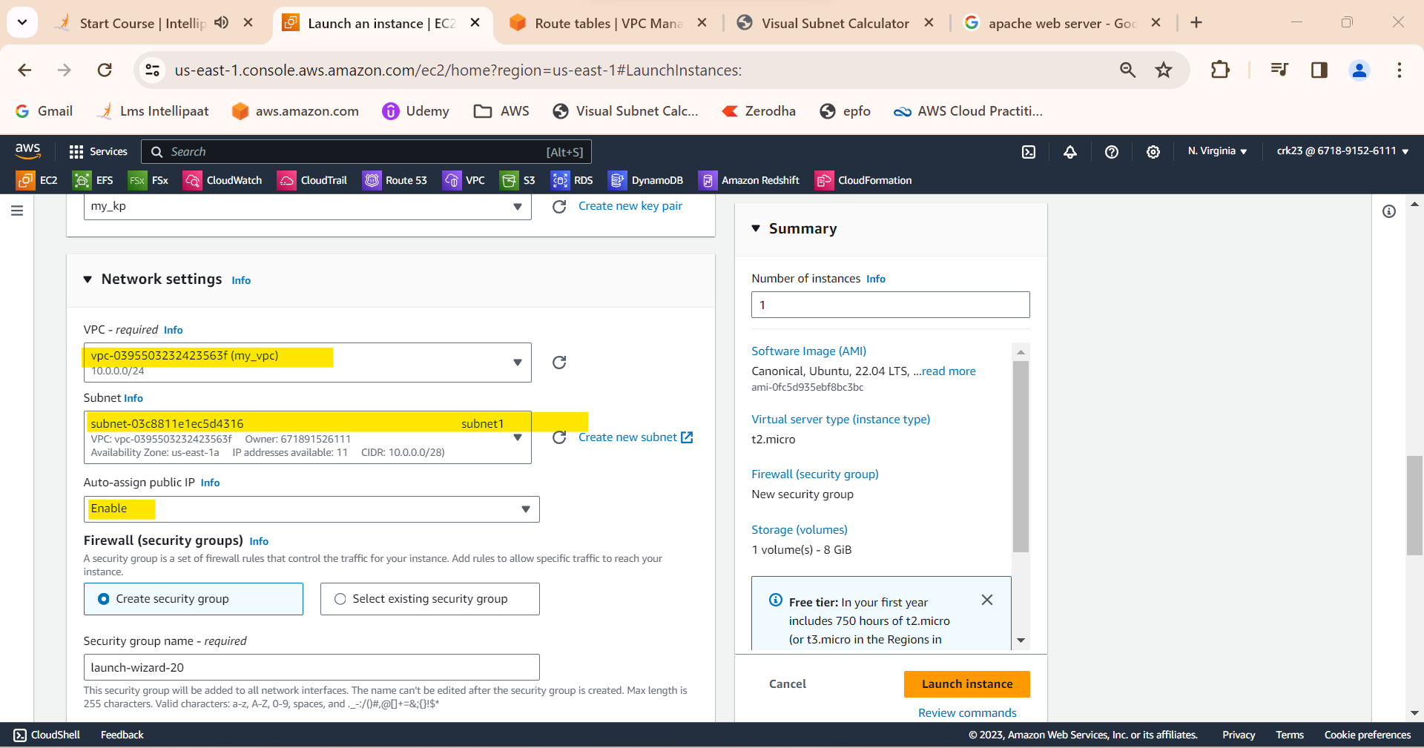

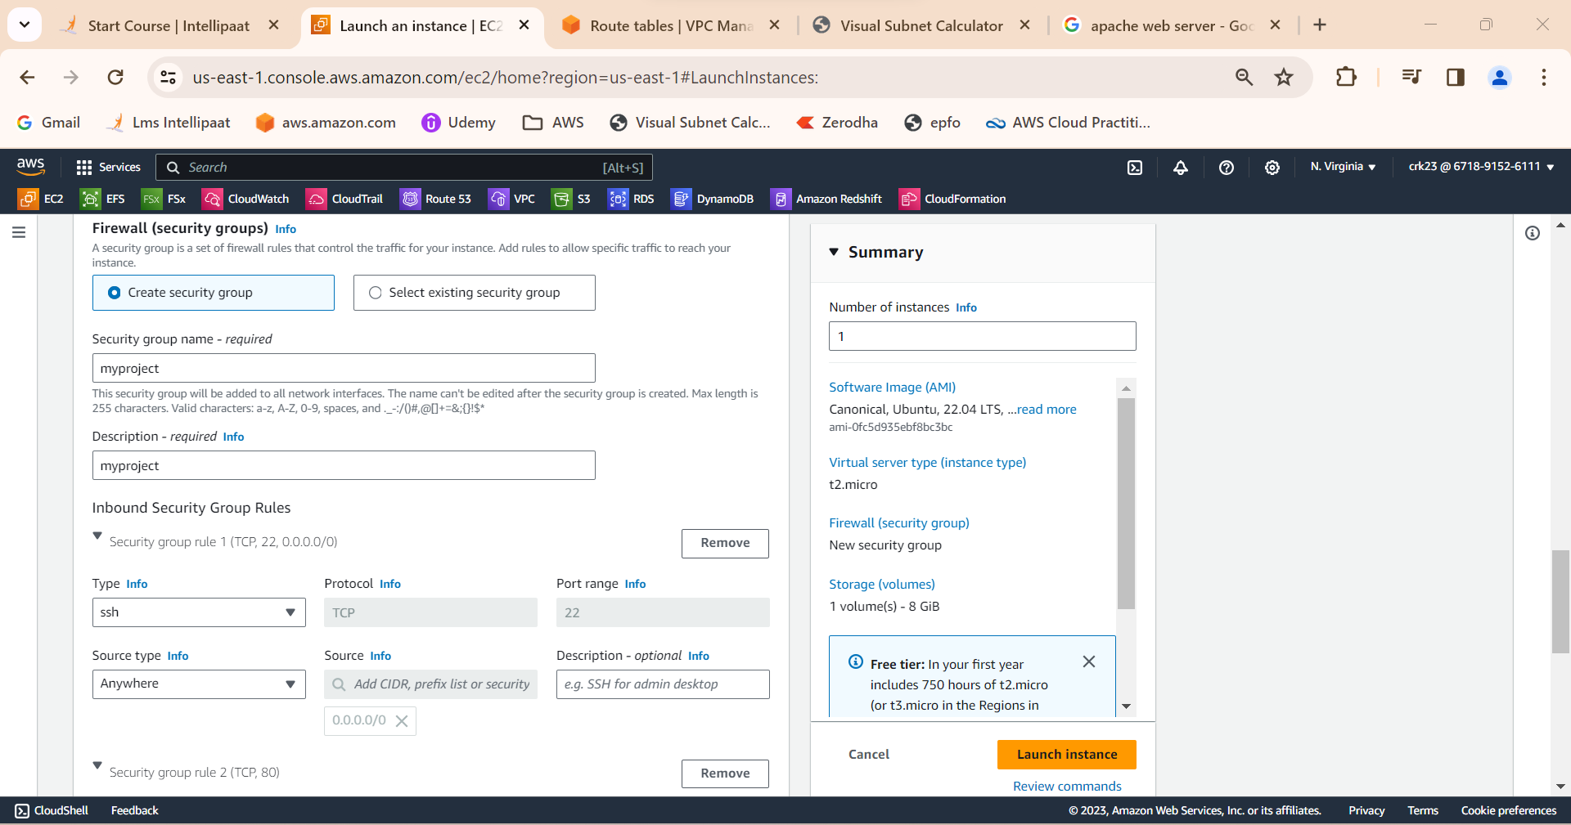

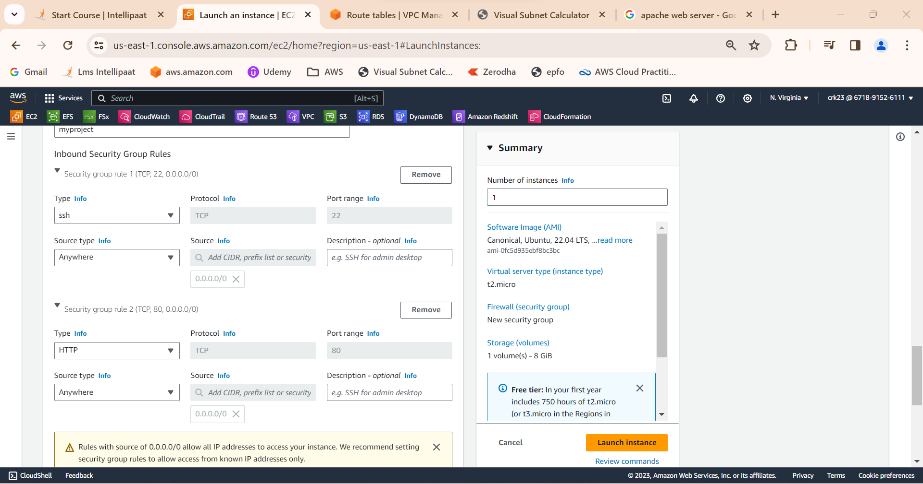

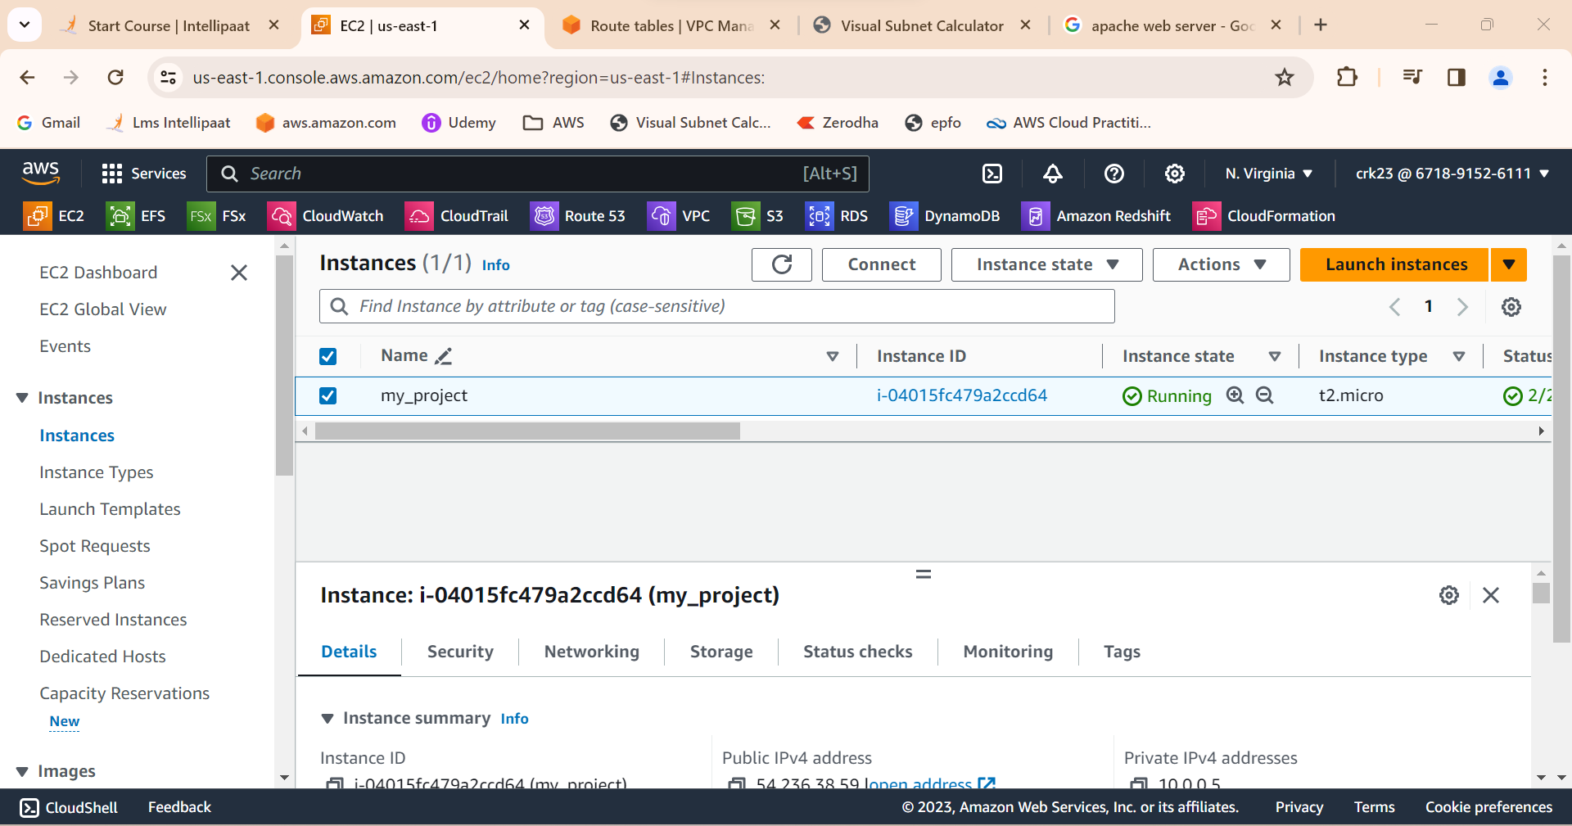

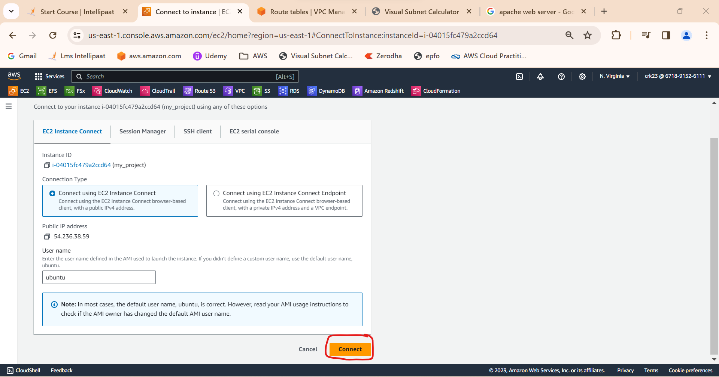

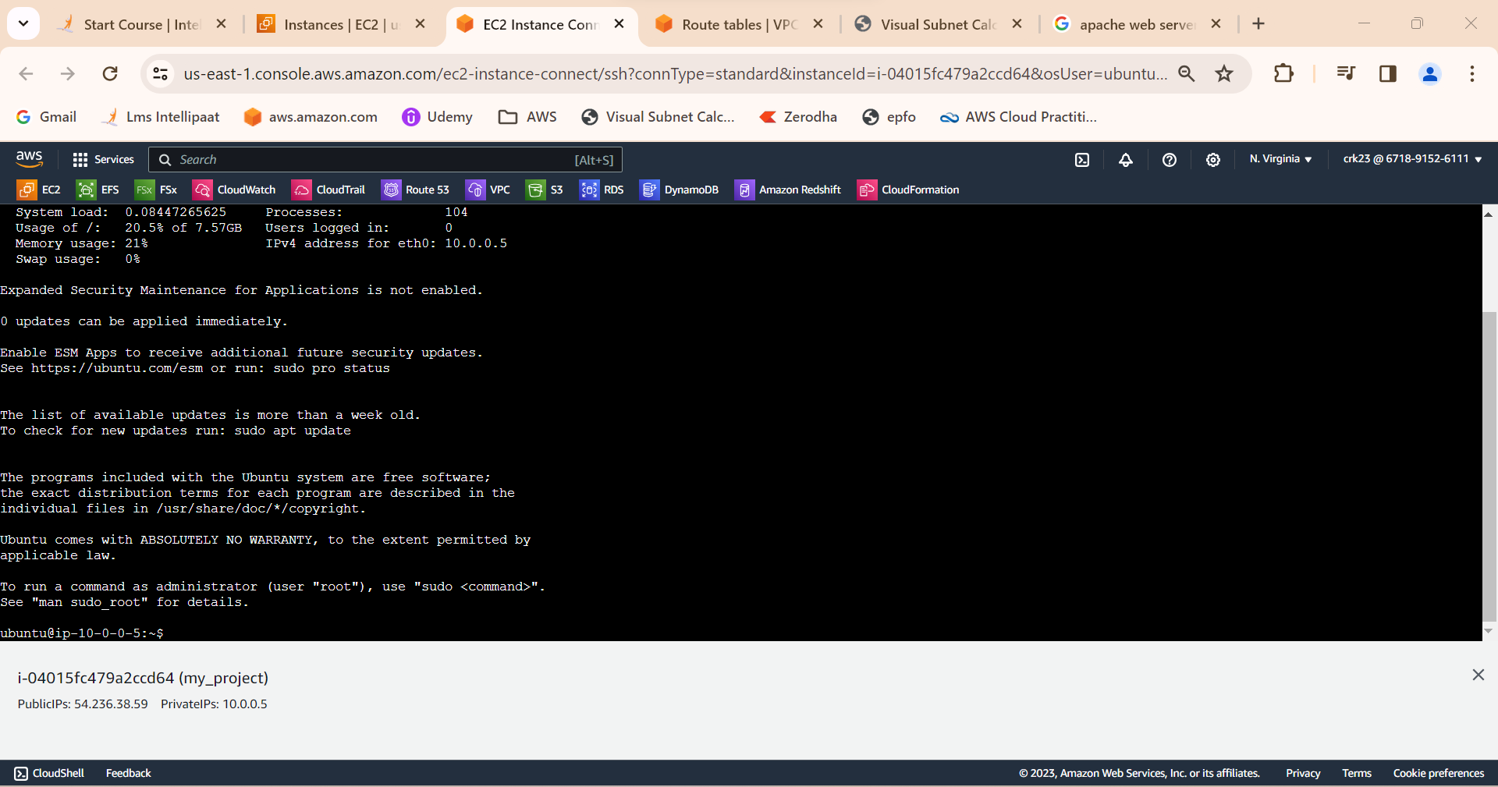

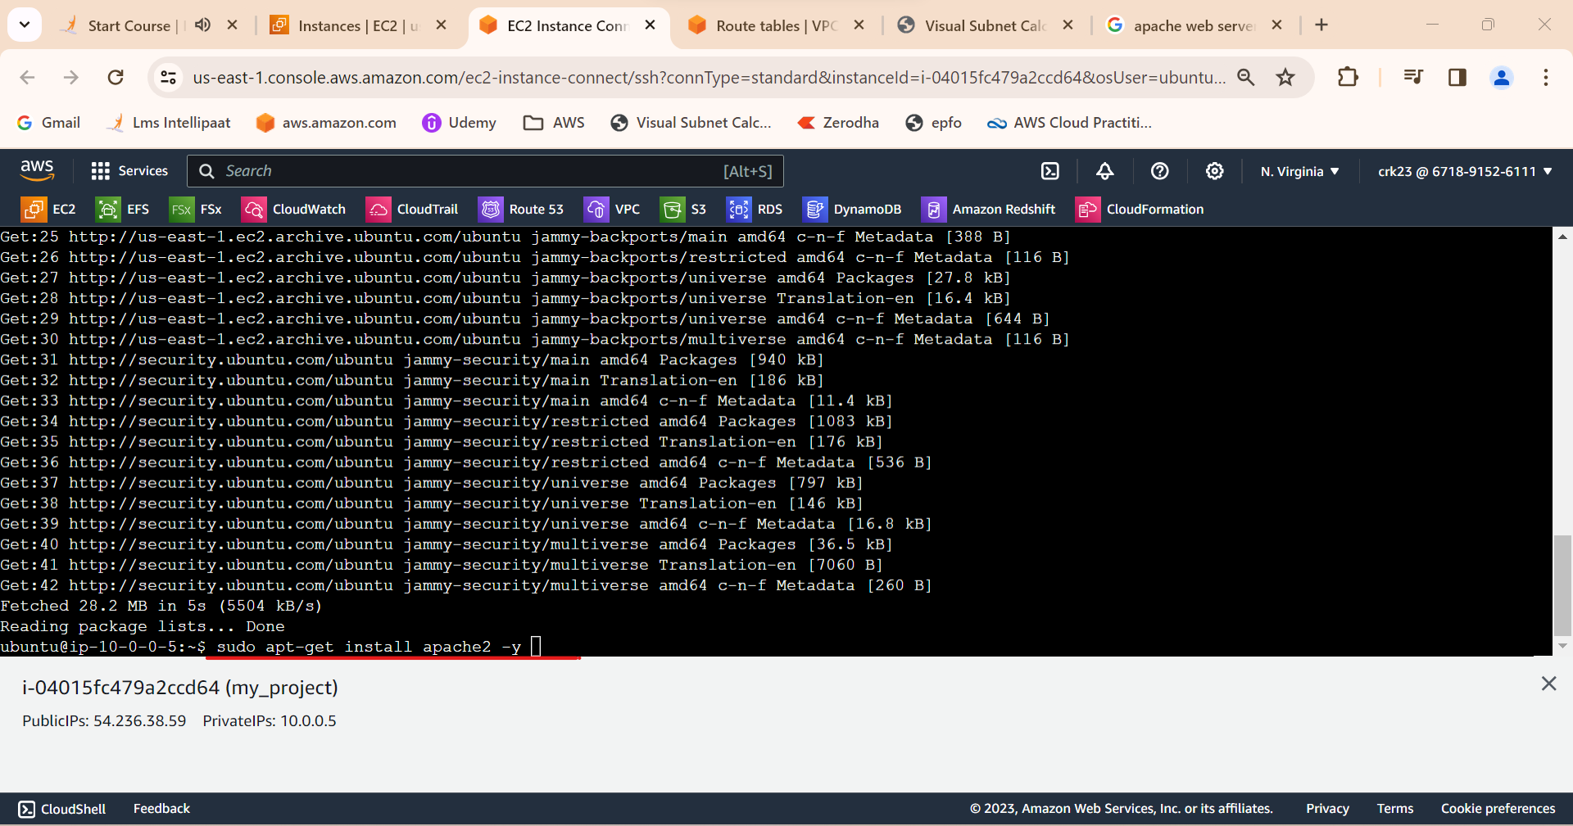

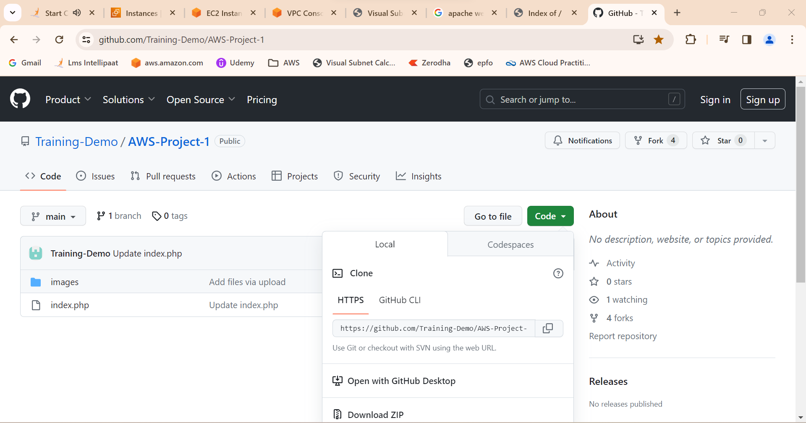

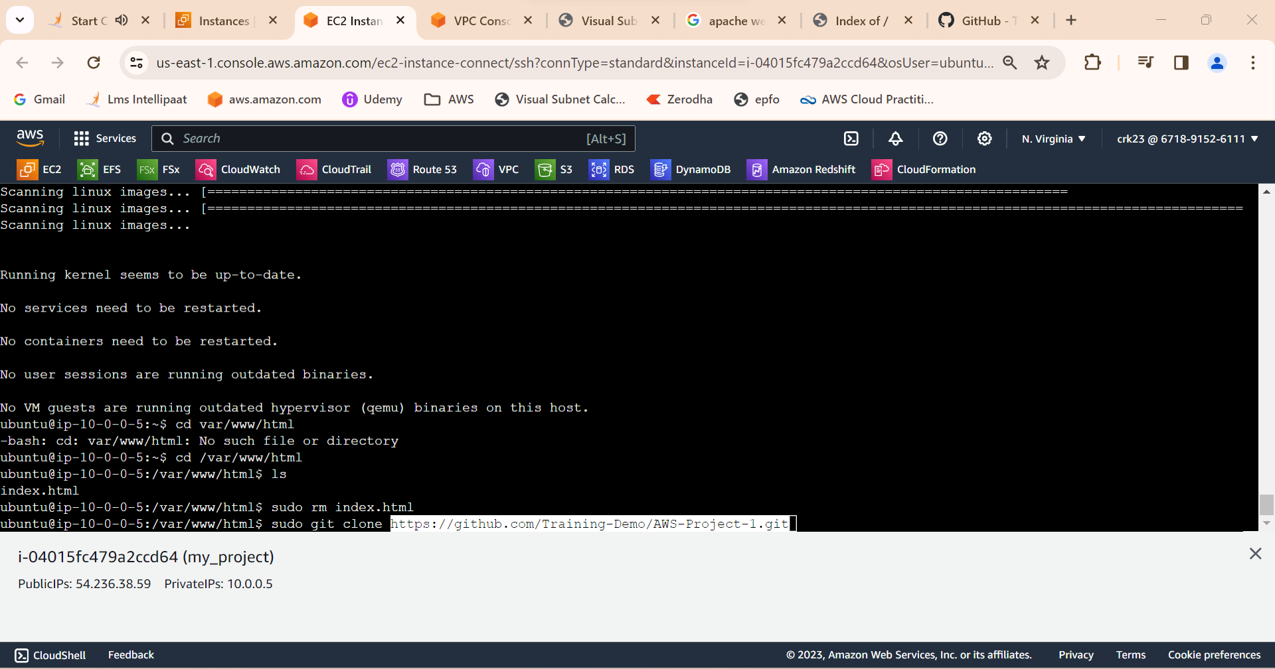

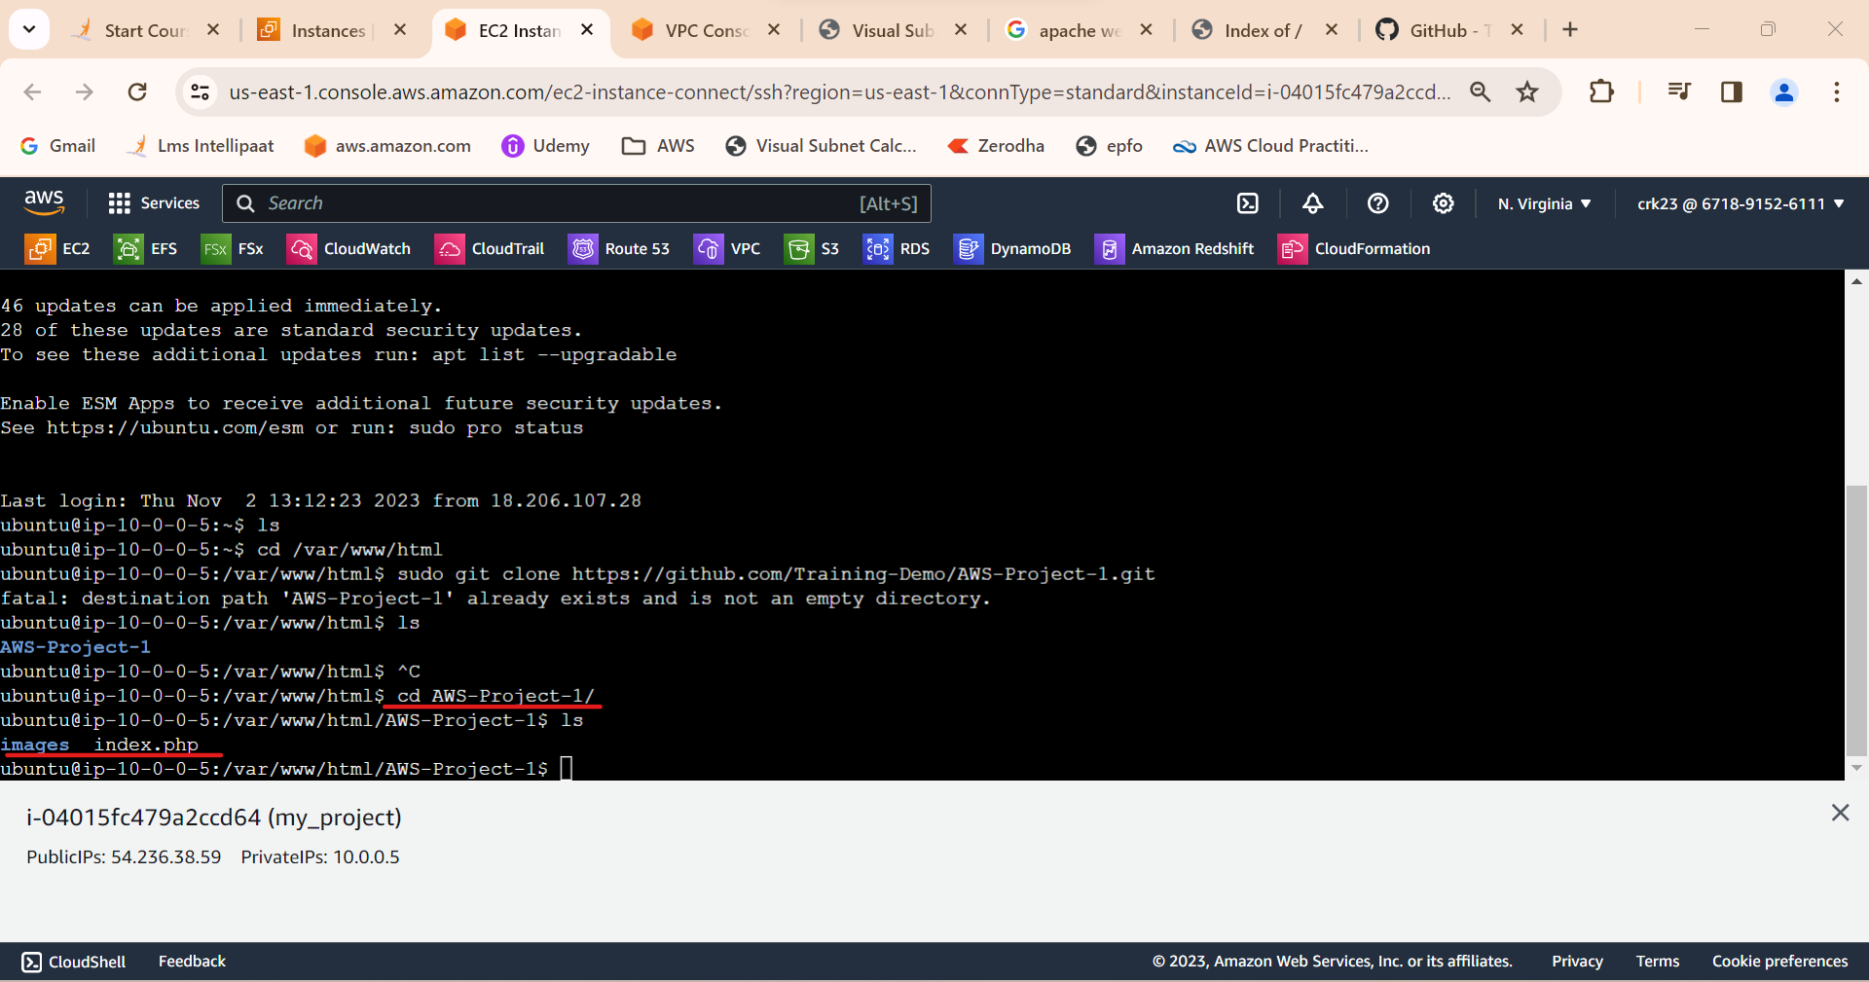

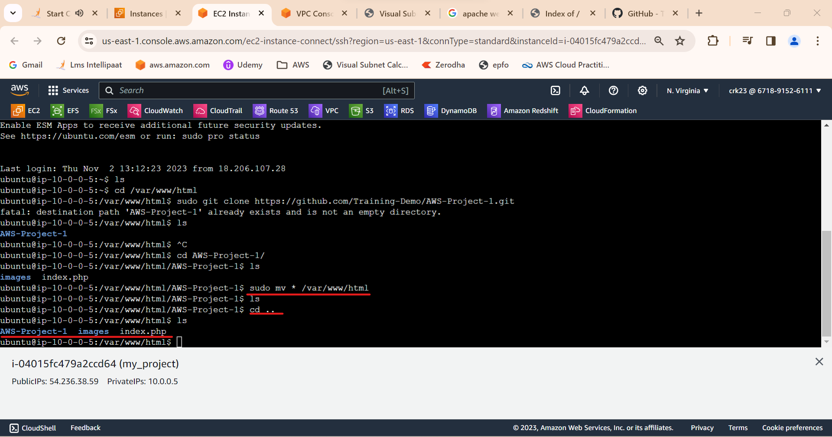

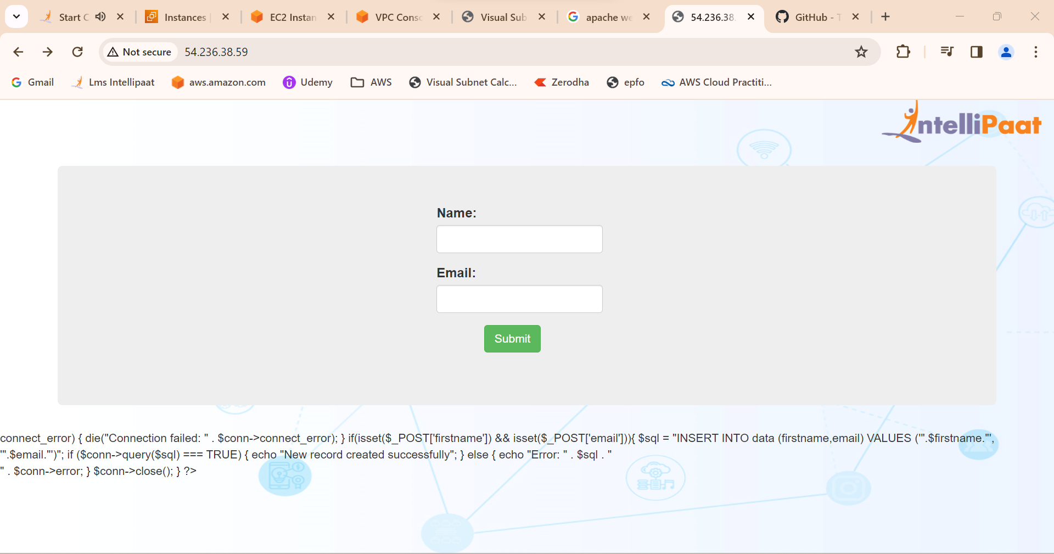

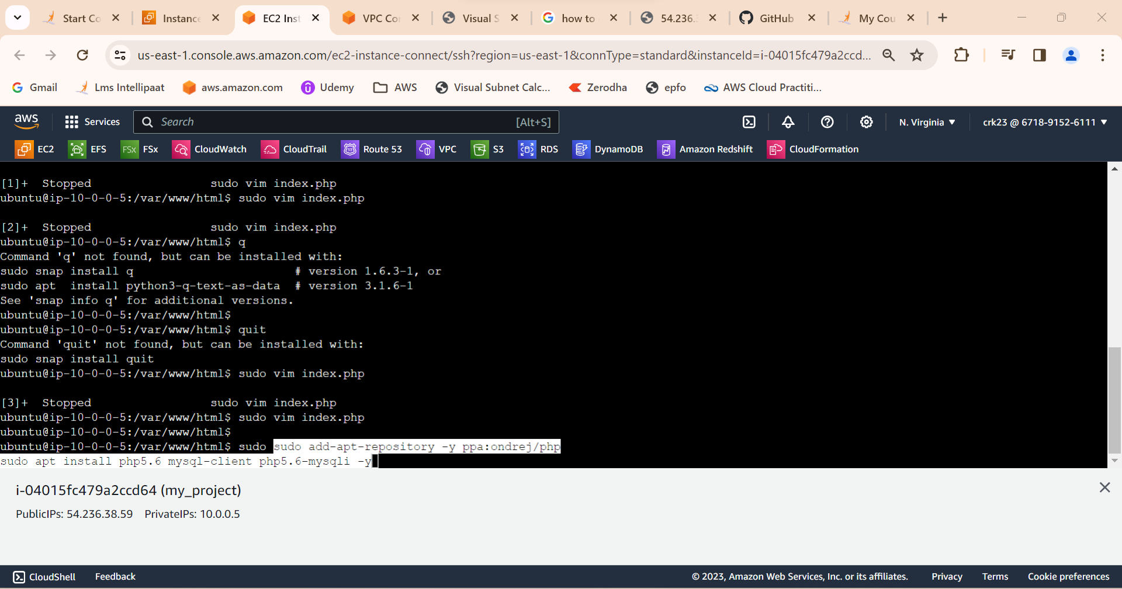

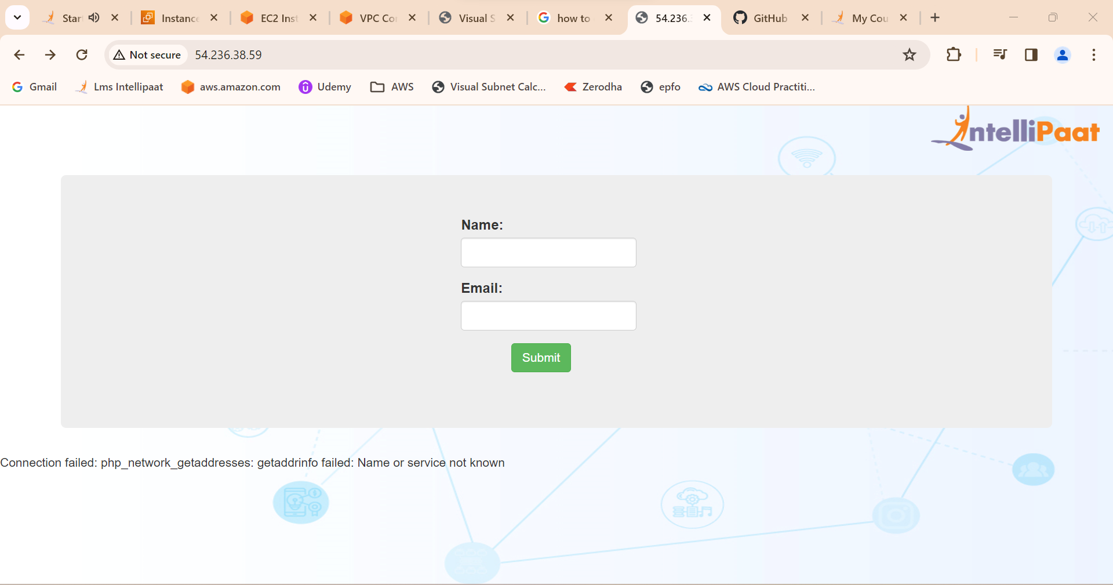

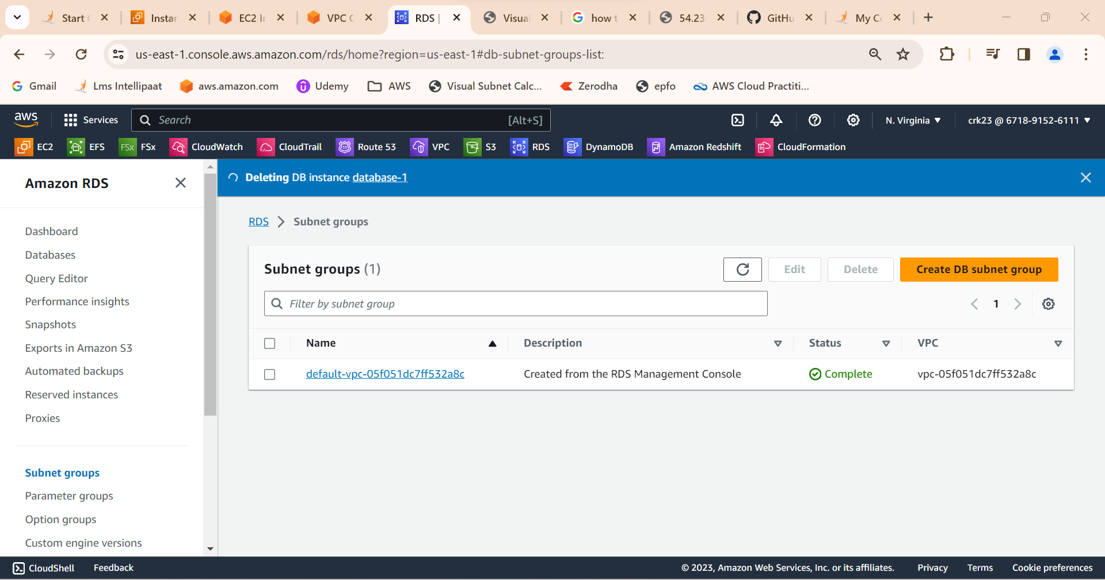

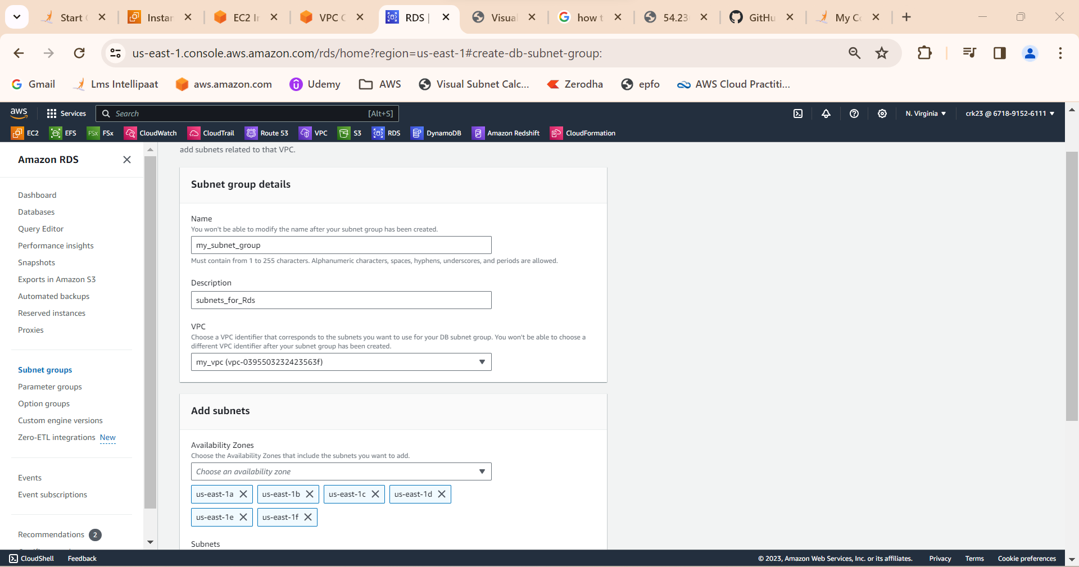

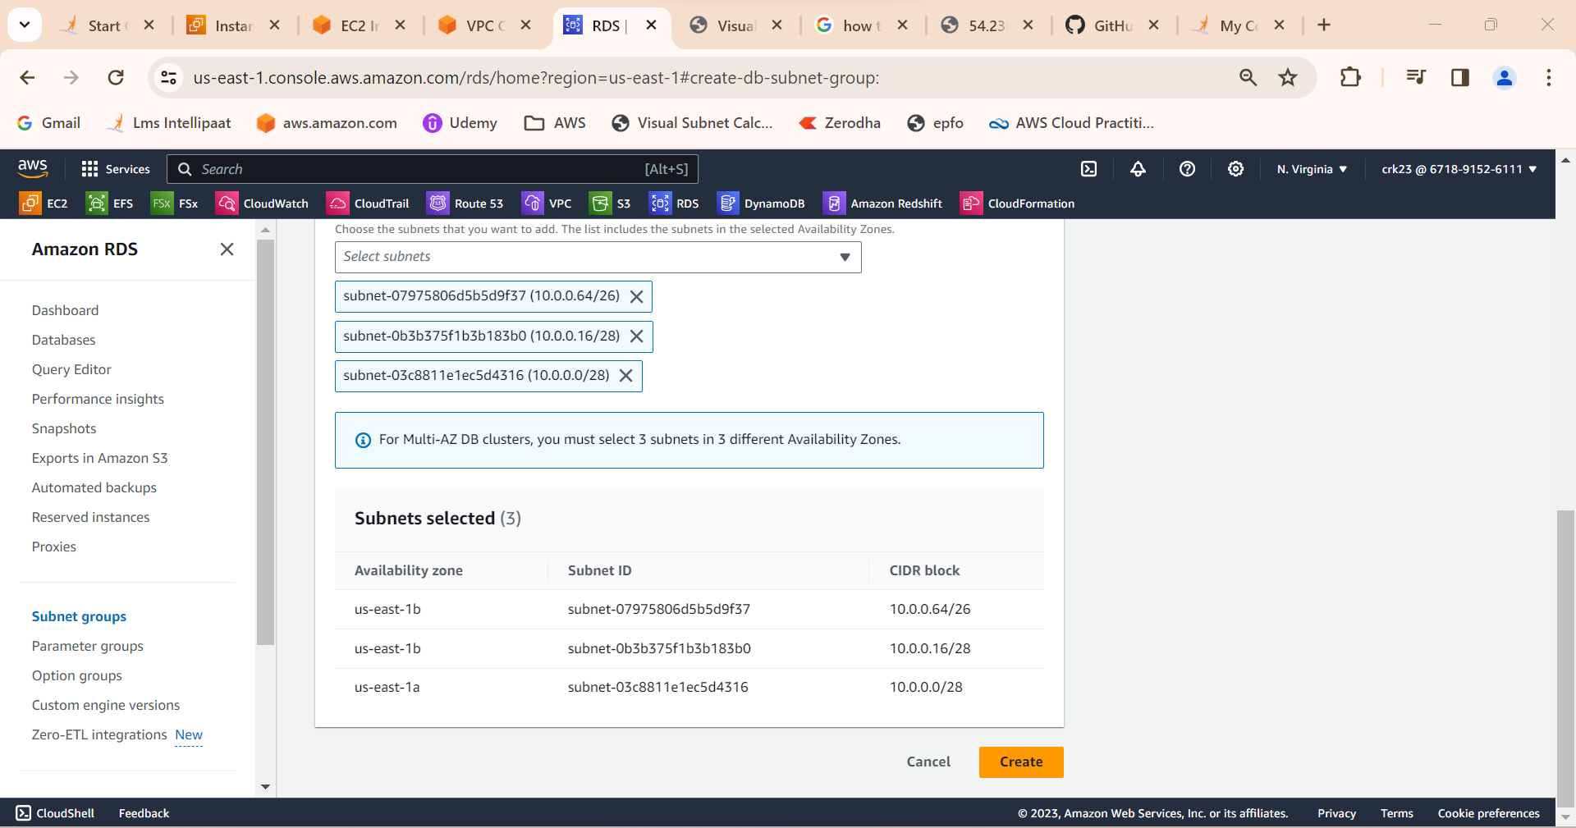

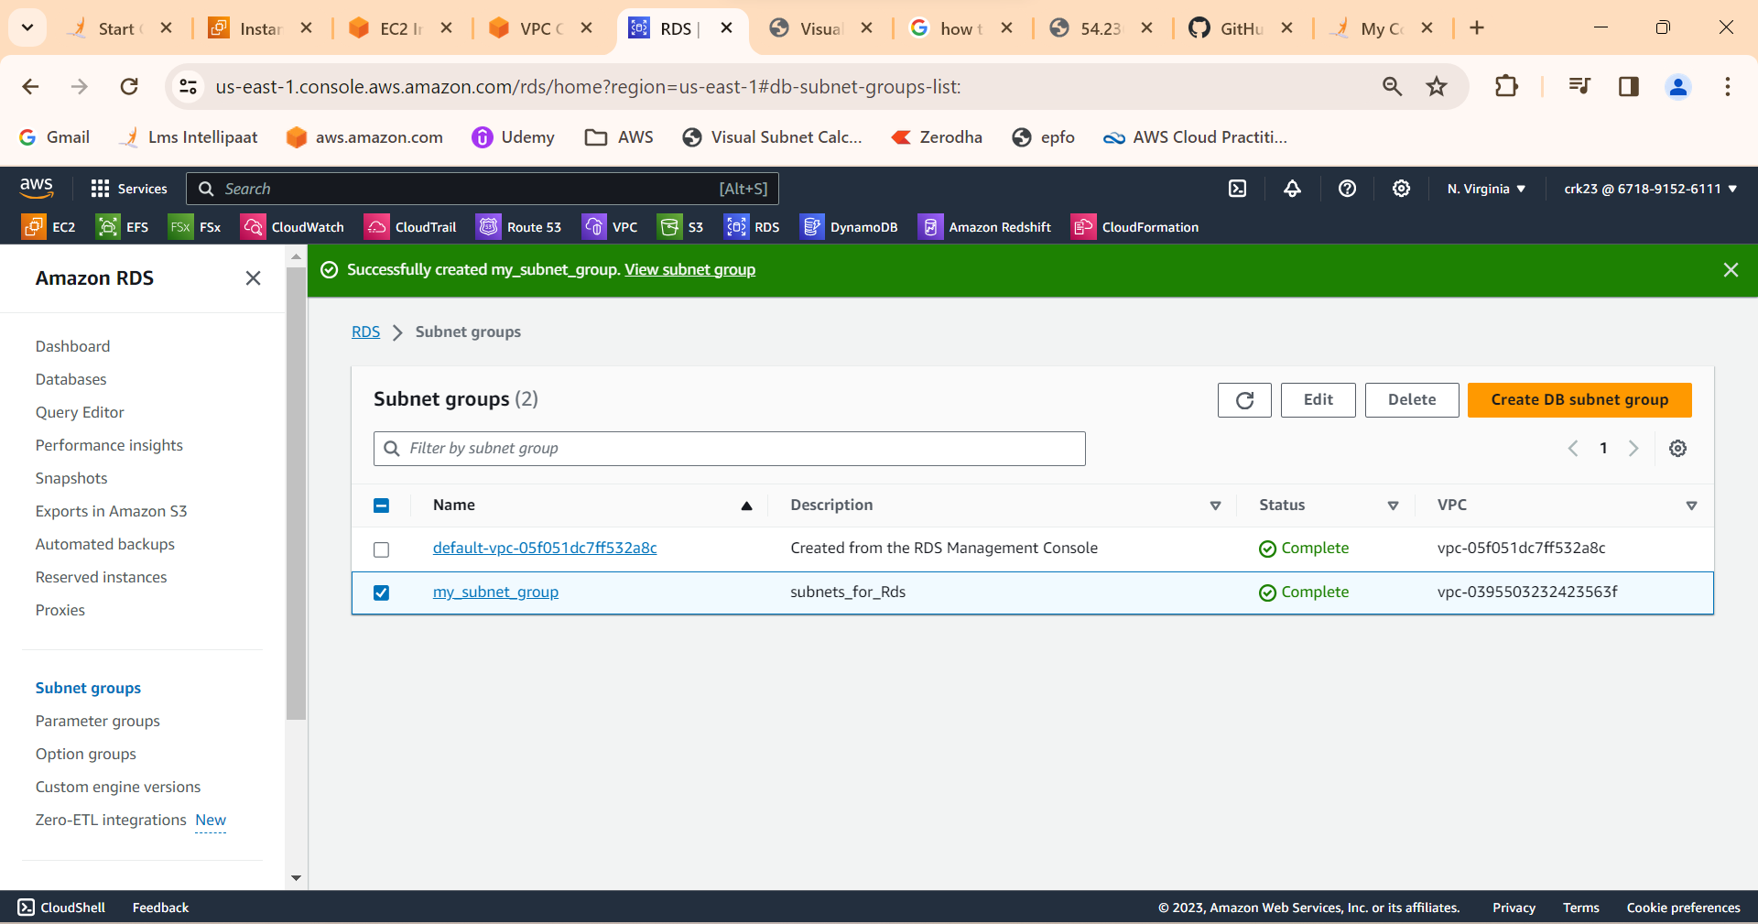

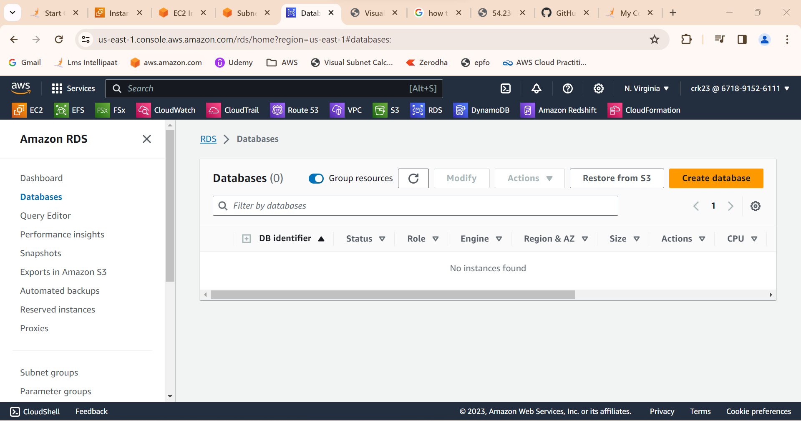

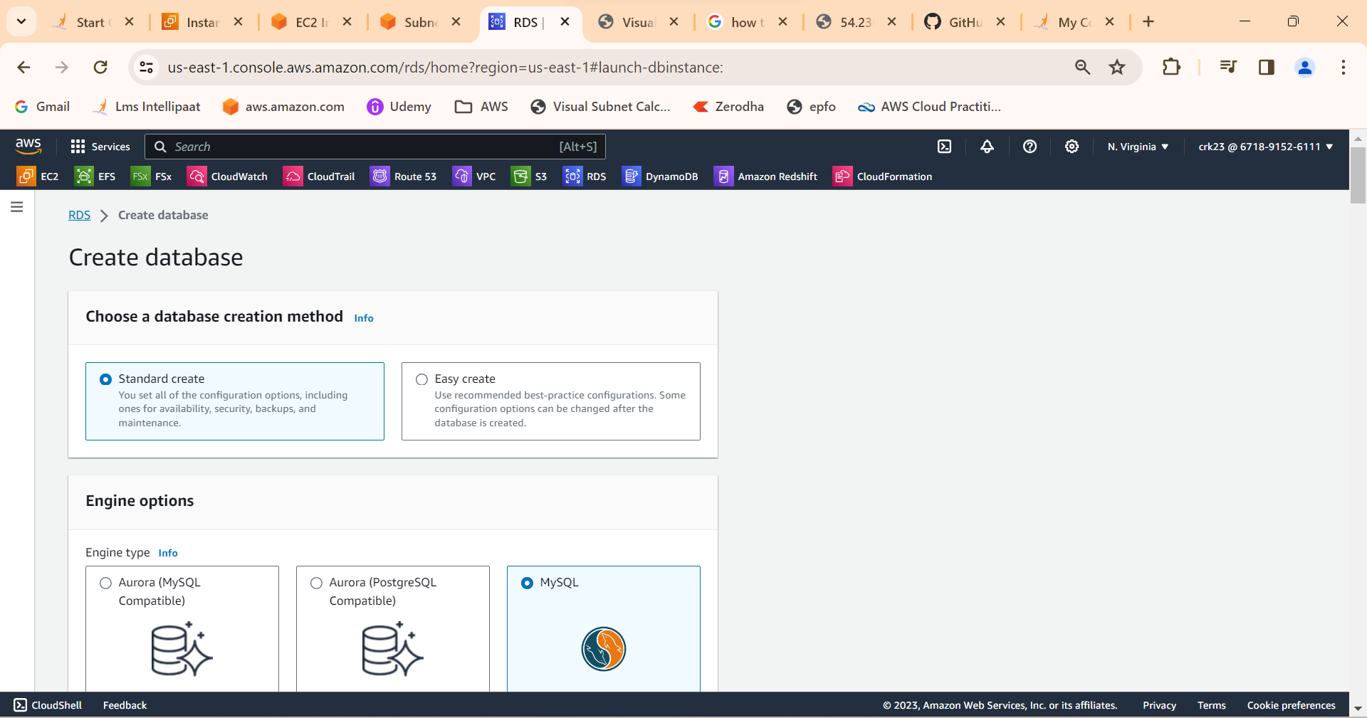

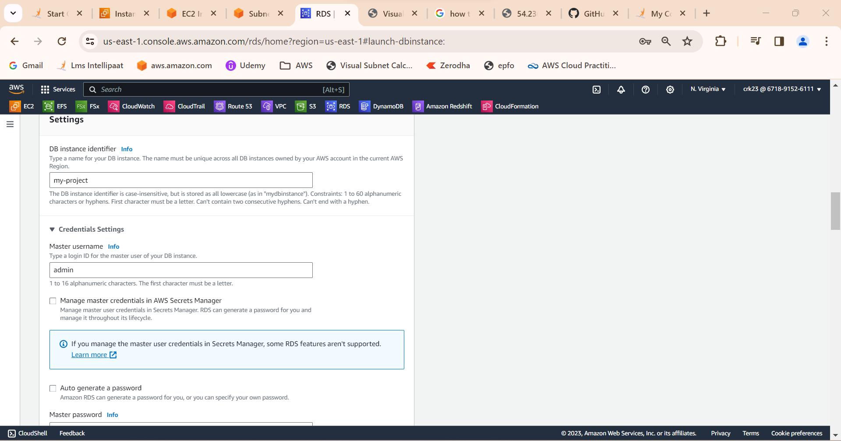

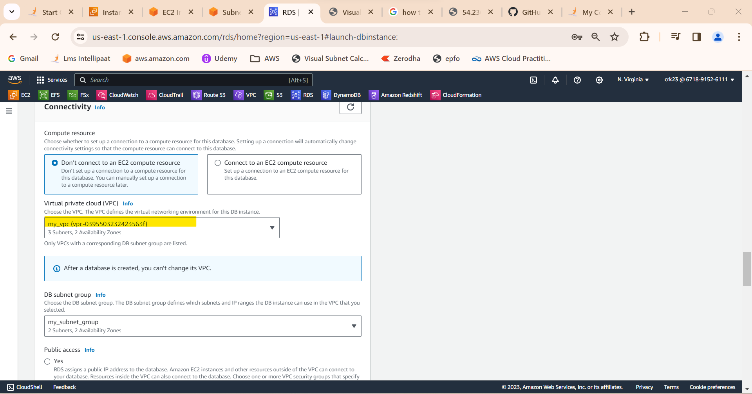

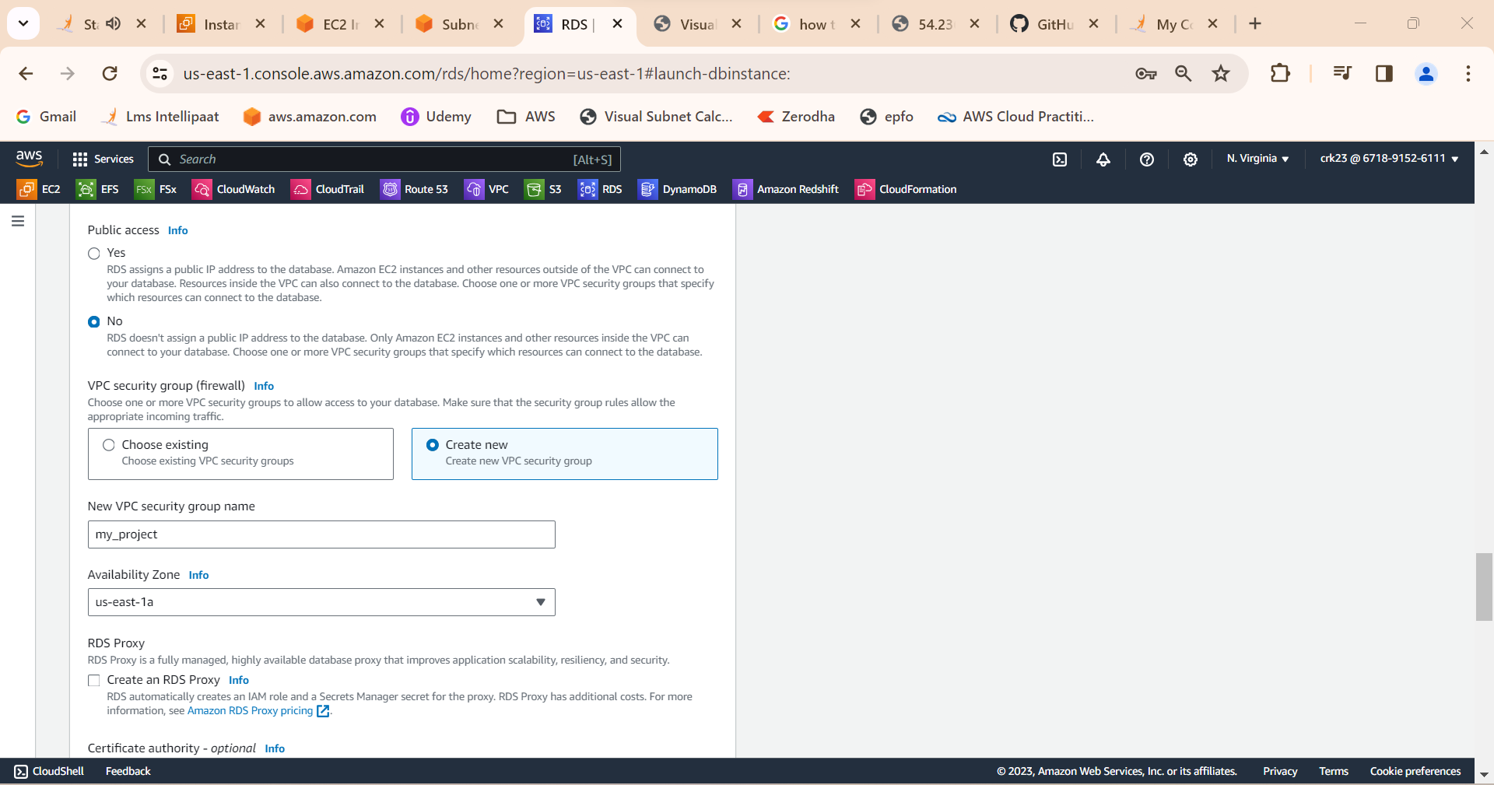

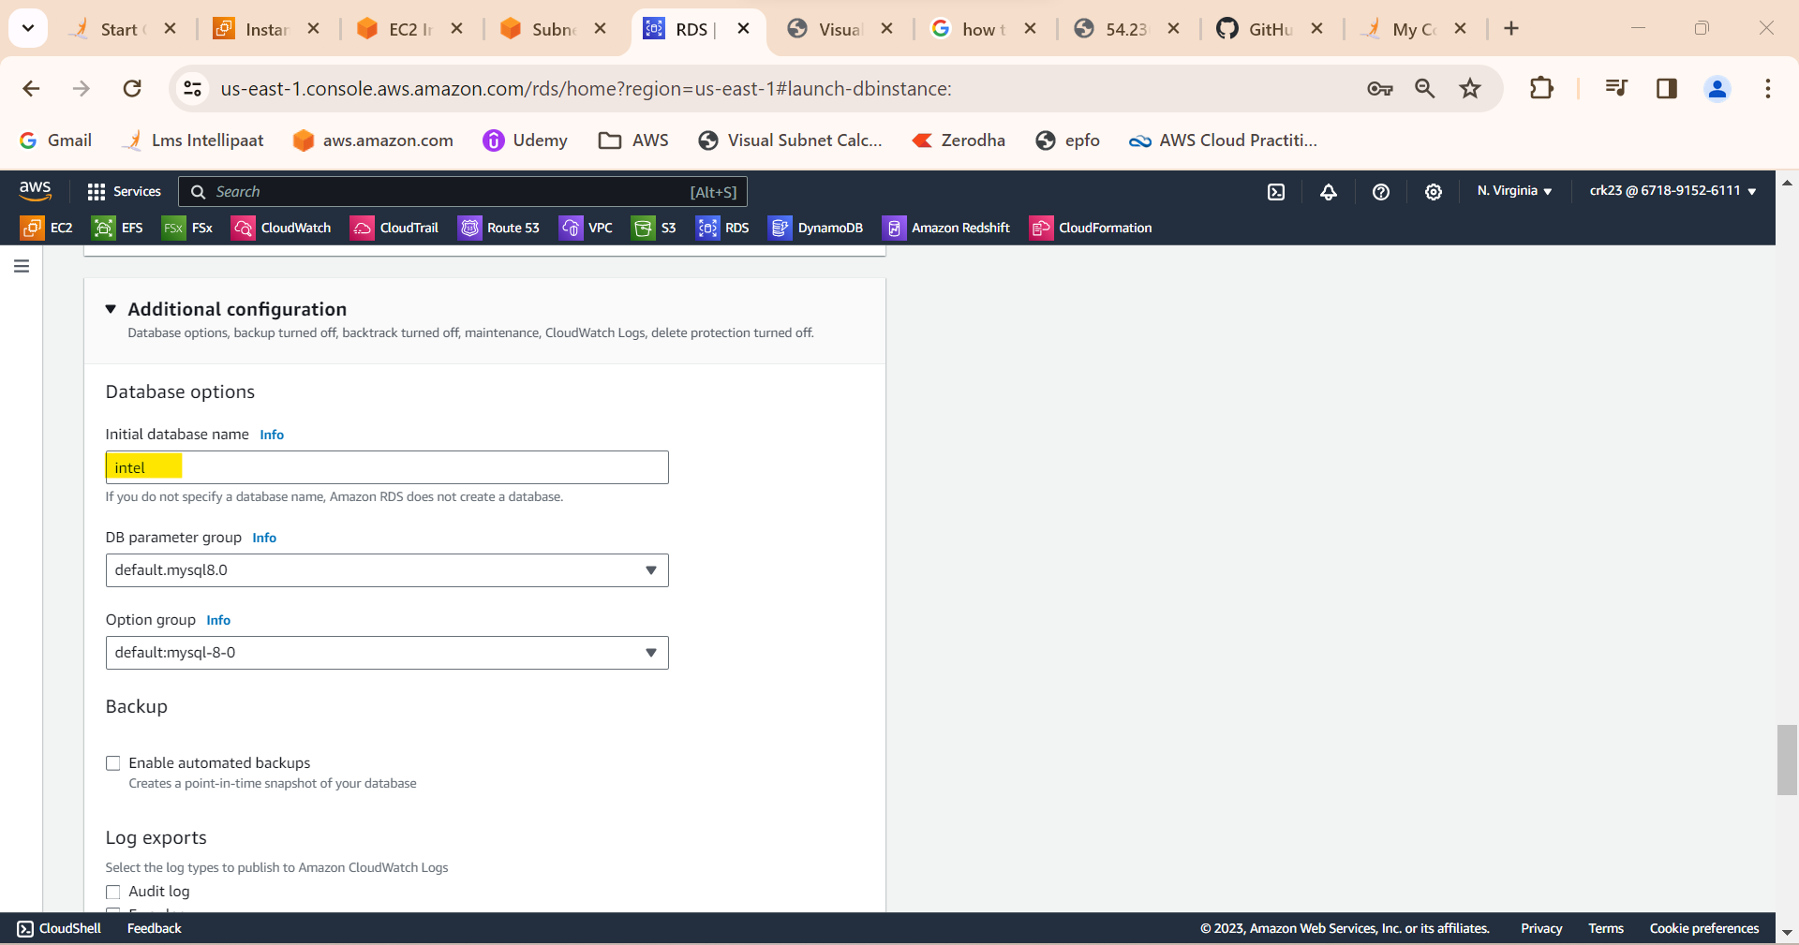

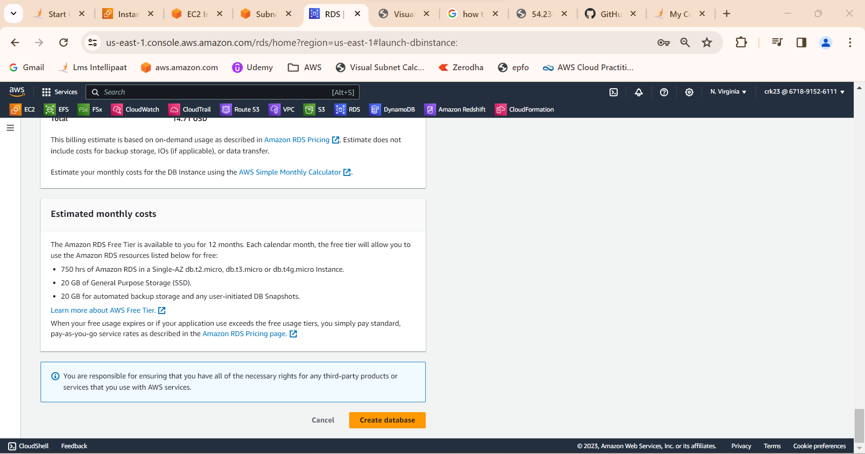

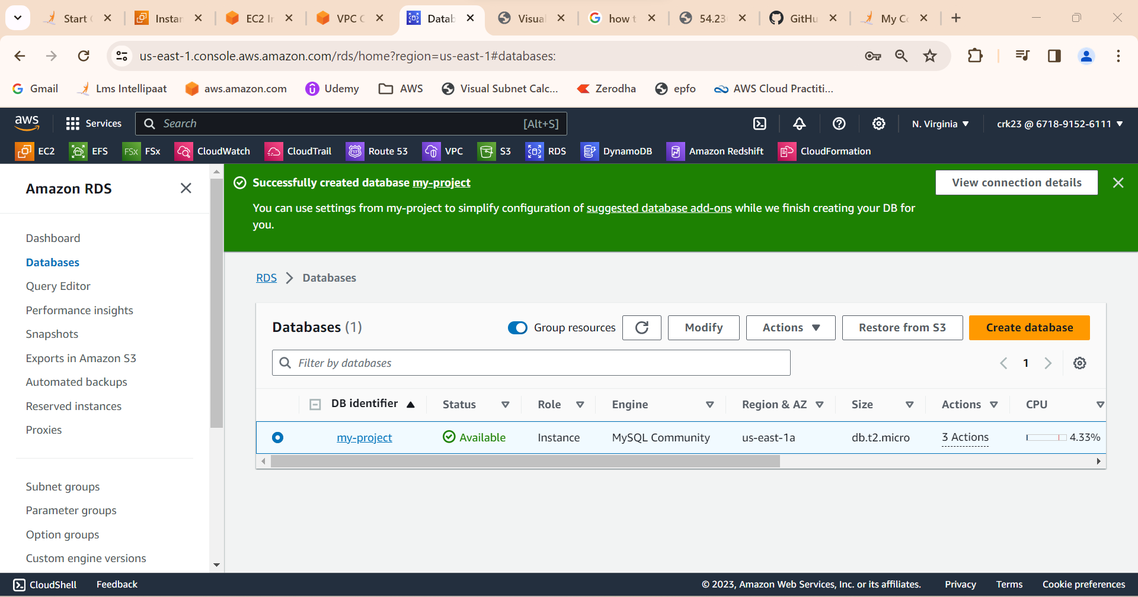

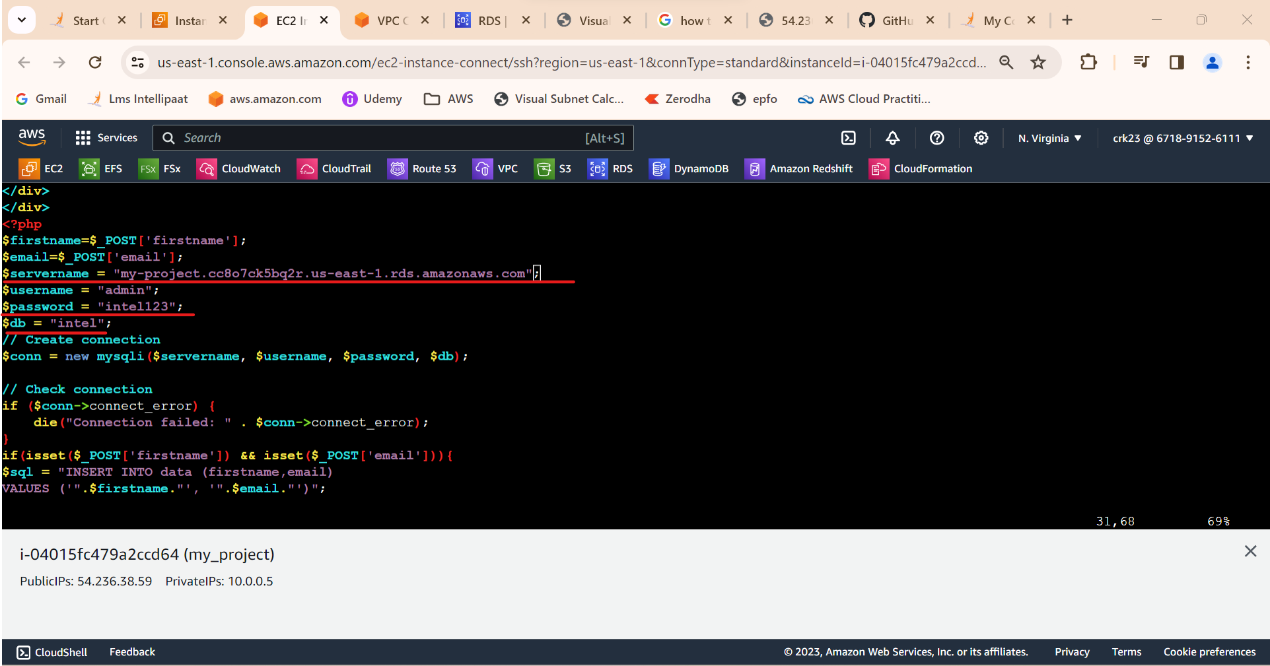

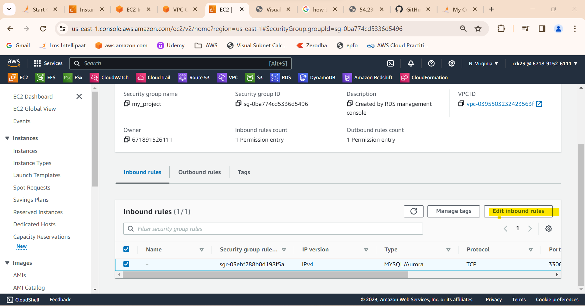

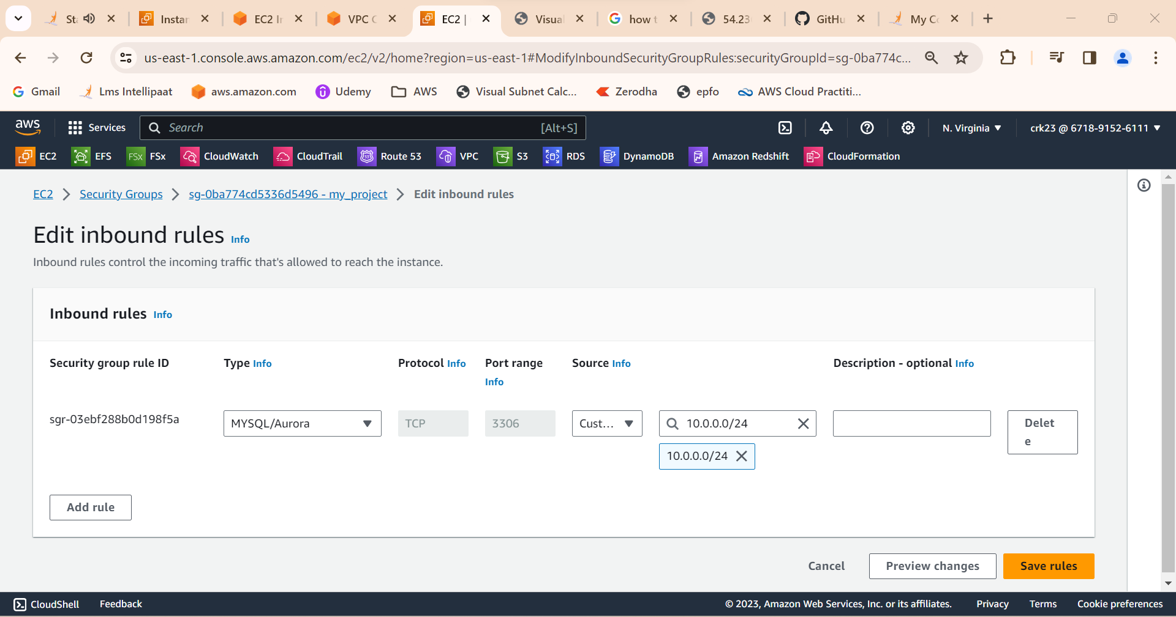

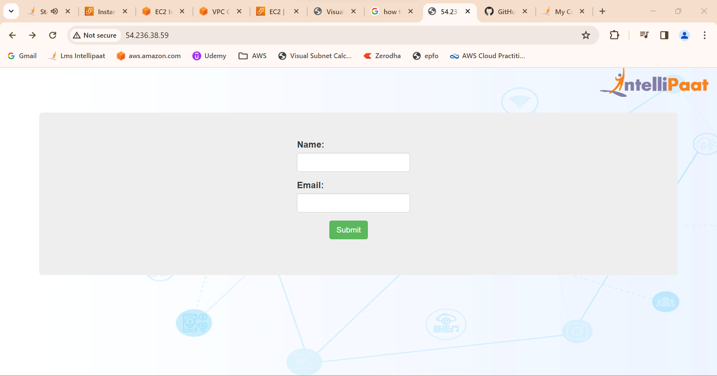

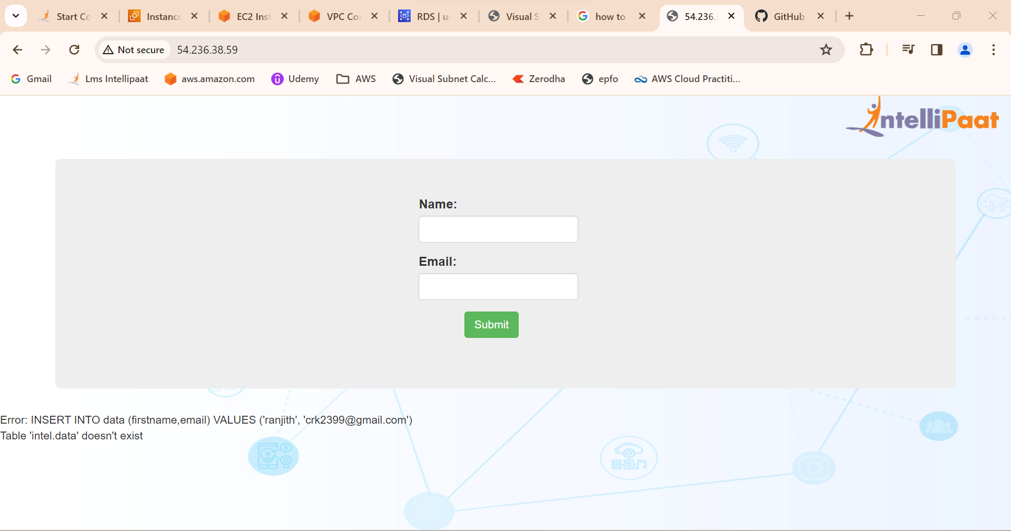

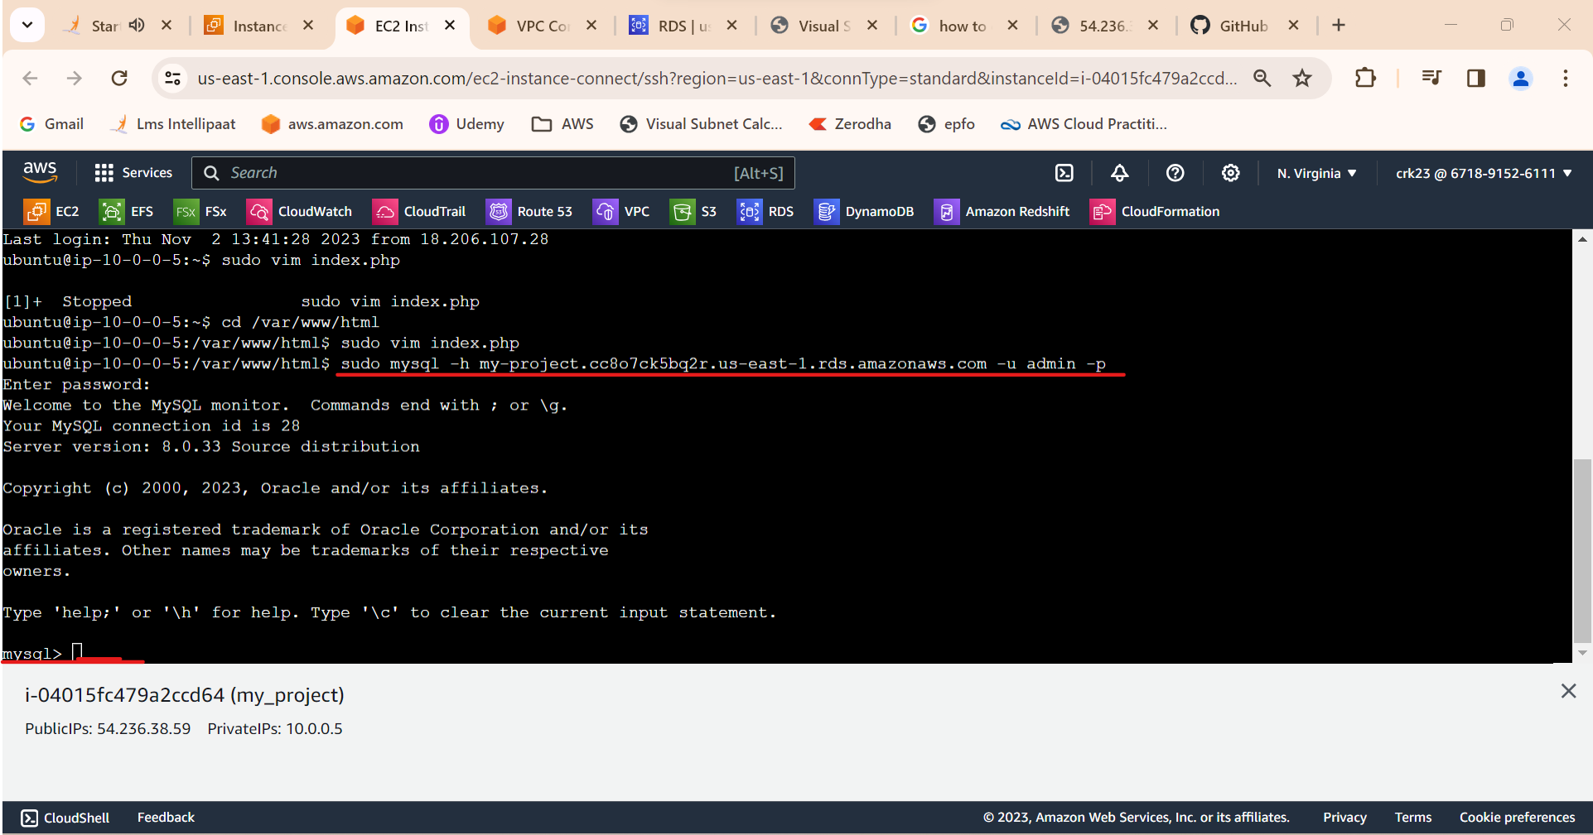

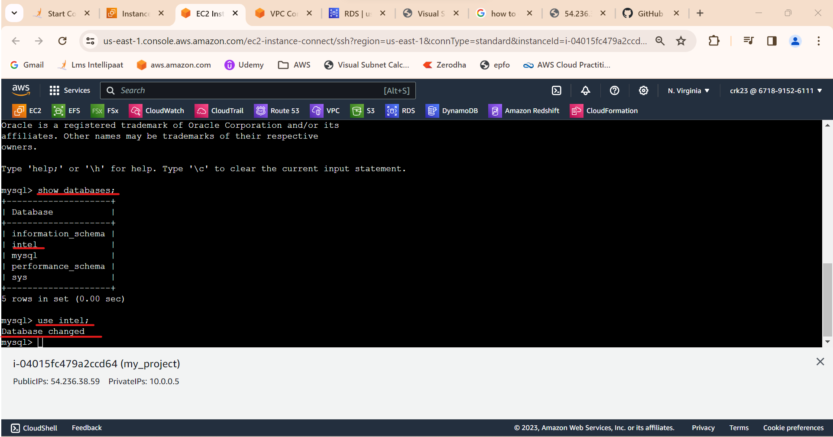

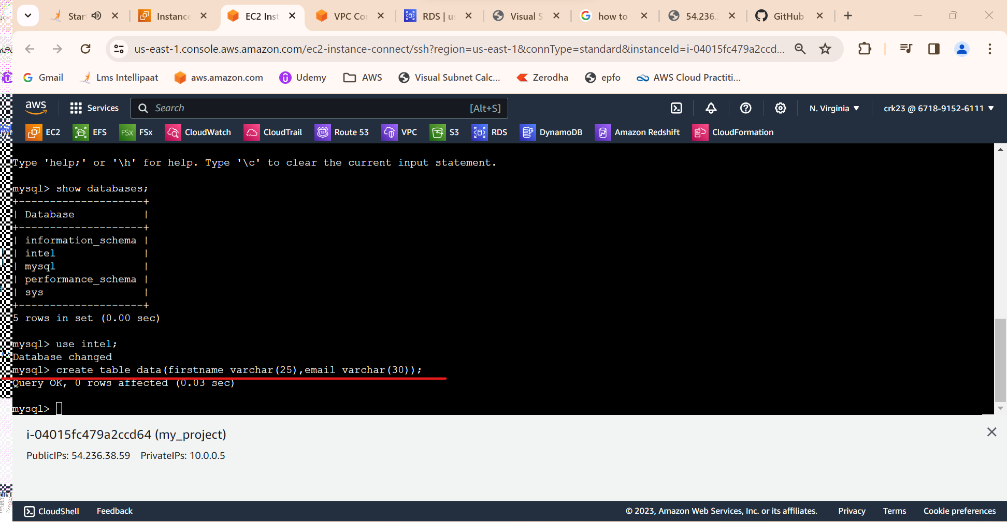

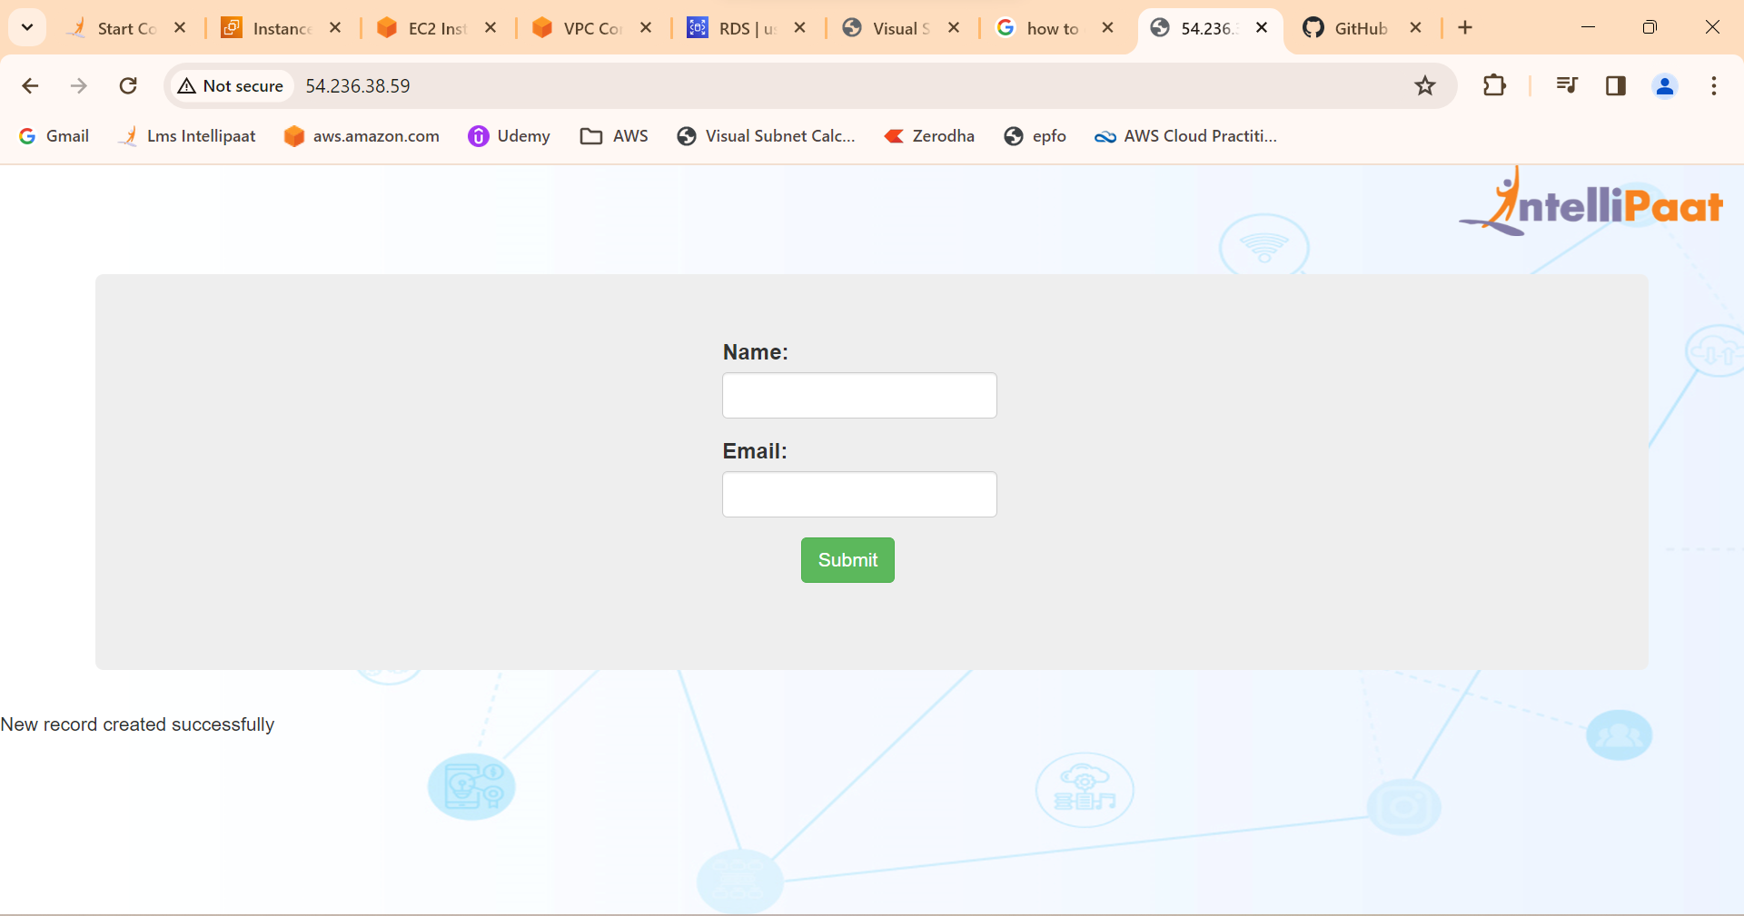

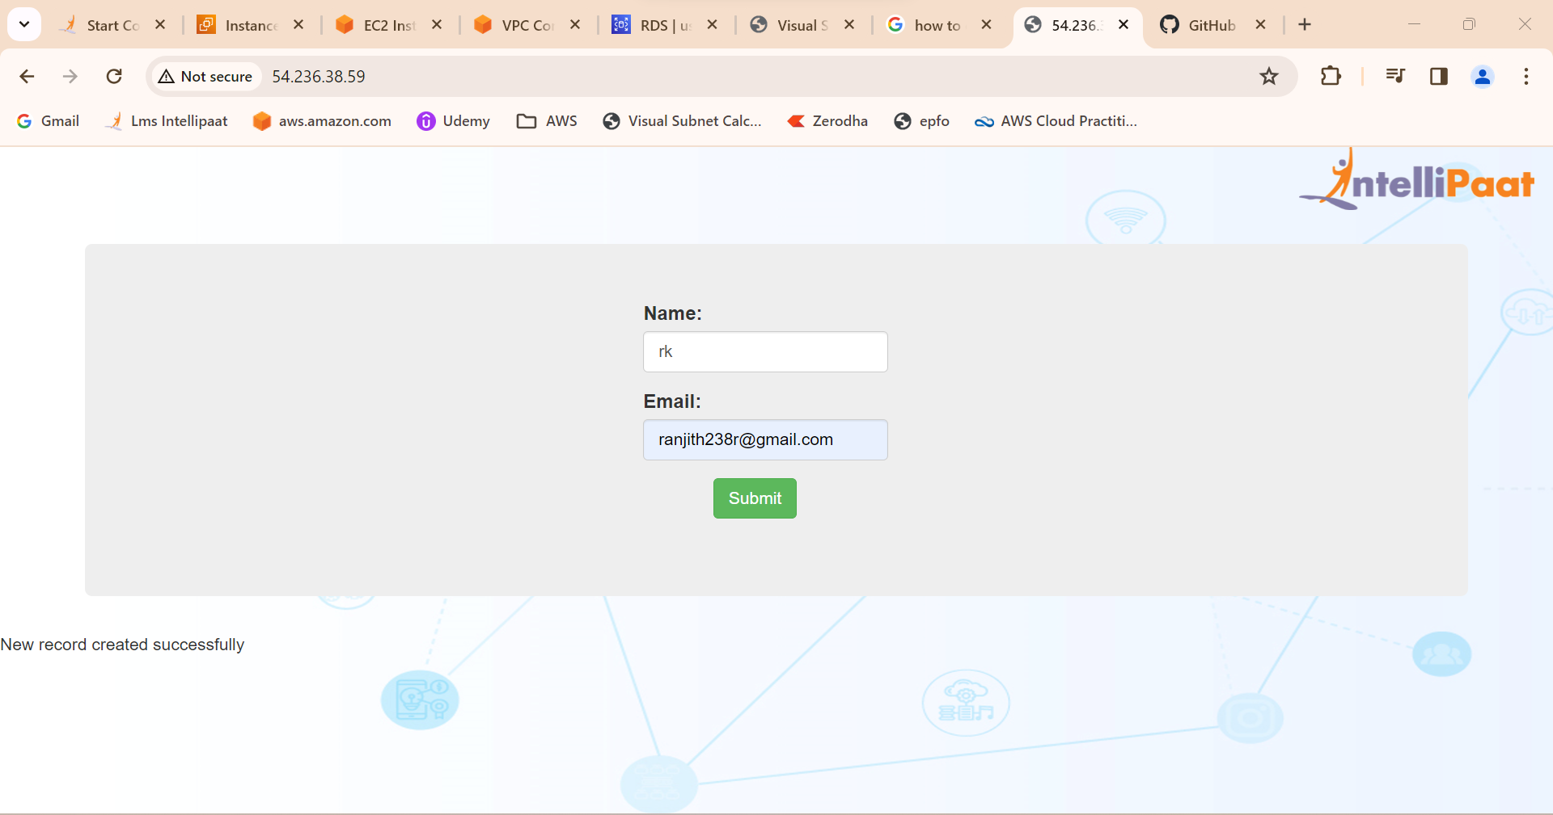

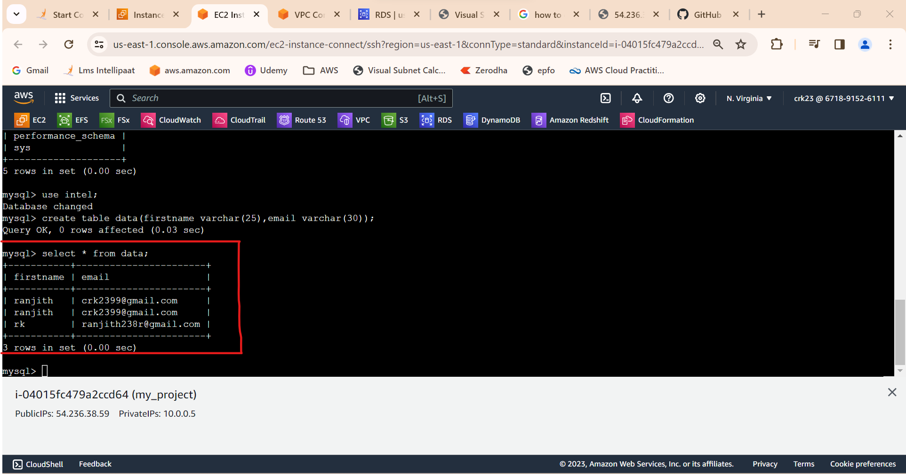

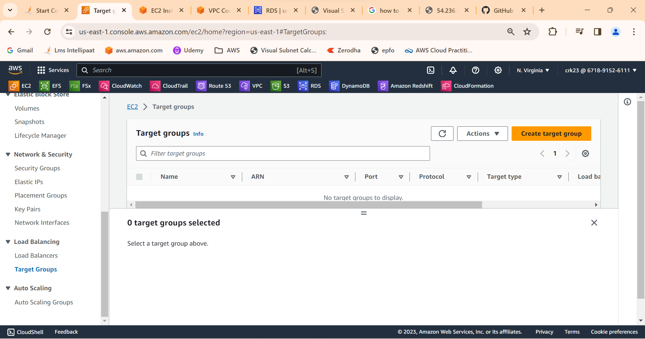

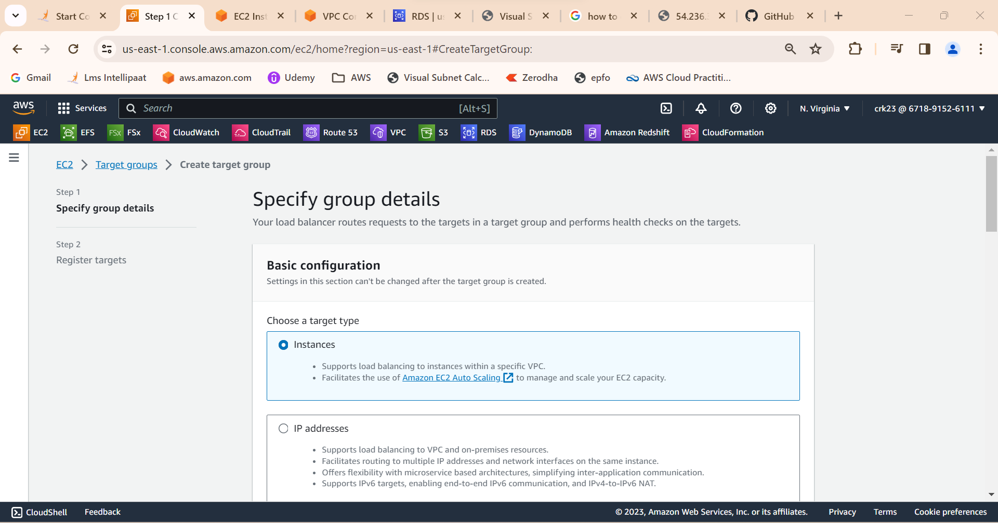

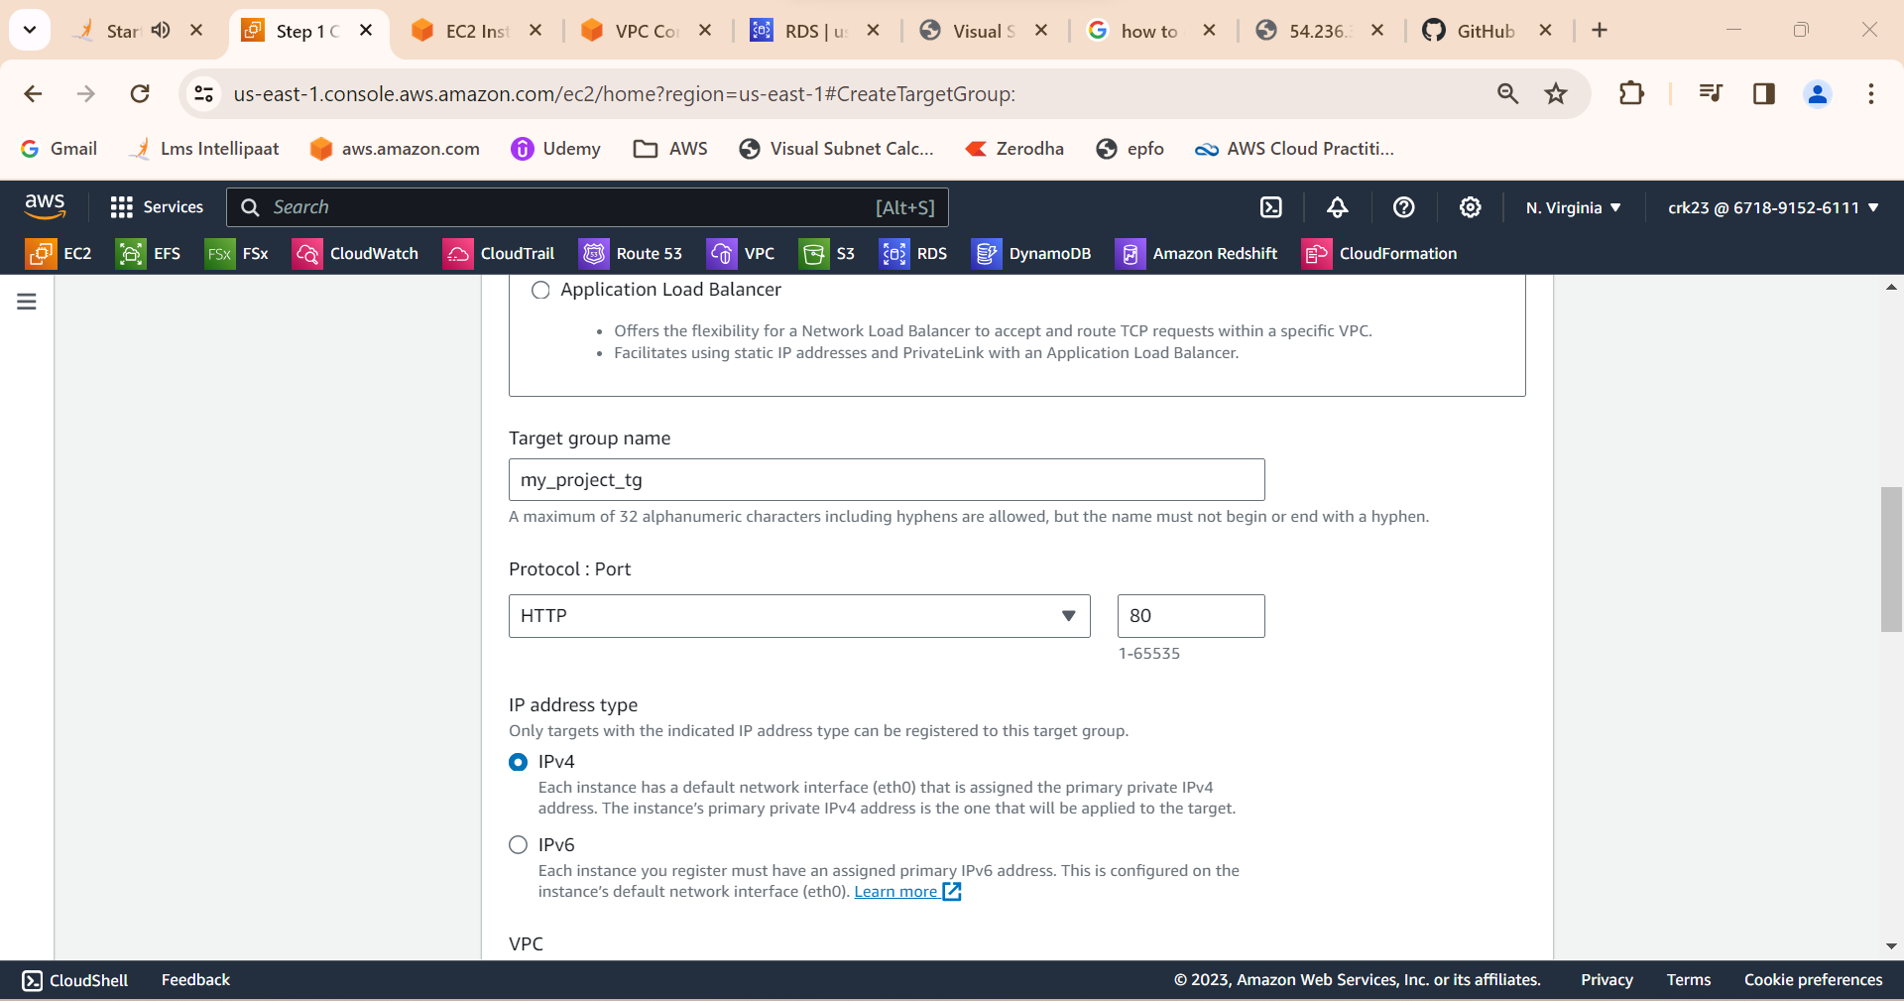

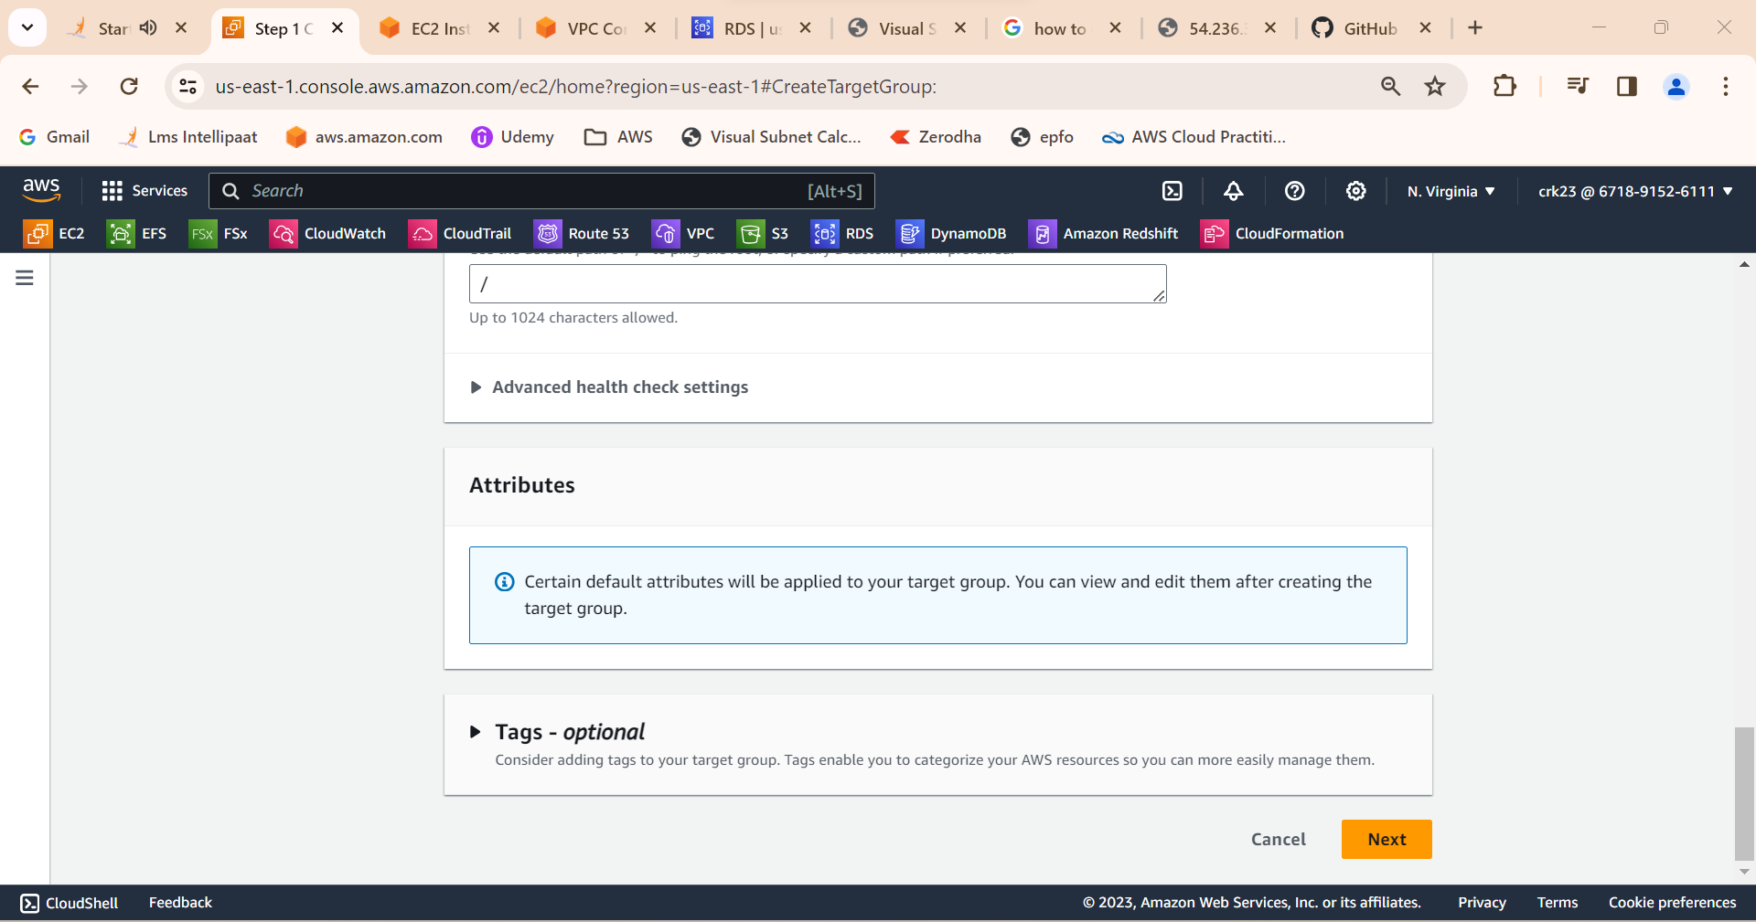

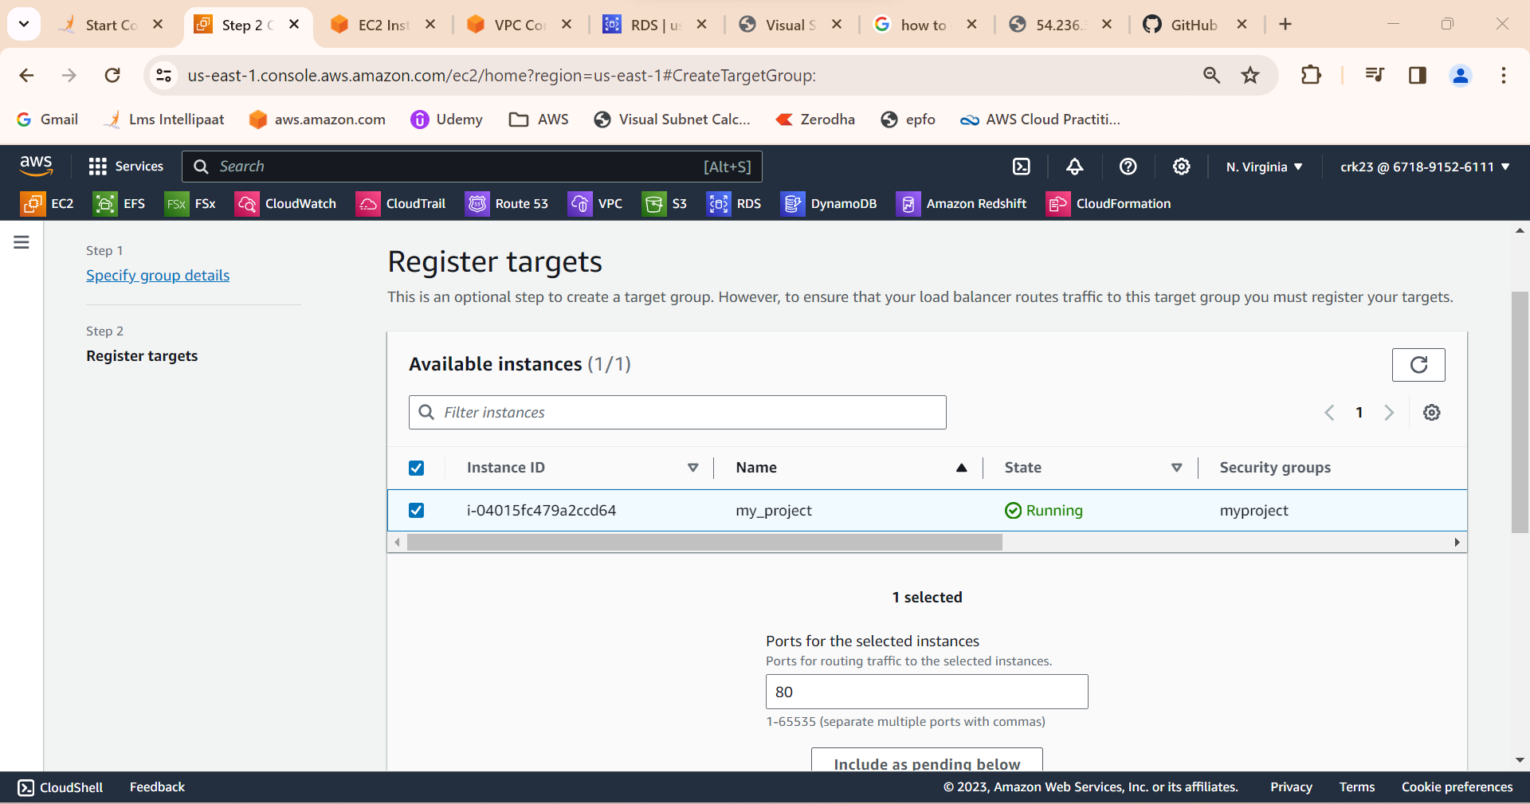

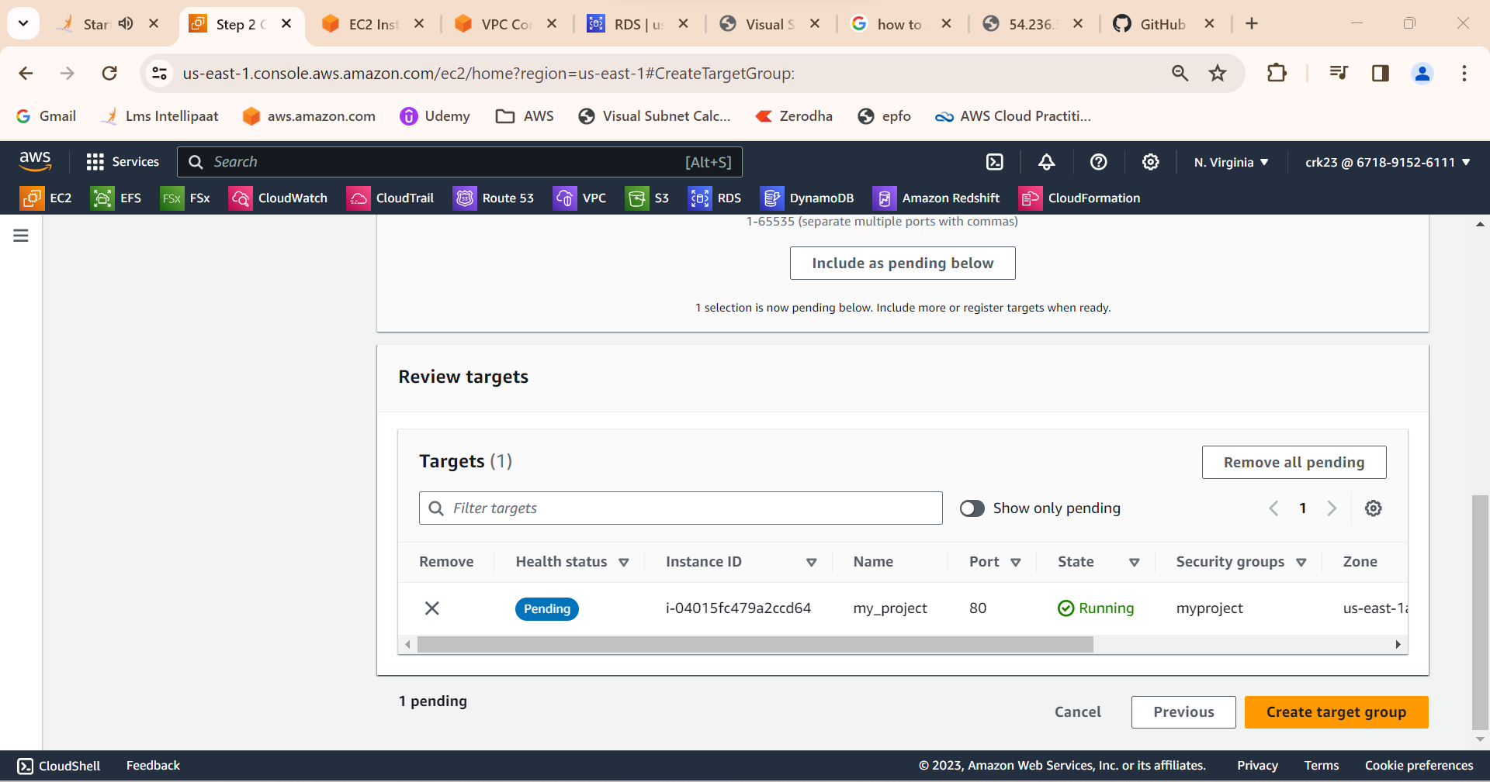

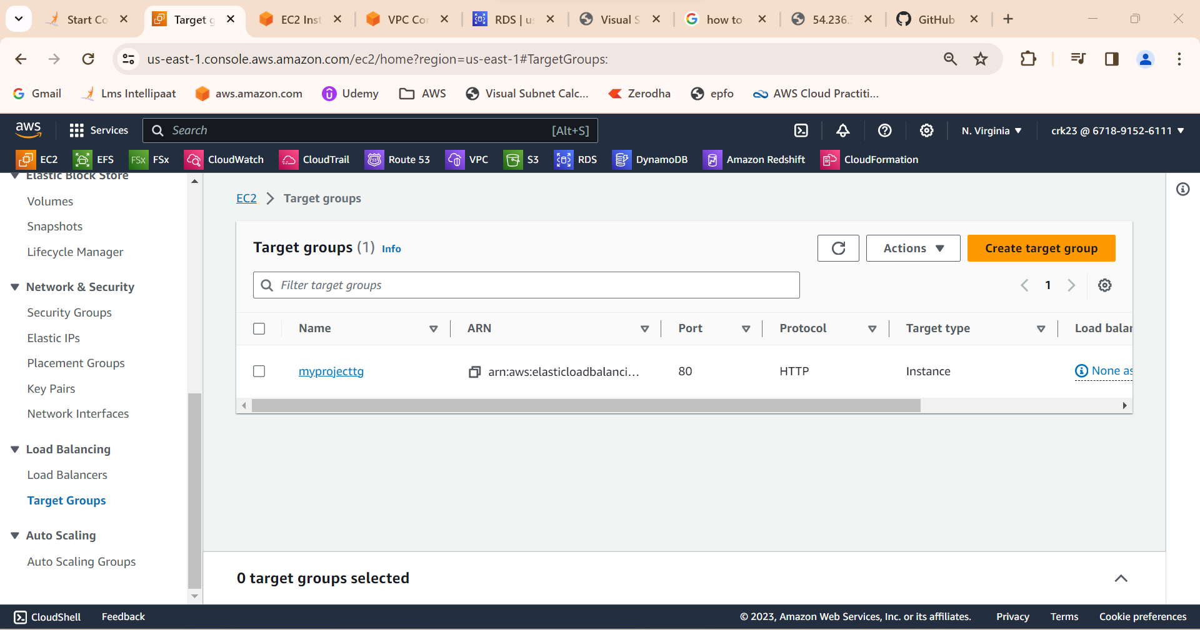

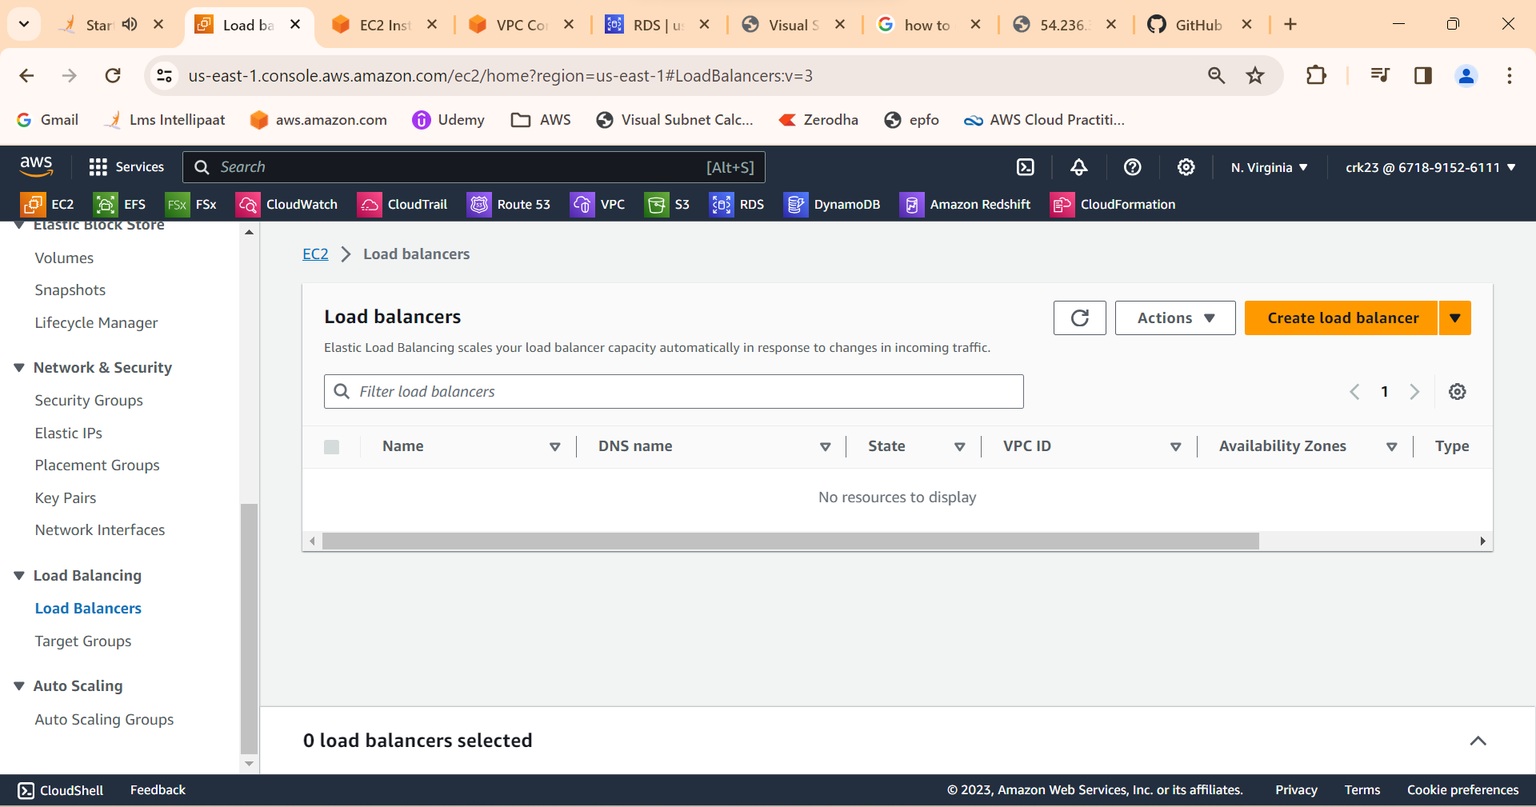

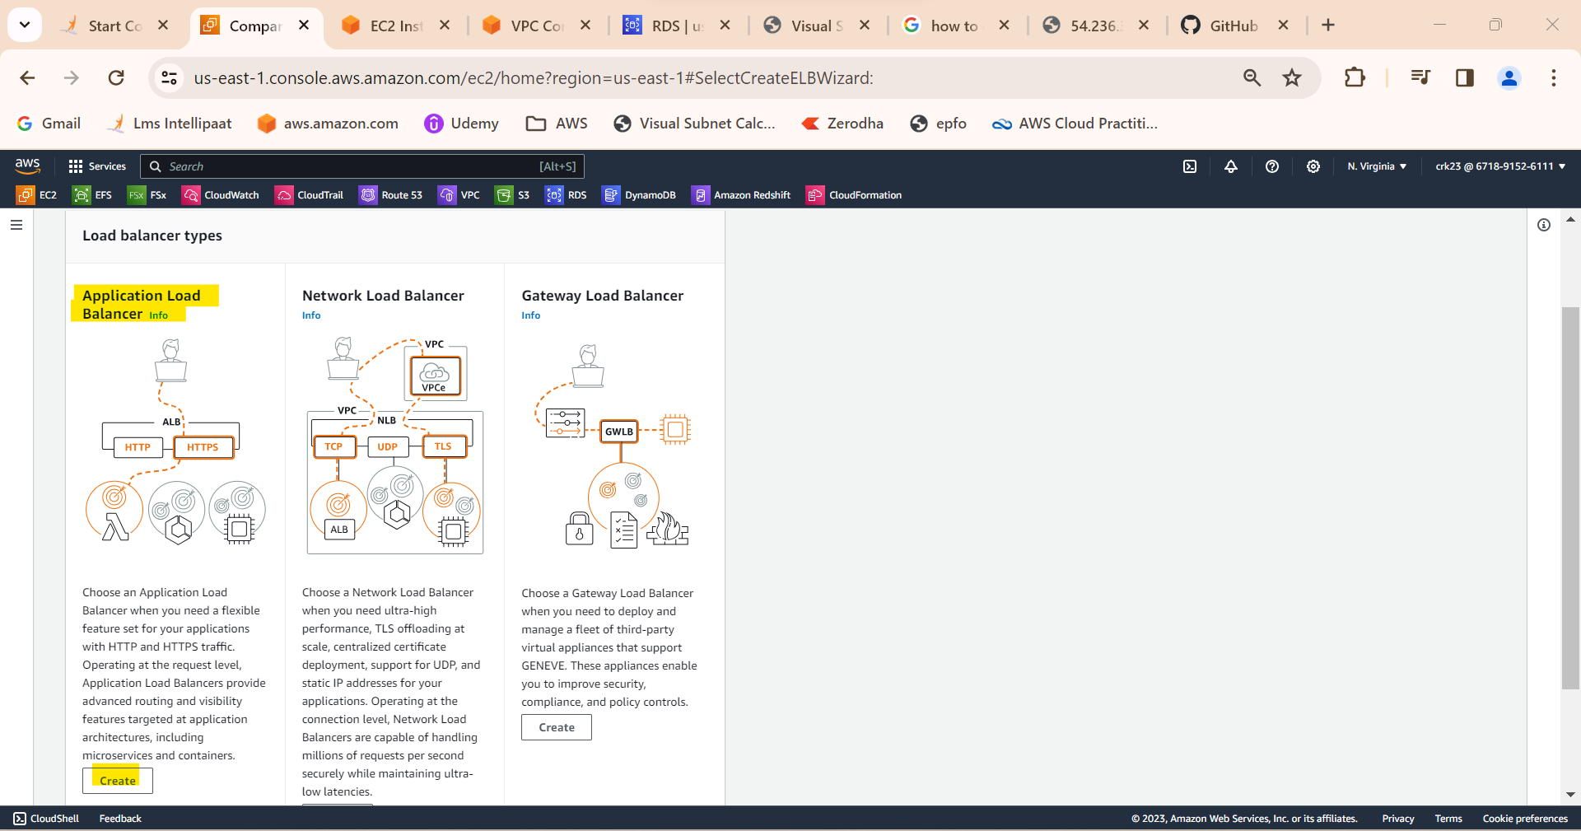

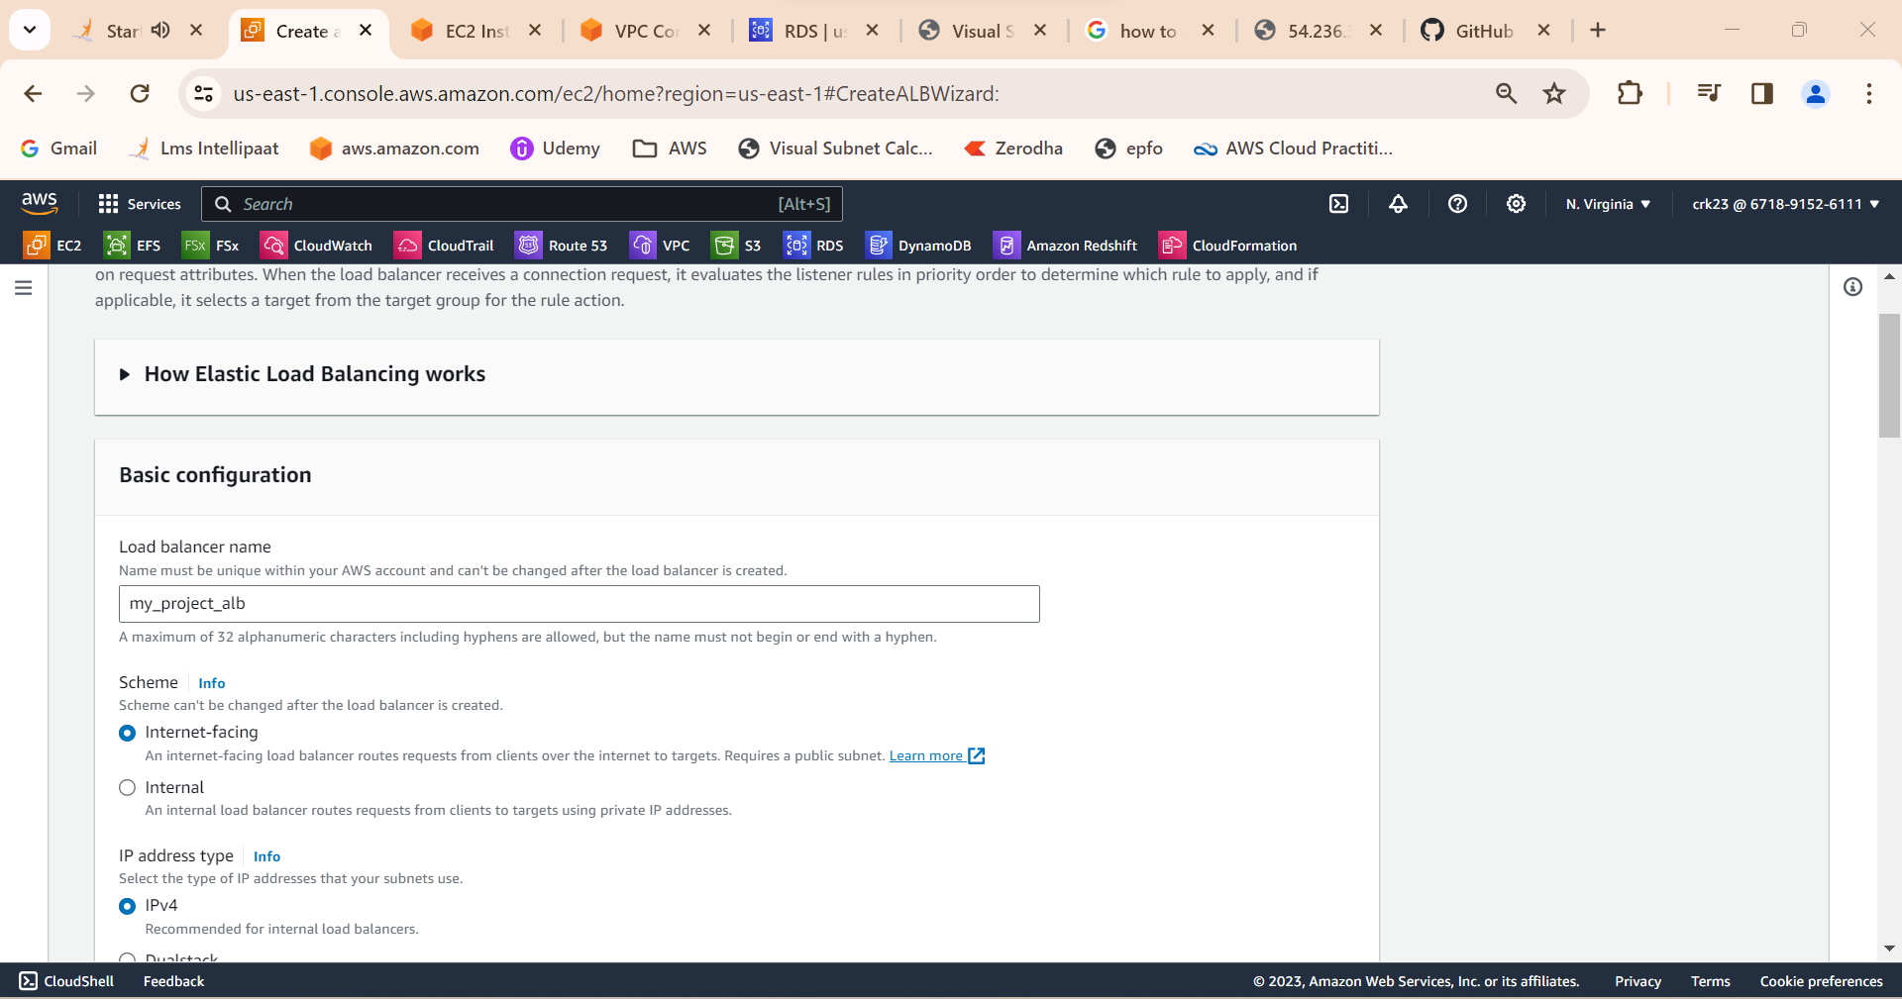

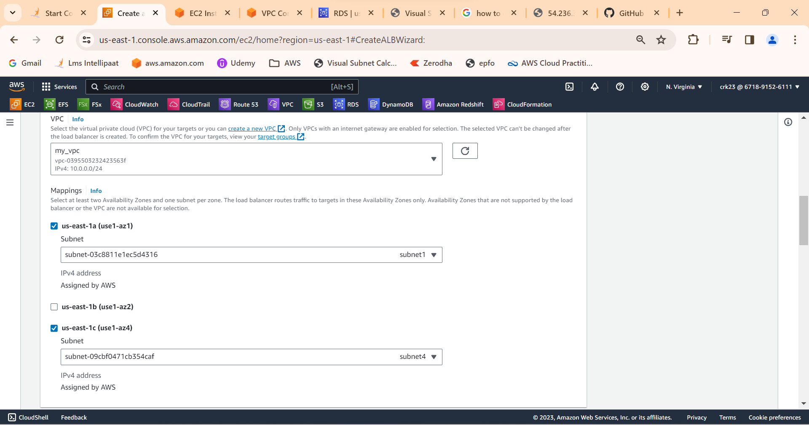

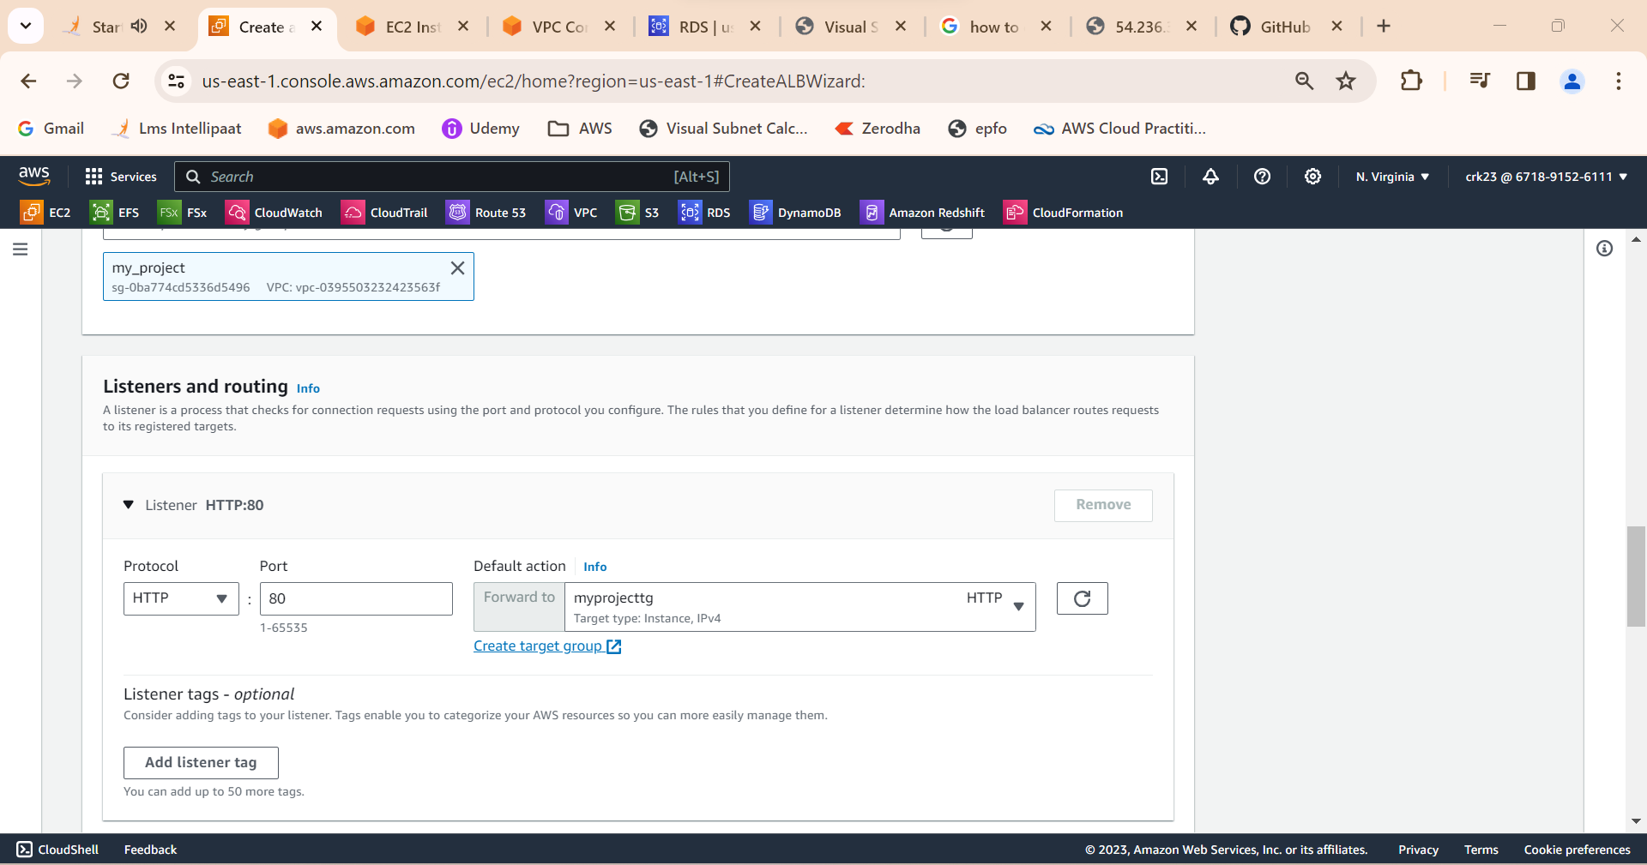

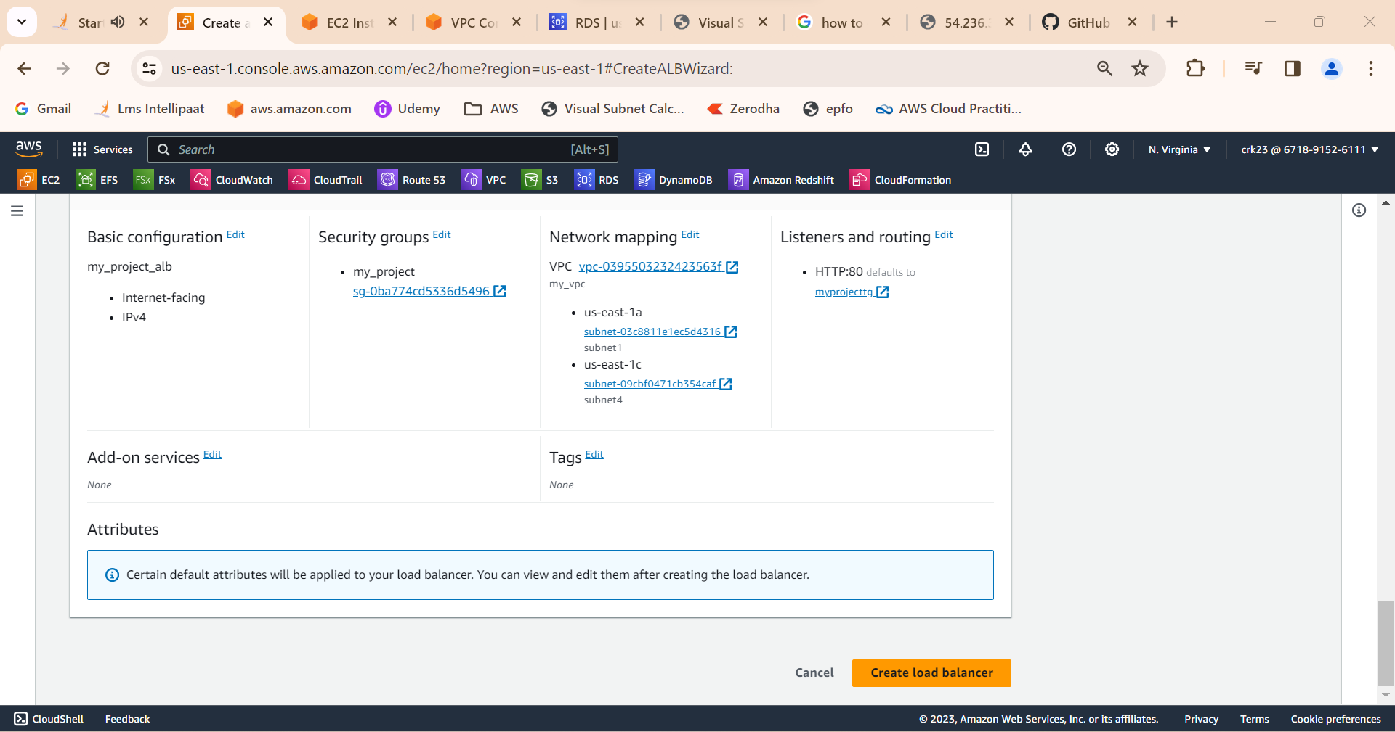

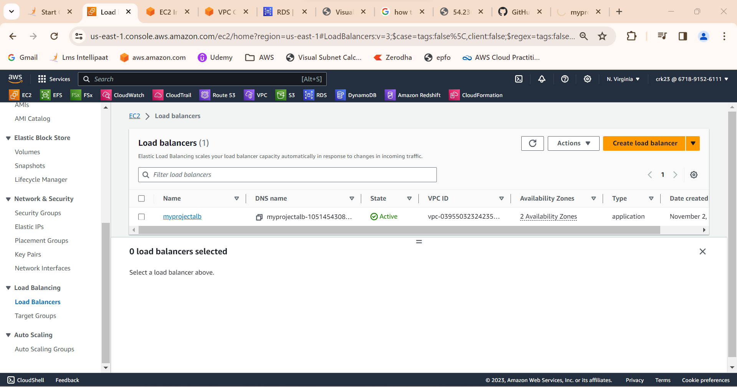

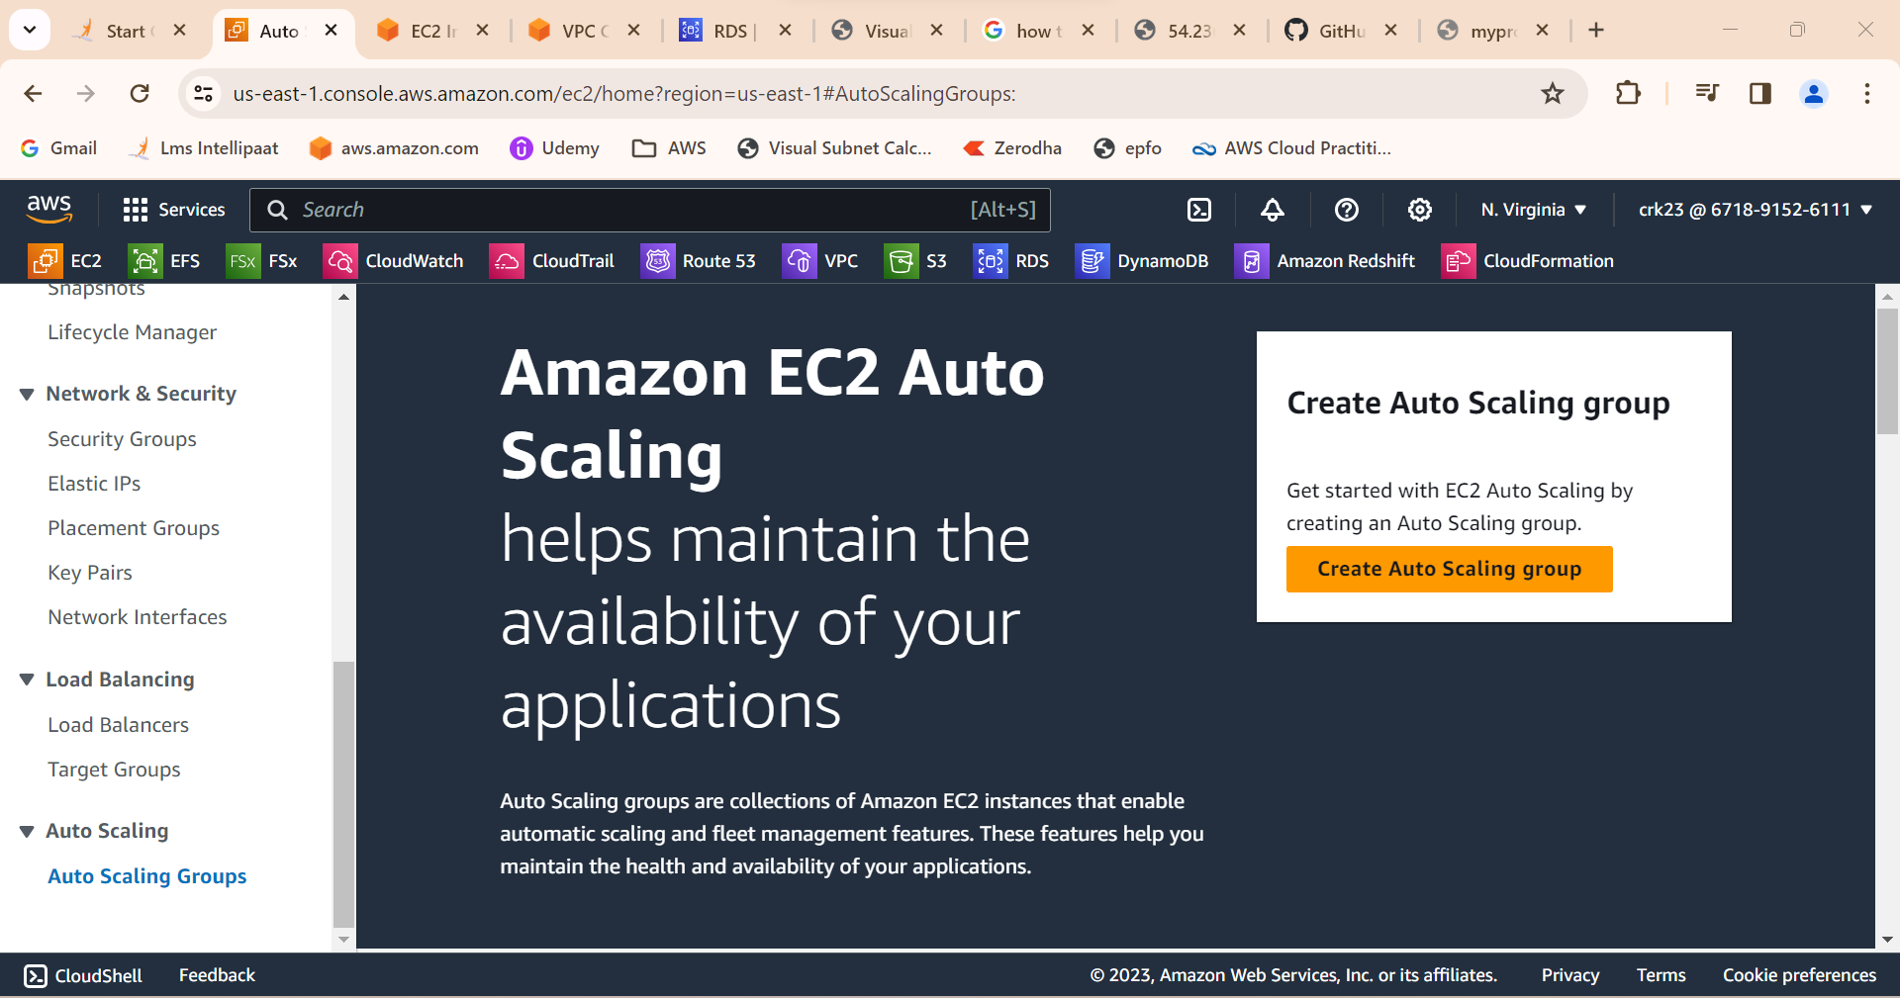

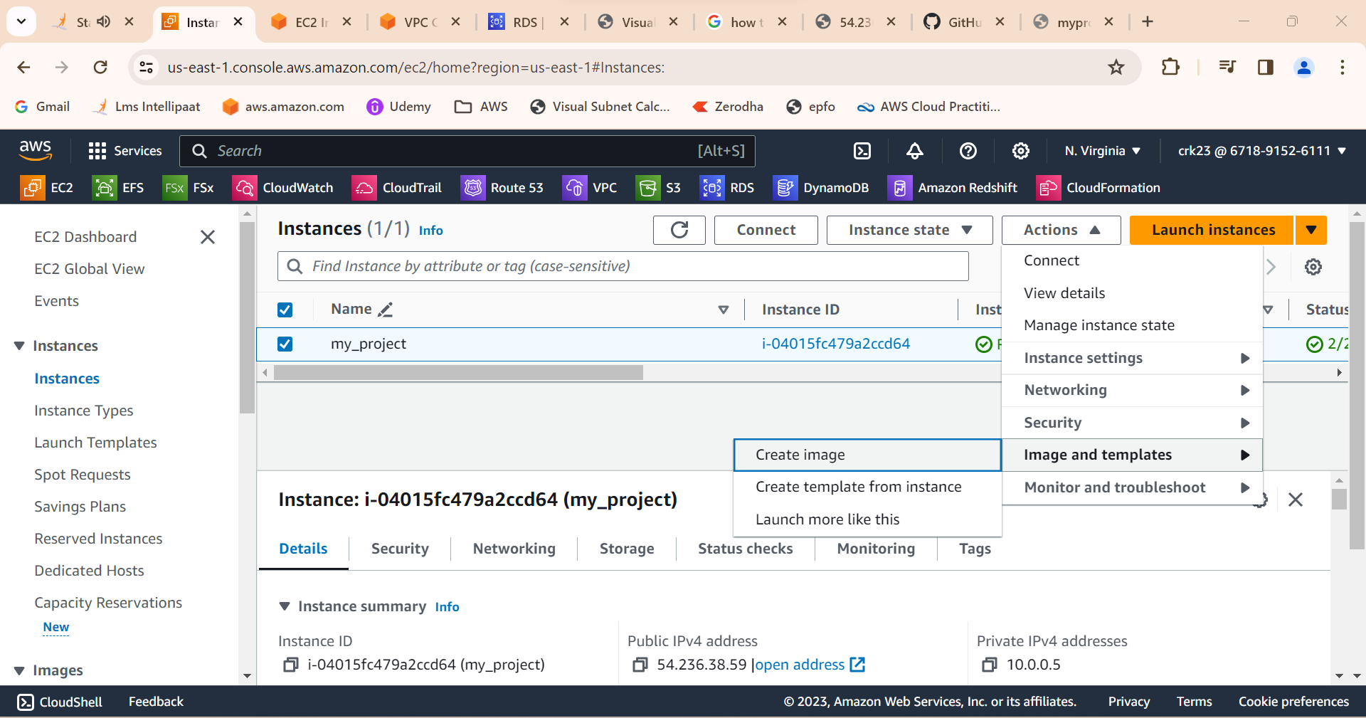

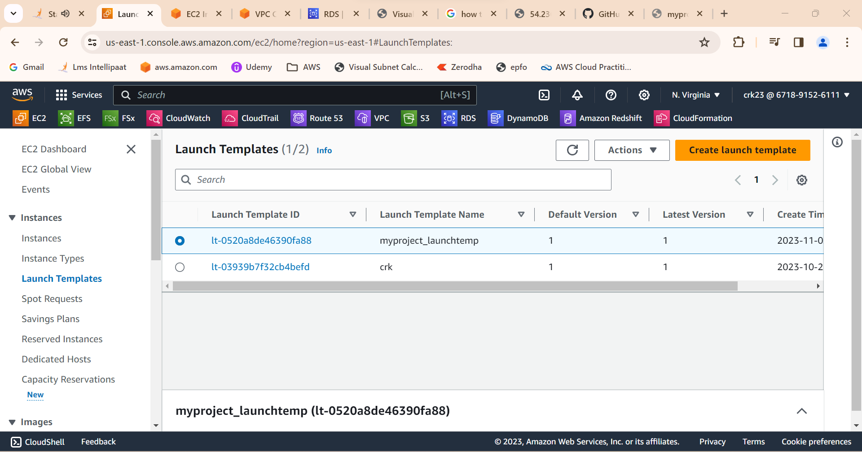

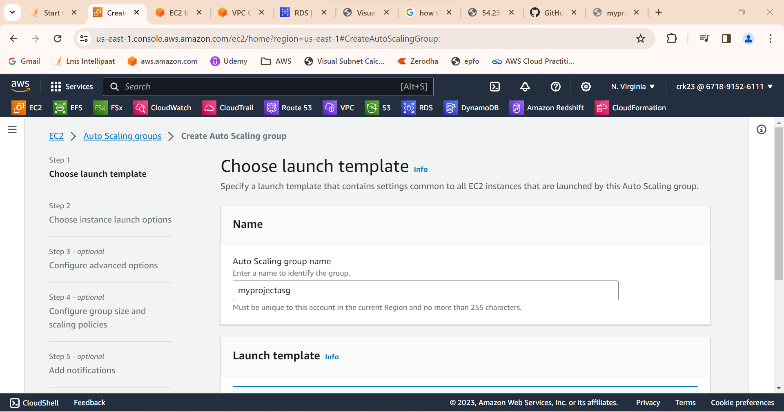

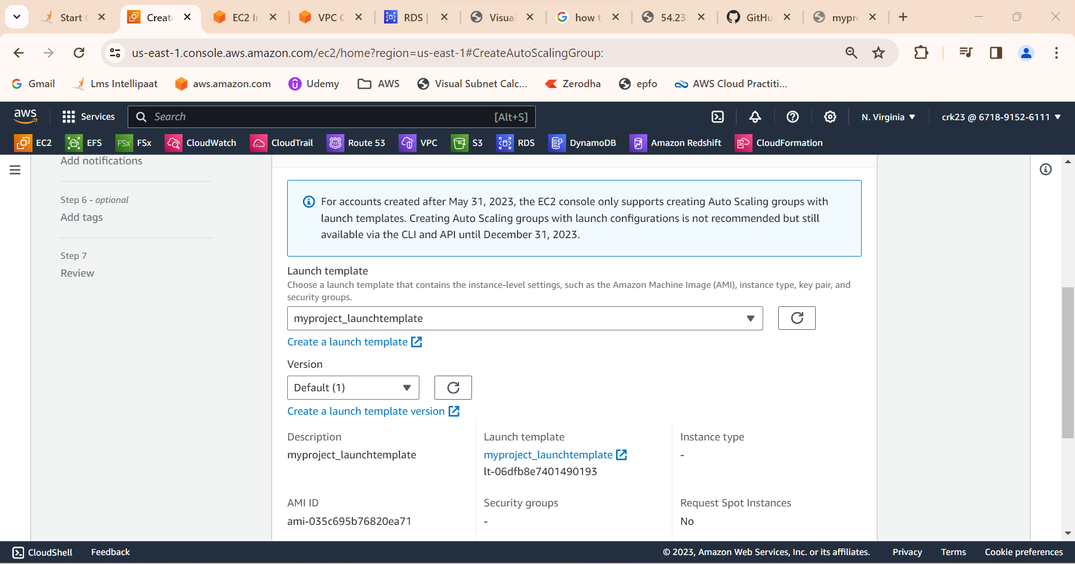

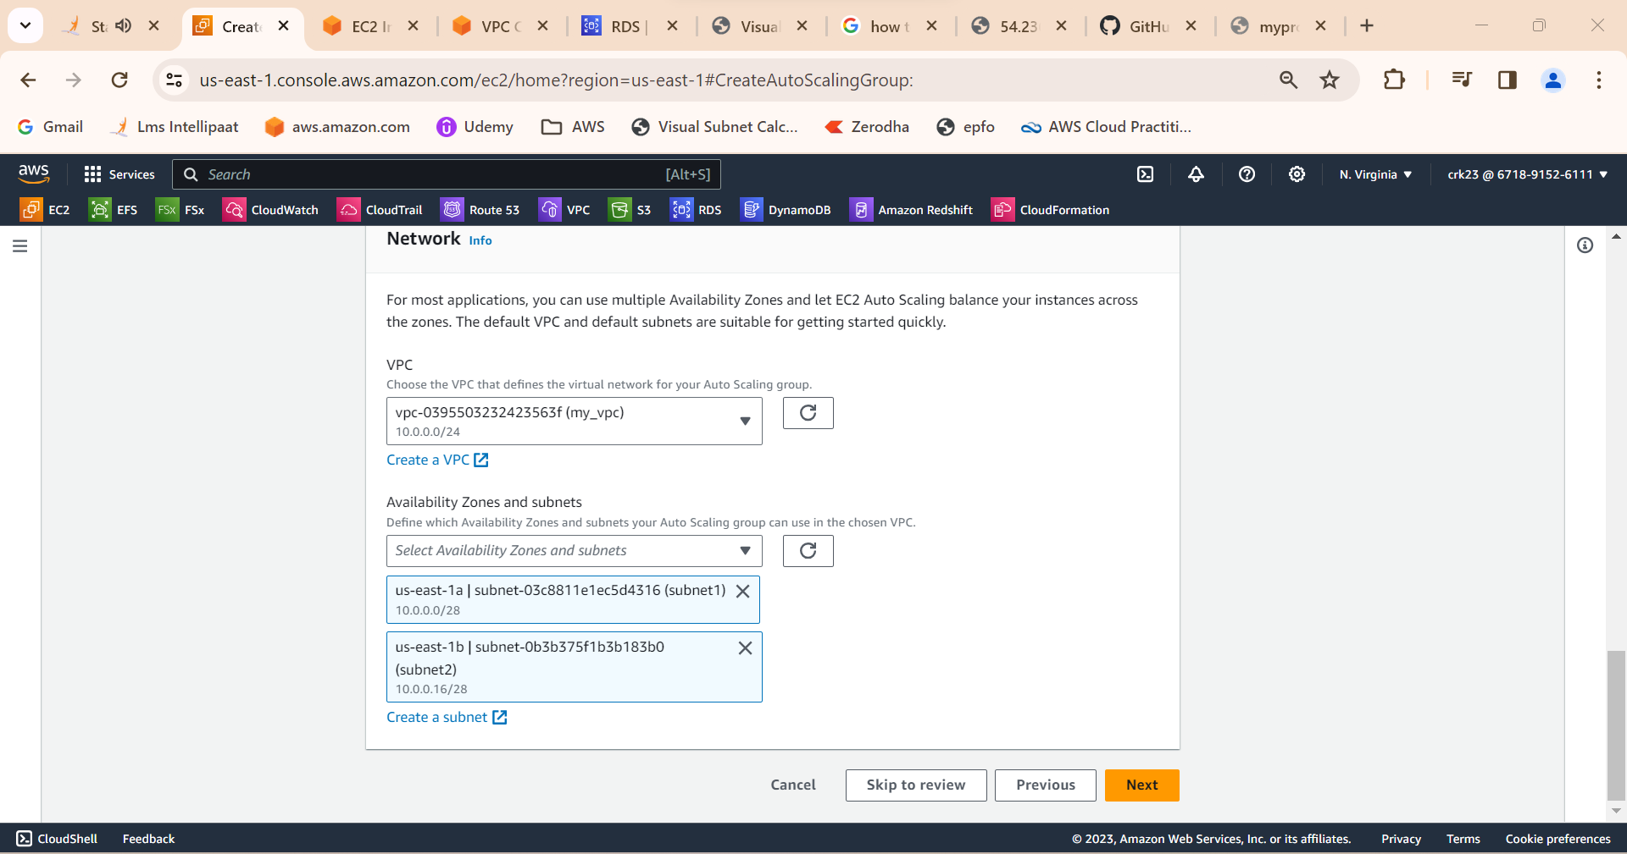

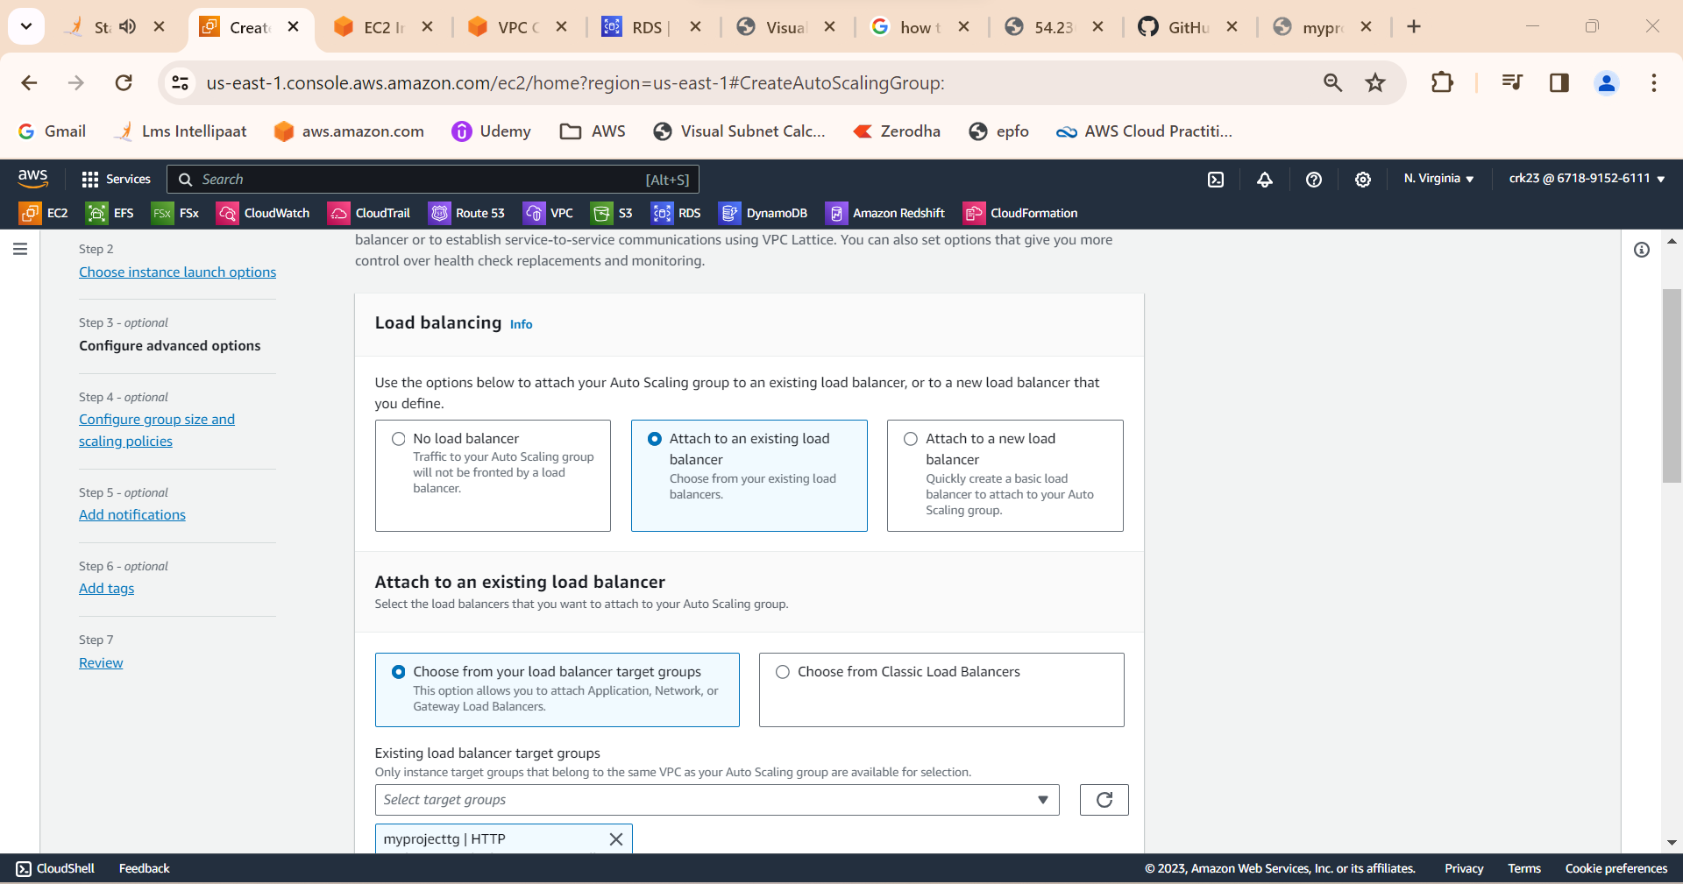

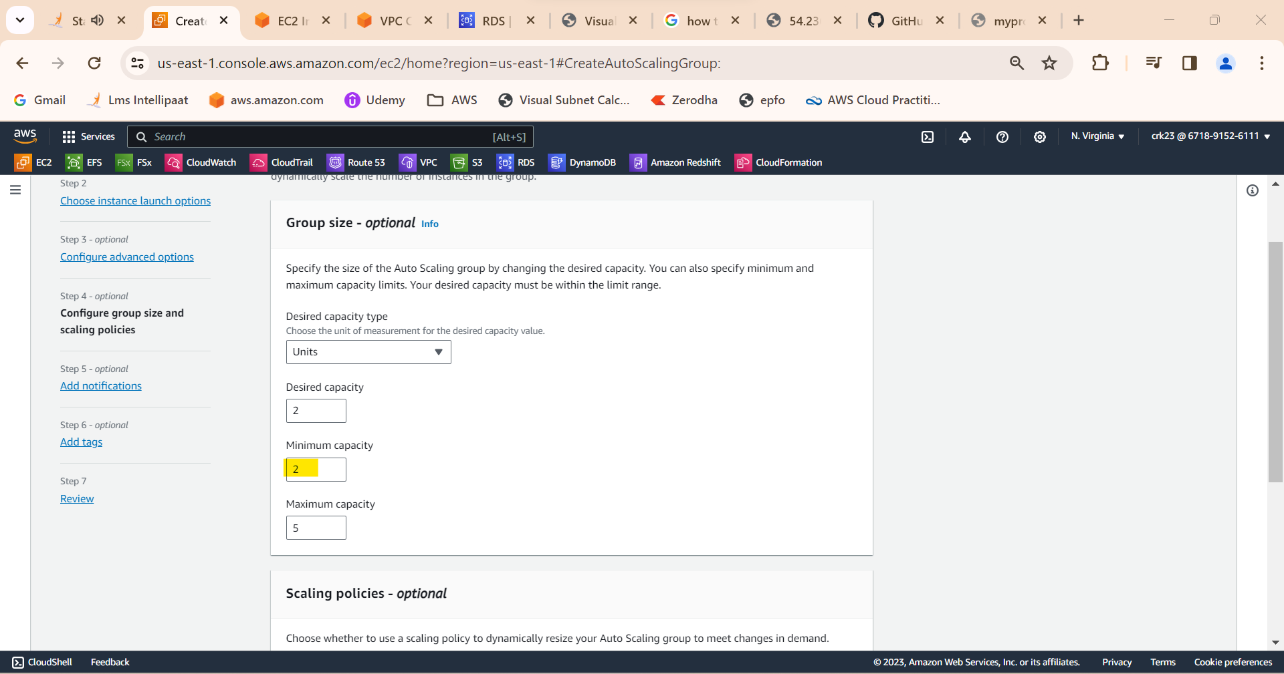

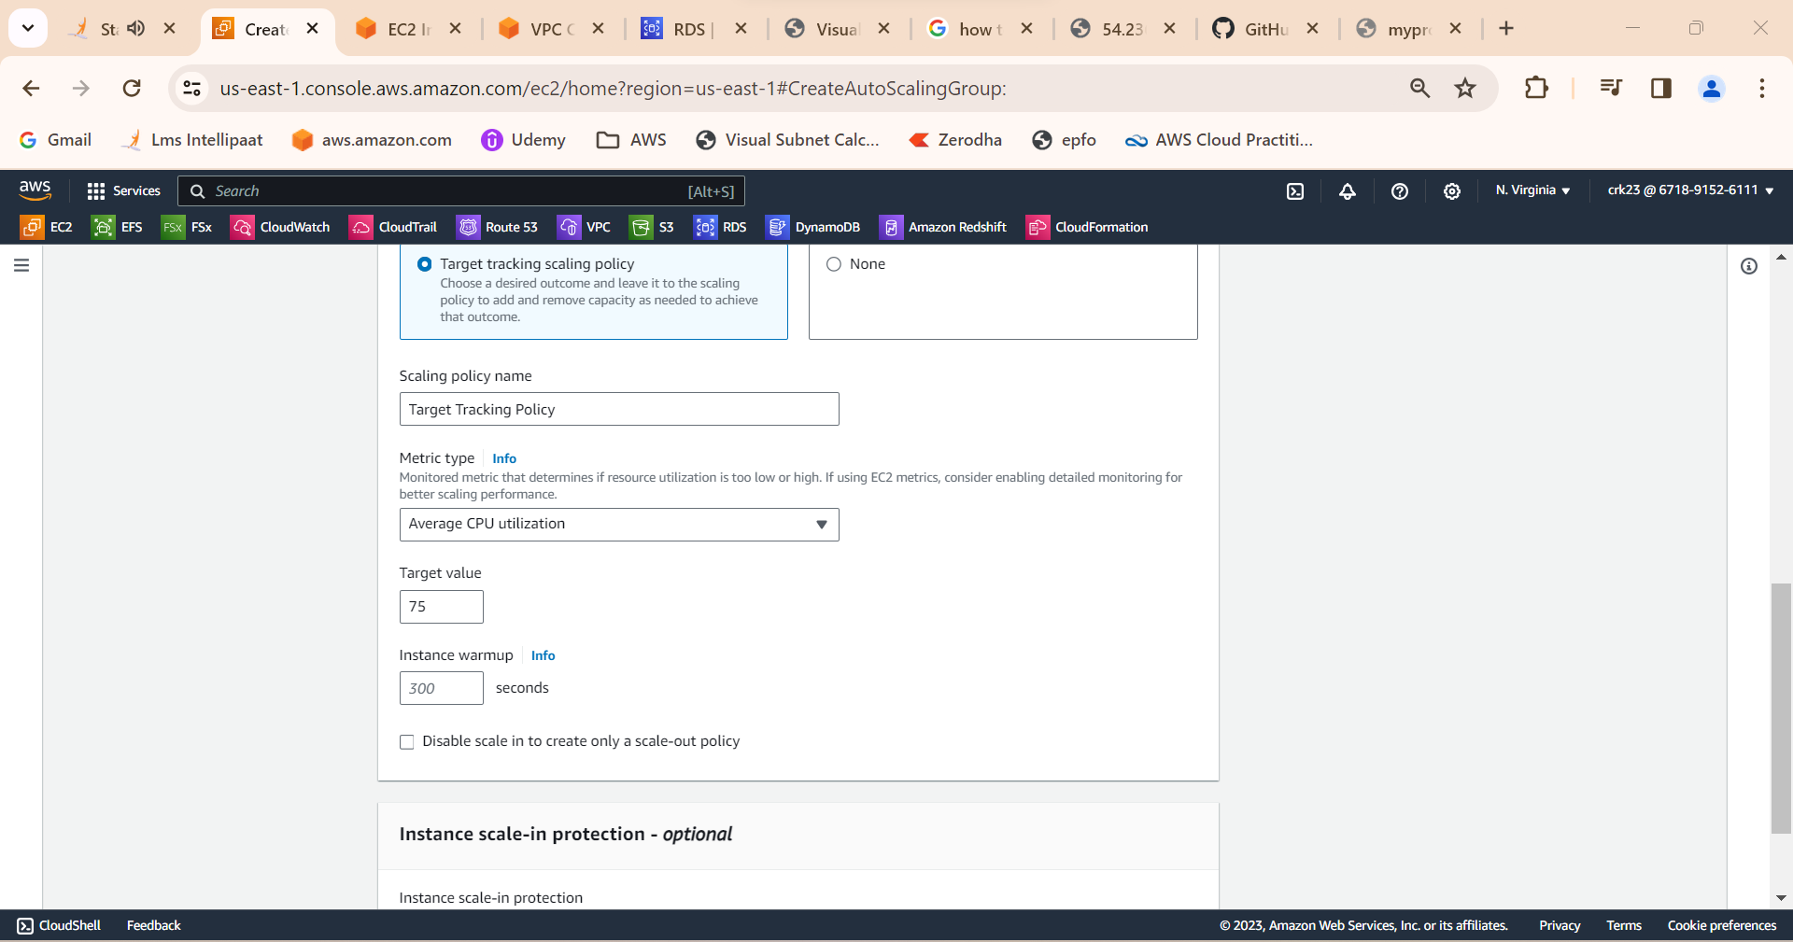

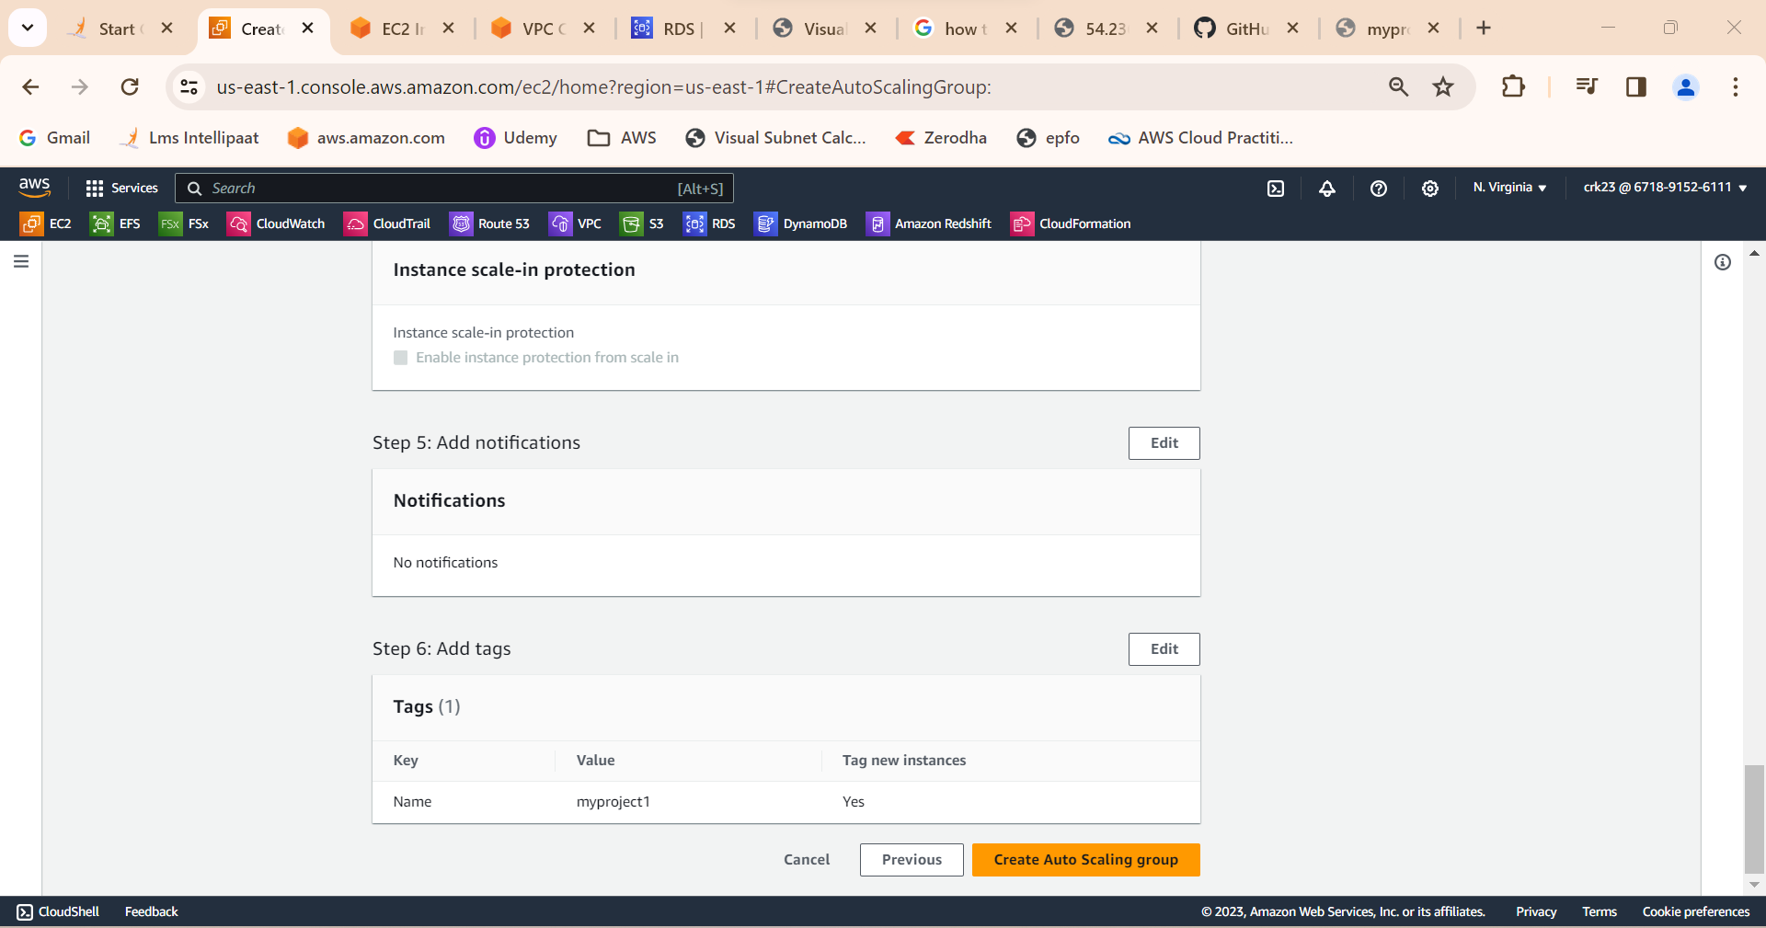

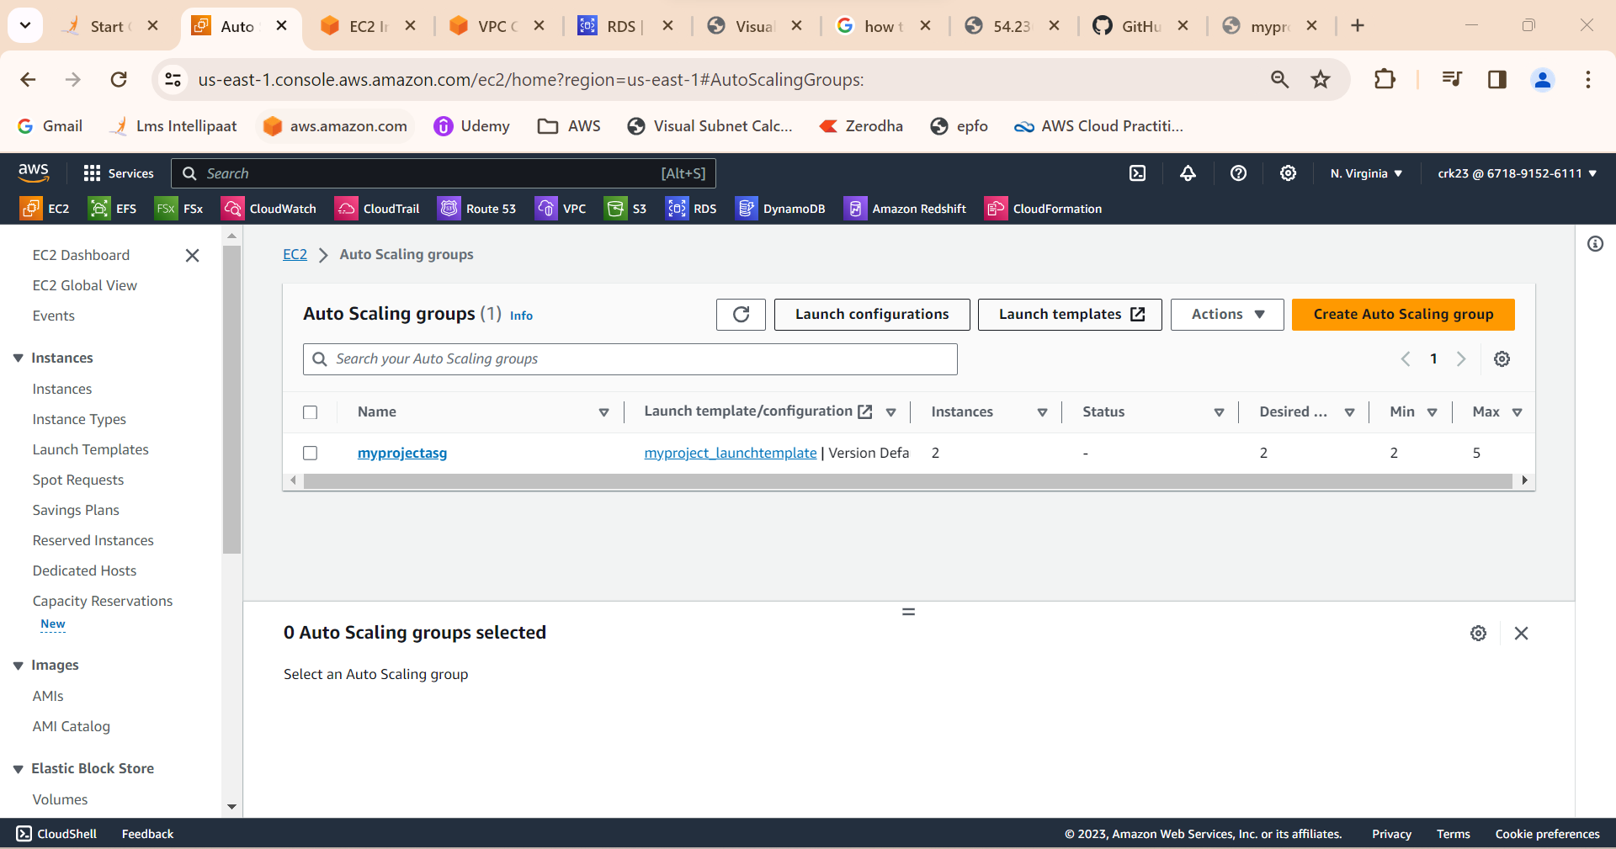

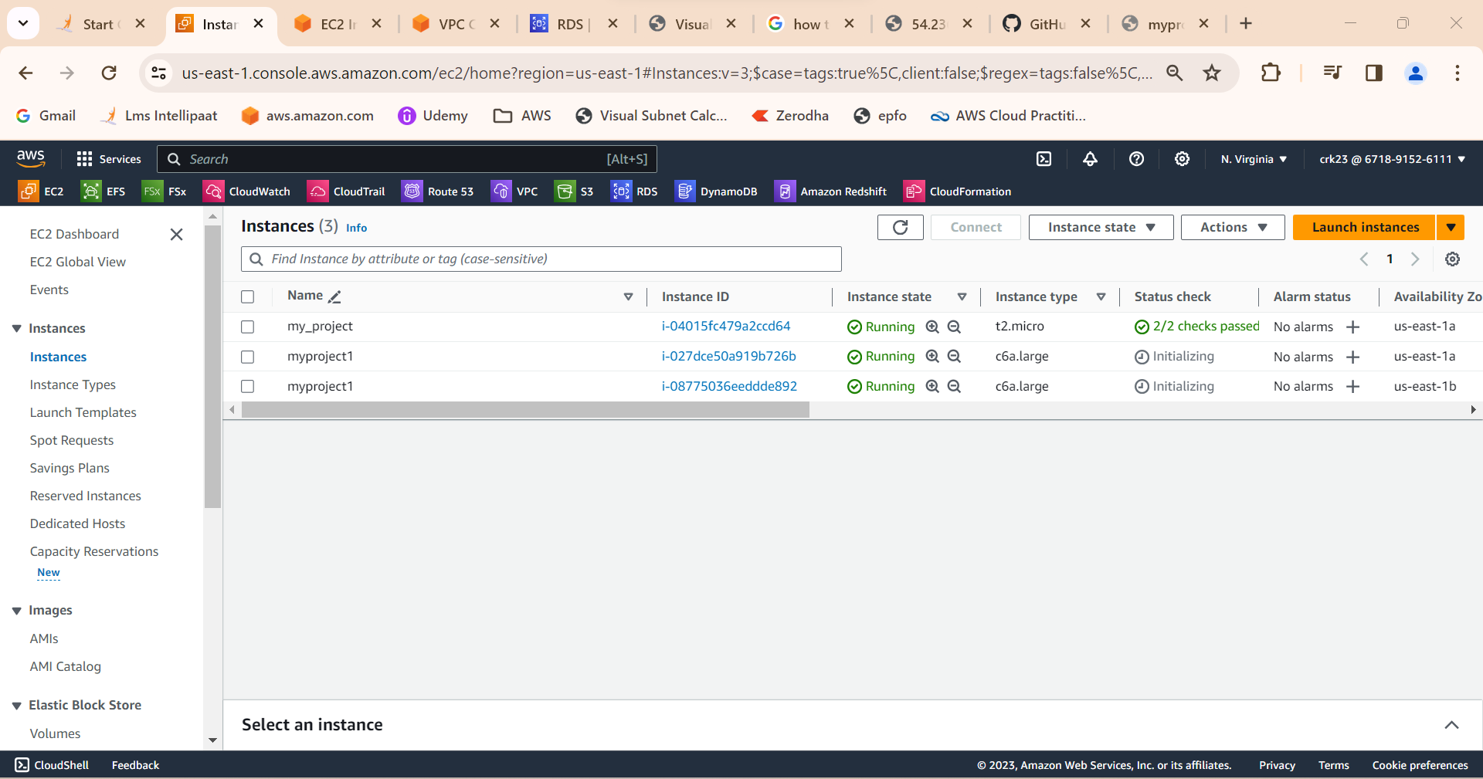

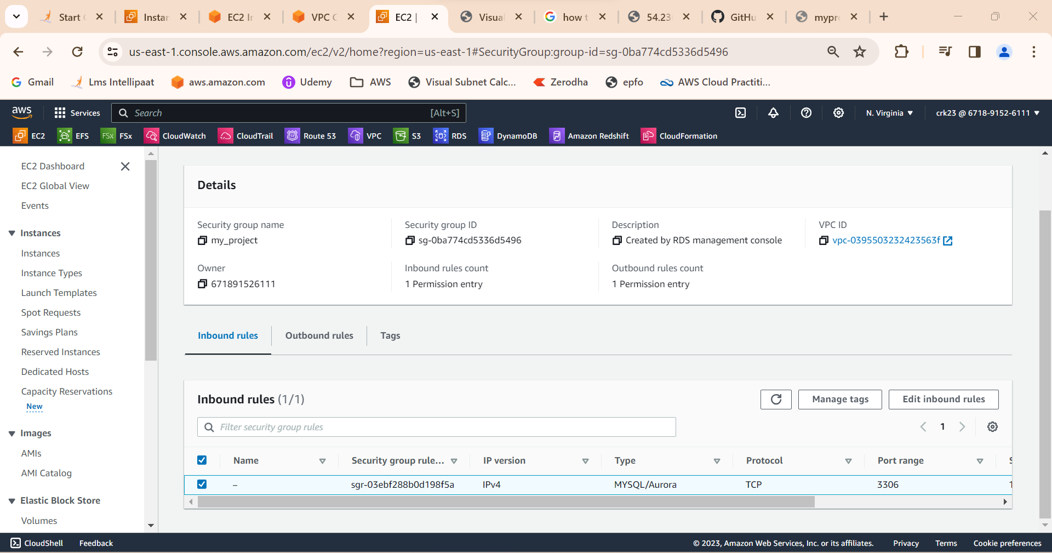

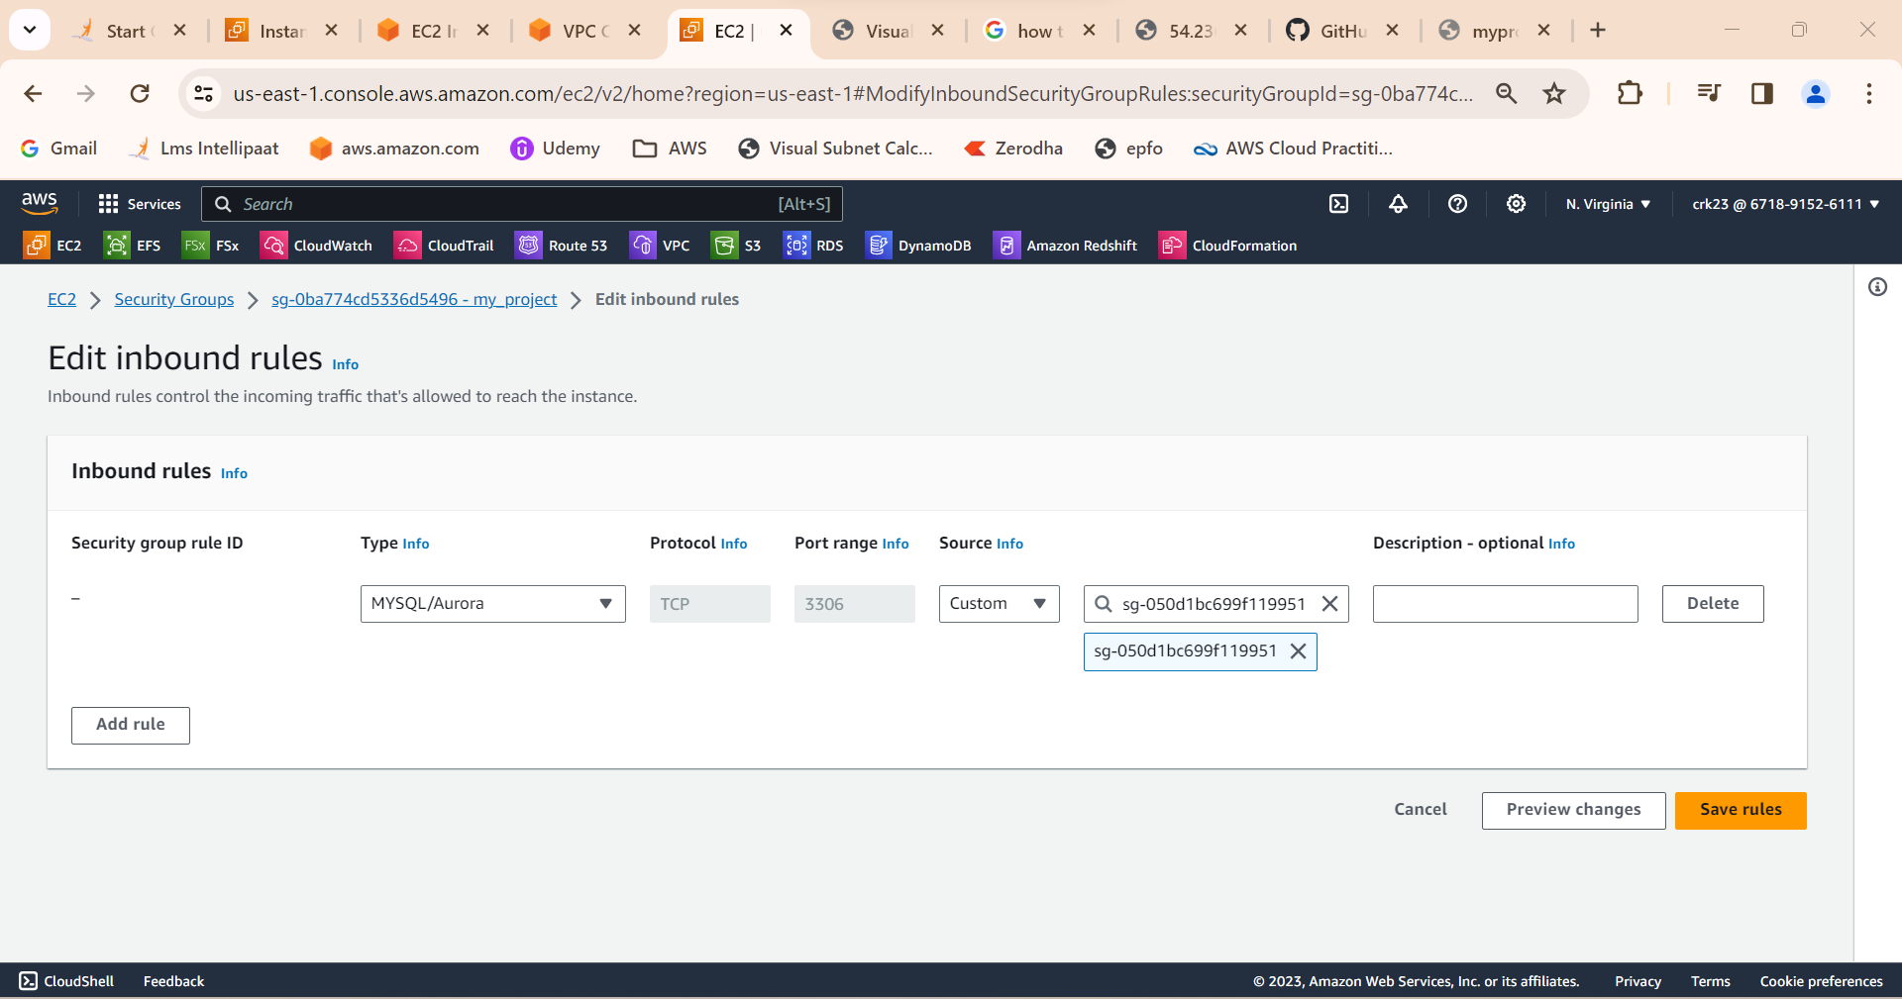

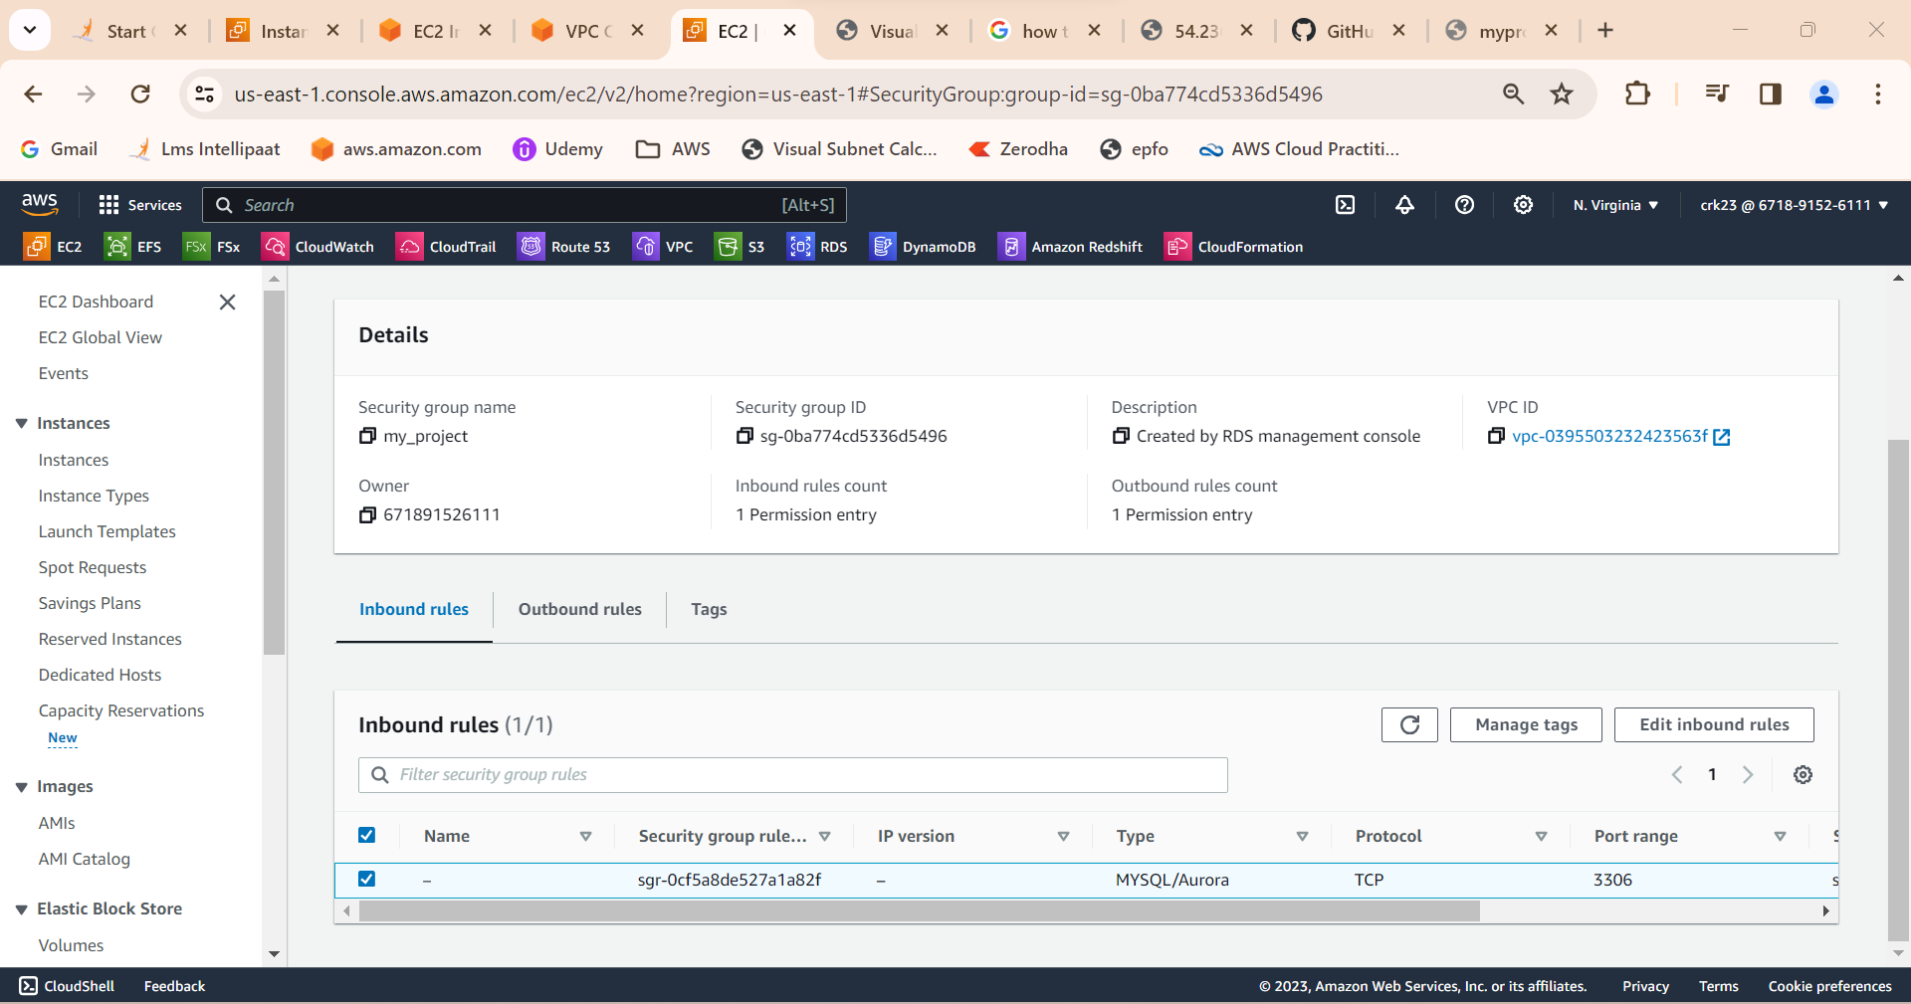

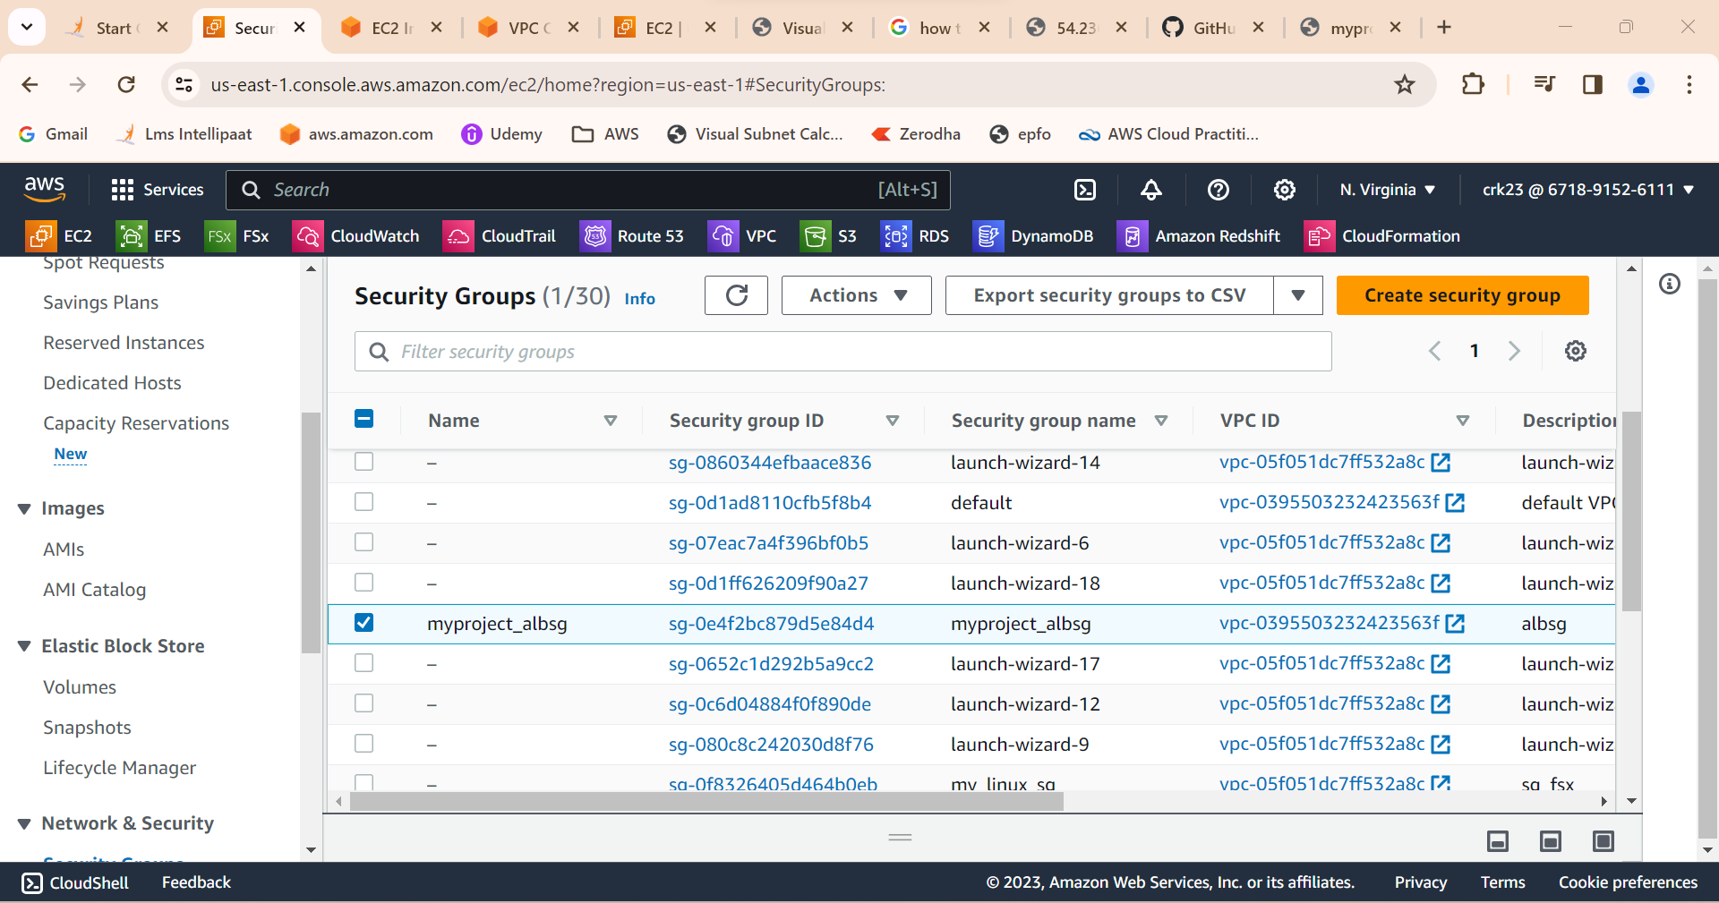

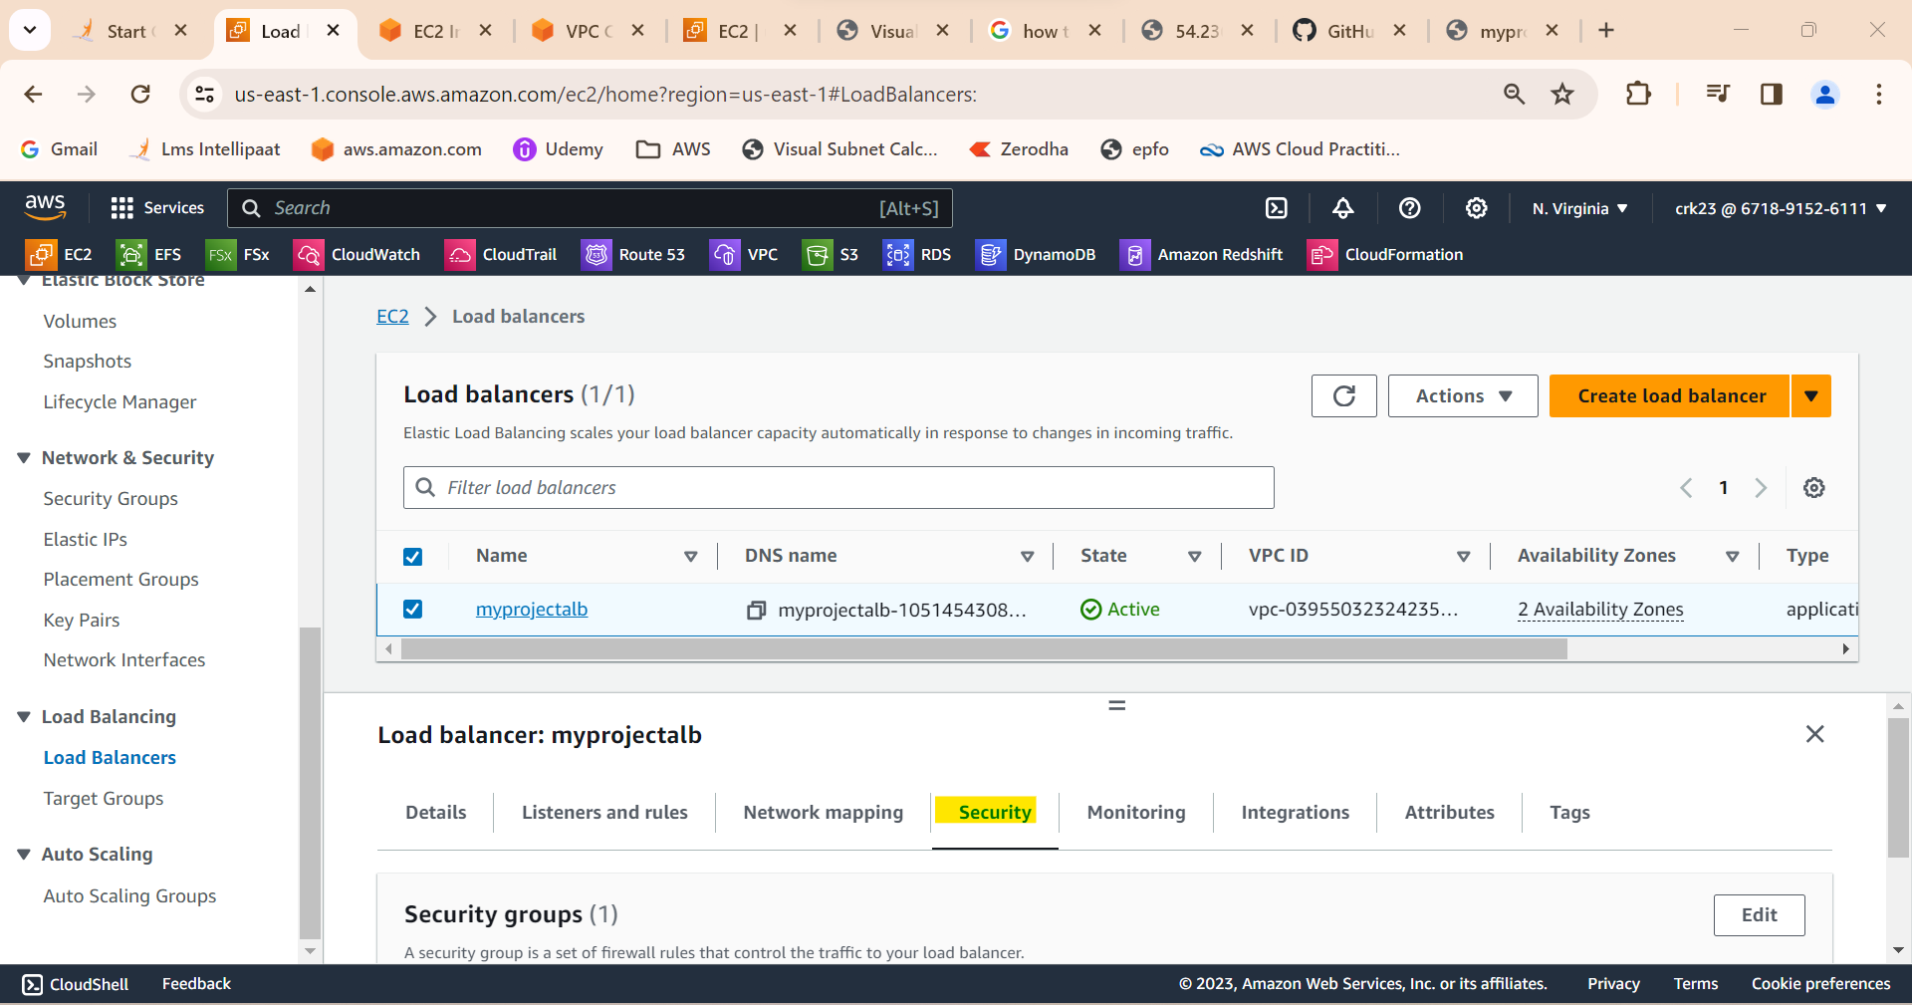

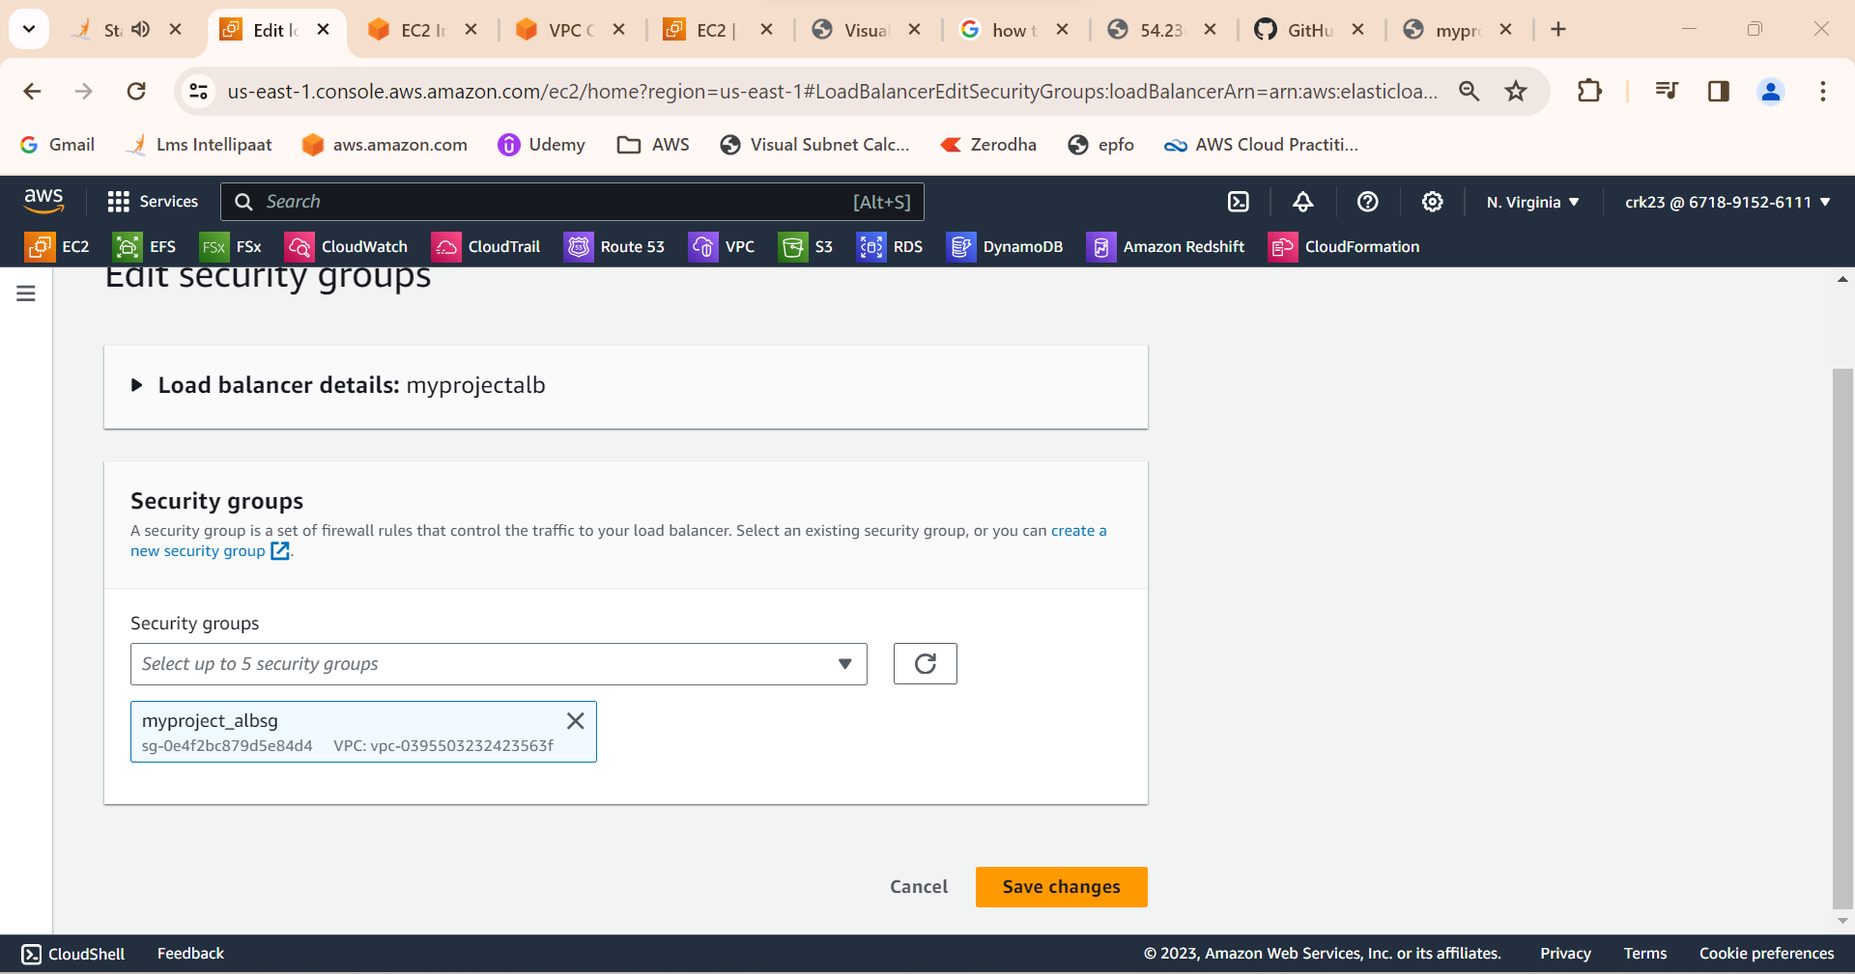

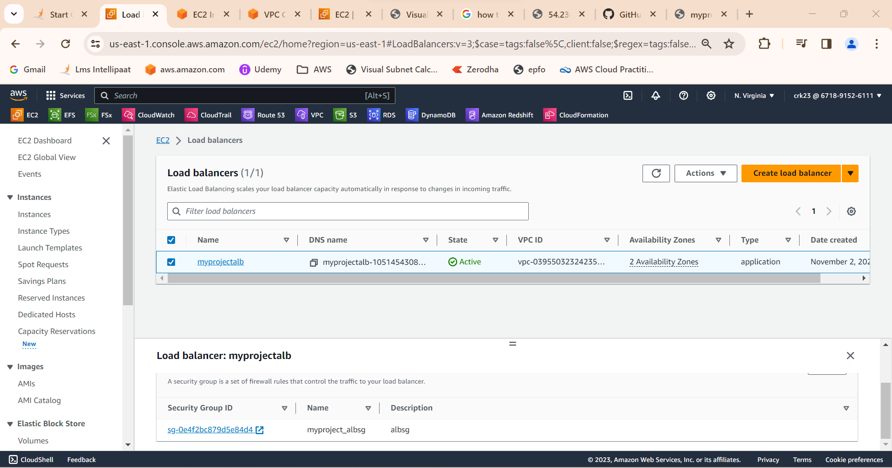

OUTPUT:

Created multi tier architecture using aws EC2 successfully.